*2nd October, Monday:*

**Lecture 1.1:**

* Statistics allows us to make sense of the world around us and draw meaningful conclusions from data, basically allowing us to make informed decisions in such a data-driven age.
* A math background is important for statistics, but focuses more on the applications of statistics as tools.
* Optional textbooks: ‘Introductory Statistics’ by Rob Gold and Ryan; ‘MyLab Statistics’ Pearson
* Statistics is a subject which has a lot of applications and one programming language used in statistical analysis a lot is R. R Studio is an environment IDE for R- very convenient to use for data analysis with computers. R is an important tool for statistical analysis, lot of function for it like even as a calculator.

Course Overview:

Core Structure- mainly 4 parts:

1. Descriptive Statistics- mainly chapters 1-4: Nature of data, what is data, what is statistics, how we can describe the data to make it meaningful- using graphs or numerical summaries to describe the variables and then how can describe the relationships between different variables.
2. Probability & Probability Distributions
3. Sampling Distributions: important for carrying out statistical inferences- the main reason we analyze data is because we’re hoping to draw some meaningful inference and conclusions from the given information in order to predict what might happen in the future based on what we have now or in the past.
4. Statistical Inference: inferences for categorical and numerical data- how we can come up with some numbers that best summarizes the information that we have or how we can generalize from the sample data that we have.

Where is Statistics Applied?

🡪 Gambling (probability theories)

🡪 Ecommerce recommendations (amazon, youtube, spotify etc. recommend relevant content to different people based on histories, searches, profiles etc.)

🡪 Ticket prices like for flights (use data from searches online used to adjust prices)

🡪 Sports (ex: moneyball theory in baseball; how different players get picked and how to analyze their strengths and weaknesses)

🡪 Insurance (data to analyze risk)

🡪 Marketing & Advertising (to analyze where to advertise product and reach target audiences to use different strategies)

🡪 Social Studies (data analysis)

🡪 Weather forecasting (probability theories; chance of rain next hour is based on data gathered)

🡪 Politics (before elections different models used to predict winning candidate)

🡪 Medical field (for ex. how do researchers determine whether a vaccine is safe and effective)

All these involve gathering data, performing data analysis, and then making decisions based on the information that we have or making predictions. Thus, the application of statistics can be traced to every field.

What is Statistics?

* About converting data or information we have into useful information- a tool for us to understand what data can or cannot tell us about the world.
* Application deals with every aspect of statistics- the collection, organization, analysis, interpretation, and presentation of the data.
* It’s both a science and an art:
  + Science, because the methods used can be learned and are basically systematic with general applications
  + Art, because even with the same data set, different people might use different methods to analyze the data and even arrive at different conclusions. The successful application depends on the skill and special experience of this person who performs the analysis, and knowledge in the field of that application.
* Statistics is the science (and art!) of data:
  + A tool to understand what data can (and cannot) tell us about the world.
  + A systematic framework for quantifying uncertainty.
* The data cycle:

1. *Asking questions* about the world
2. *Consider data* that needs to be collected and from who/where, to answer this question; quality of data
3. *Analyze data* to ascertain whether the conclusions drawn are an accurate reflection of reality
4. *Interpret data* to convey/present it so that the general audience will be able to understand the analysis.

* Finally, this might lead to new questions which might lead one to collect a larger sample size or modify question and thus, cycle continues.

Population vs. Sample

* *Population:* The entire collection of objects of interest – often difficult to obtain
* *Sample:* A portion/subset of a population of interest – easier to obtain since there’s no way to study all of the subjects in a large population, thus a more practical approach to examine and collect data from a subgroup or ‘sample’ of the population

*🡪 Sampling:* The step that we draw by a subgroup is called sampling; usually the first step in data analysis

🡪 *Inference:* By studying the sample and using the findings discovered from it, the goal is to learn about the population as a whole and this backwards step is called inference.

* Thus, we first take a sample from the large population, and then using the information in that sample, make inferences about the general population. For larger populations, quality of the sample is very important- it needs to be representative of that population; this is very important to ensure that the inferences drawn from the population are plausible.
* The population is really what we want to learn about, and we learn about it by studying the data in our sample.
* Survey studies online, through phone calls or flyering is a common way of sampling to obtain a representative sample and have negligible bias.

The Statistical Process:

1. *Identify population of interest*
2. *Collecting data from the population* (sampling process)
3. *Exploratory data analysis/ EDA* (to make sense of data need to summarize or visualize it)
4. *Make inference about the population*  (draw conclusions based on observations and results)

🡪 But, before we can draw conclusions, need to look at how sample being used might differ from population and how accurately it reflects it- this is where probability gets involved to factor and examine the difference between the sample and the population into the analysis.

*Probability* is the machinery that allows us to draw conclusions about the population based on the data collected.

*‘The Big Picture’* :

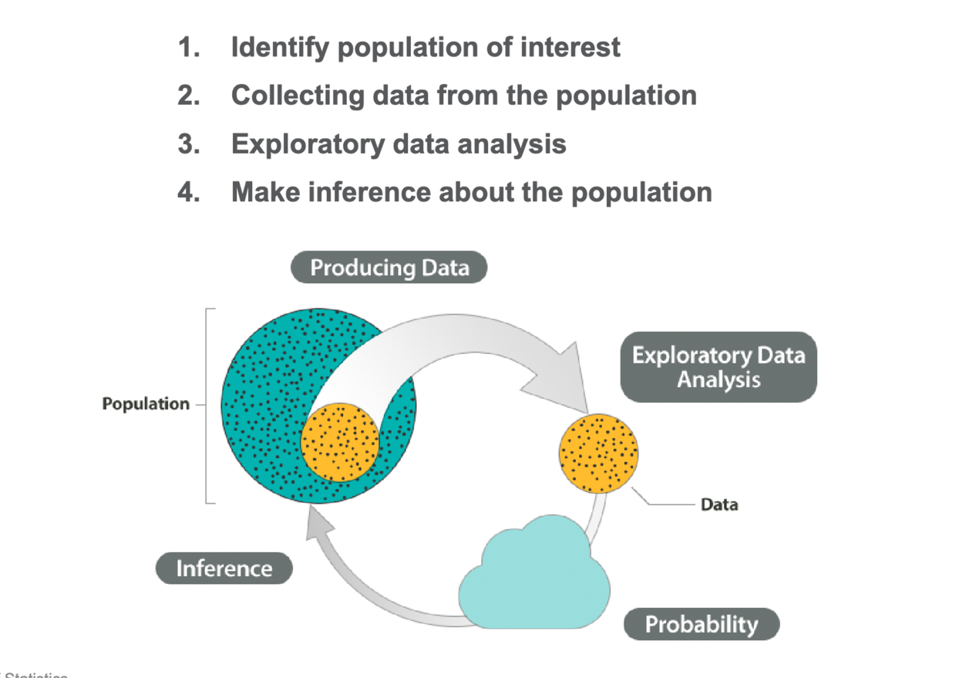

What is Data?

* The raw materials of statisticians- first impression of data is numbers, height, weight, measurements, numerical indices, etc.
* In math can study the number by itself, but statistics is more concerned with the context or story behind those numbers. Without context, we don’t know what the numbers mean or how they make sense and thus, meaningful conclusions cannot be drawn.
* Information/measurements/observations that is recorded/collected- numbers are most common format of data but can also take other forms like text, images, sound files etc. More complicated data formats will require a lot of time in data cleaning and organizing before any analysis can be performed- investment in resources and money in different sectors nowadays by researchers to get data.
* A collection of data is called a *data set* (or *dataset*).
* Polls, surveys, experiments, forms, interviews, cookies on internet, google searches, automatic data collection devices (like digital watches, phones) etc. are all ways of collecting data for analysis. But if not collected the correct way, can be ridden with bias- survey study minimizes these biases to get more accurate results.
* Currently we’re in a golden age of data but can also be thought of as a dark age of privacy- all activities online like google search, credit card transactions, social media posts etc. leave a data trail as information about the user for behavior to be analyzed. Also stirs up the debate of ownership of data and manipulation.
* Data science is a field that uses techniques and theories from mathematics, statistics and computer science to analyze data.

Variability:

*Data and Variability* are the two major concepts underlying the study of statistics.

* Variability very broadly is the differences or changes in an item’s condition, amount or level.
* If everything is identical and the same scenario always has the same outcome, then we say it’s deterministic; no variability = not much statistical potential

There is an inherent element of *randomness* in each situation that caused possibly different outcomes of something.

* Same medical treatments have different effects on different patients
* Price fluctuates for the same stock
* Draw a circle by hand

Thus, variability caused by this randomness is hard to predict due to a wide range of differences being present in the data. However, these variations in many cases can be controlled or even reduced- quantifying variability is a big concept in statistics.

Variables and Observations:

* Because of variability, certain characteristics will differ. Any recorded information or characteristics about the object is called a variable- named so because the data varies.

*Data are usually organized into variables and observational units.*

*Variables*:

* Any piece of information we record. Any characteristics, number or quantity that can be measured or counted.

*Observations:*

* A set of data collected from an object/unit of interest (a particular observational unit)
* In a data table, the columns represent certain characteristics of the subject- the variables. The rows represent certain observational units – different numbers to reflect variability in numbers

Classifying Data:

Generally, two types of data:

1. *Numerical data (Quantitative data)*

* Tell us how much or how many (often expressed in numerical values)
  + Discrete (can take certain values that can be listed out or counted ex. 1,2,3,4)
  + Continuous (can take infinite possible values within a certain range
* Example: number of siblings, weight, temperature,…

1. *Categorical data (Qualitative data)*

* Tell us what type or what kind (describes some qualitative aspect; category or label values and place each observation into one or several groups; categories do not overlap; numerical operations do not make sense for this type of data)
  + Nominal
  + Ordinal
* Example: eye color, zip code, major in school,…

**LECTURE 1.2:**

Examining Distributions:

Distribution -- what values the variable takes, and how often the variable takes those values.  
➢ Recognize trends, patterns  
➢ Identify unusualness in data  
➢ Make comparisons between groups  
➢ Learn about real-world processes  
- Graphics can be extraordinarily powerful ways of organizing data, detecting patterns and trends, and communicating findings.

Examining Categorical Distributions:

*Frequency Tables:*

🡪 Frequencies (or counts): The number of times a value is observed in a data set.

🡪 Relative Frequency: The proportion/ percentage of times a value is observed in a data set.

*Visualizing the Distribution:*

**1) Pie Chart**

🡪 WHAT DOES IT DO? Shows the proportion of observations that belong to each category.  
🡪 HOW DOES IT DO IT? Each category is represented by a wedge in the pie. The area of the wedge is proportional to the relative frequency of that category.

🡪 HOW IS IT USED? To understand which categories are most frequent and which are least frequent. Sometimes it is useful to label each wedge with the proportion of occurrence.

**2) Bar Chart**

🡪 WHAT DOES IT DO? Shows the distribution of a categorical variable.  
🡪 HOW DOES IT DO IT? Each category is represented by a bar in the pie. The height of the bar is proportional to the frequency of that category.  
🡪 HOW IS IT USED? To see patterns of variation in categorical data. The categories can be presented in order of most frequent to least frequent, or they can be arranged in another meaningful order.

Describing a Categorical Distribution:

🡪 Mode: typical outcome, category of the highest frequency.

* There may be more than one mode if more than one value is tied for occurring most frequently.

🡪Variability/ Diversity:

* If many observations spread across many different categories, then the variability is high.
* If many observations fall into the same categories, then the variability is low.

Examining Numerical Distributions:

**1) Dot Plot:**

🡪 WHAT DOES IT DO? Shows a picture of the distribution of a numerical variable.  
🡪 HOW DOES IT DO IT? Each observation is represented by a dot on a number line.

🡪 HOW IS IT USED? ☛ To see patterns in samples of data with variation.

**2) Histogram:**

🡪 WHAT DOES IT DO? Shows a picture of the distribution of a numerical variable.  
🡪 HOW DOES IT DO IT? Observations are grouped into bins, and bars are drawn to show how many observations (or what proportion of observations) lie in each bin.  
🡪 HOW IS IT USED? By smoothing over details, histograms help our eyes pick up more important, large-scale patterns. The vertical axis can display the frequency, the relative frequency, percentages, or densities.

*Notes about the Histogram:*

🡪 Bin width:

* Bin width is the width of the interval.
* Changing the width of the bins in a histogram changes its shape.
* Too many bins show too much detail while too little bin shows too little.

🡪 Boundary points

* Observations may land right on the edge (or boundary) of two bins.
* We need to decide which bin these edge cases would fall into.

🡪 Be consistent!

* Put "boundary" observations in the bin on the left. (a, b], (b, c], (c, d]
* Put "boundary" observations in the bin on the right. [a, b), [b, c), [c, d)

Describing a Numerical Distribution:

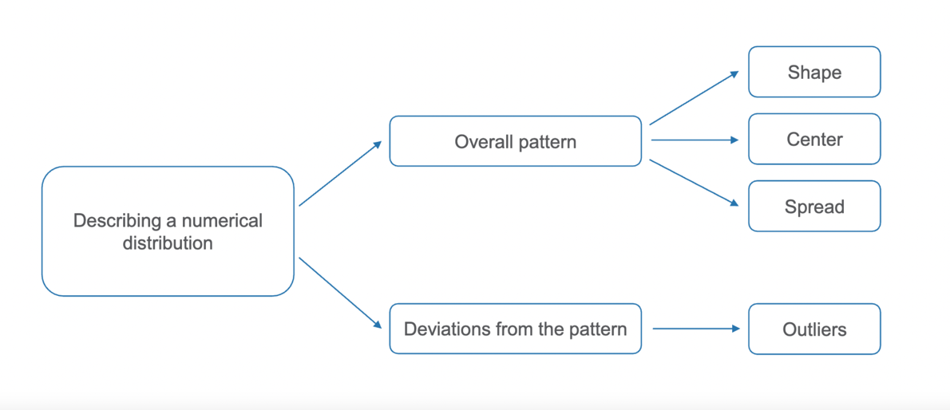

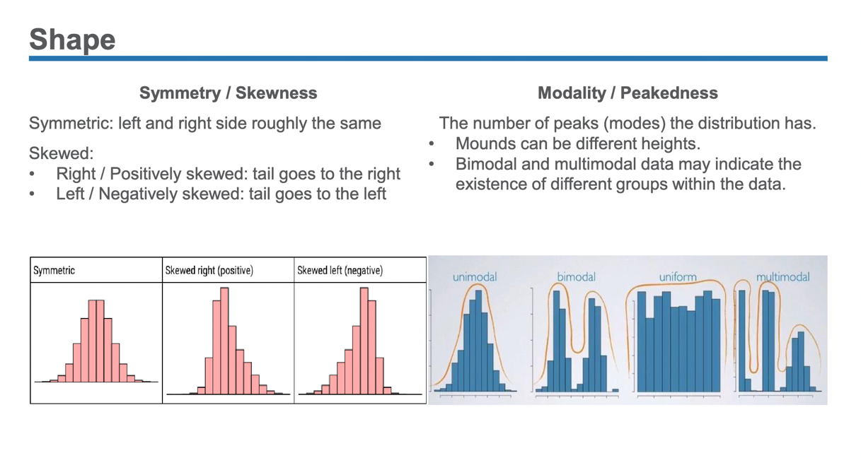

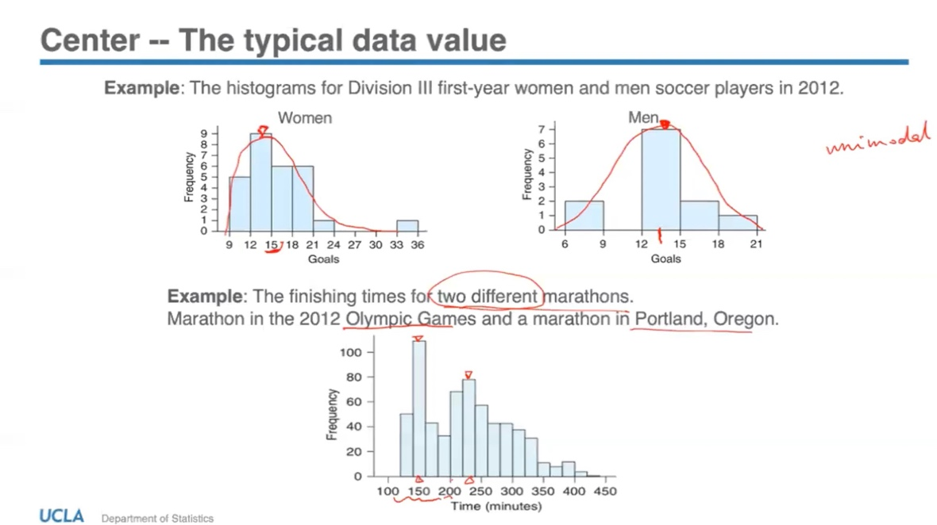

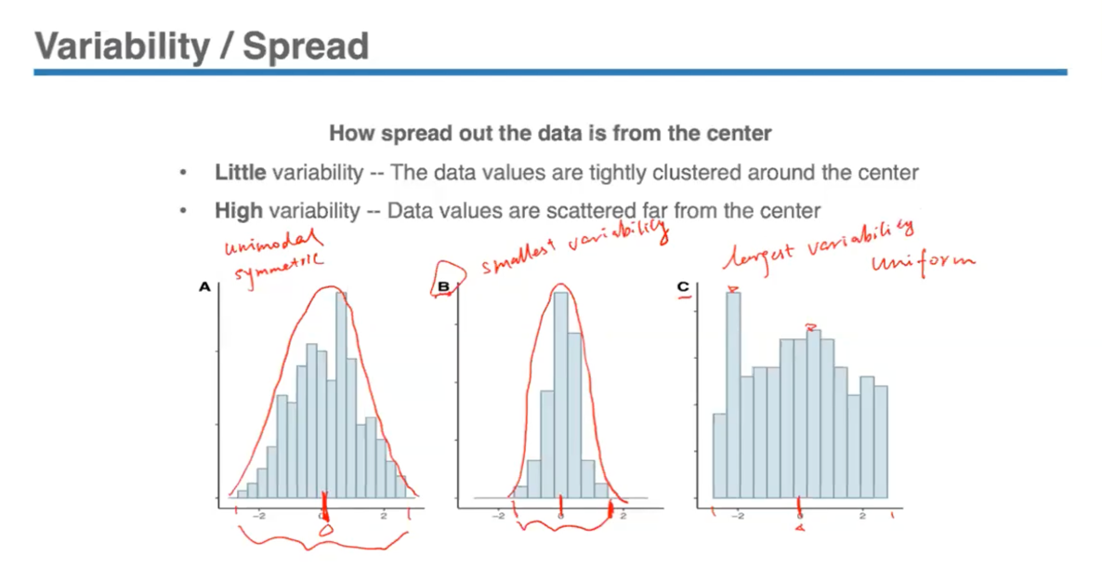

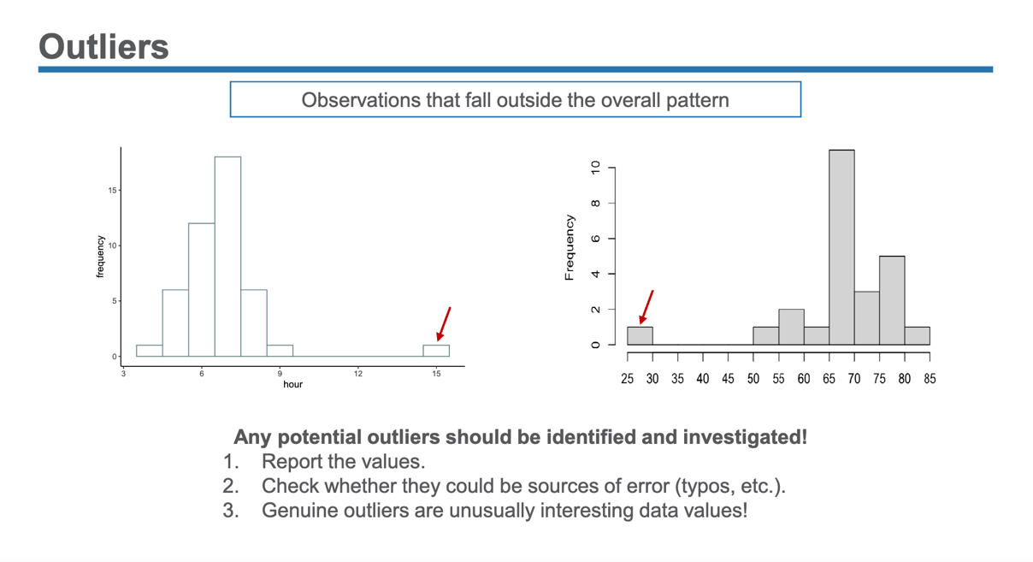

**LECTURE 2.1:**

Measures of Centre:

**1) The Mode**

🡪 The most commonly occurring value in a distribution

* There can be more than one mode
* No mode if all the values have the same frequency

**2) The Mean**

🡪 The centre as balancing point

* Calculated as the arithmetic average of a set of observations
* Suppose we have n observations: 𝑥1, 𝑥2, ... , 𝑥𝑛, the sample mean is:

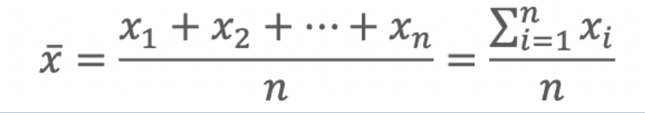

**3) The Median:**

🡪 The center as the middle point of ranked values

1. Sort all data values in increasing order.  
2. Find the center observation in the ordered list, where about 50% of the observations are below the median and about 50% are above it.

* If 𝑛 is odd, the median sits at the 𝒏+𝟏/𝟐 position.
* If 𝑛 is even, the median is the mean of the two center observations, sits in between the 𝒏/𝟐 and 𝒏/𝟐 + 𝟏 spots.

*Mean VS. Median*

* In calculating the mean, the *actual values* of the data points play an important role.
* In calculating the median, the *order* of the data is the key.
* The mean is more sensitive to outliers and extreme values than the median.
* So, for symmetric, unimodal data with no outliers 🡪 mean is a good measure since it considers all the values together (will also be close in value to the median)
* For right/left-skewed, unimodal data with outliers 🡪 median is a better measure since it will be able to retain its position in the data
* Thus, with heavily skewed distributions, the mean may not represent our idea of typical value because it does not divide the data into two halves.

**LECTURE 2.2:**

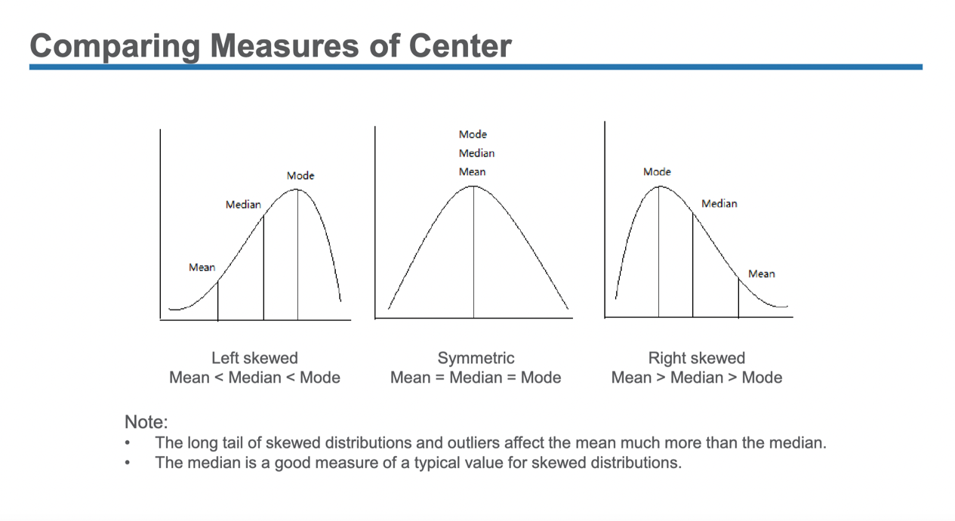

Measures of Spread:

**1) The Range**

* Range = Maximum – Minimum
* The distance spanned by the entire data set
* The range is useful for a quick measurement of variability because it’s very easy to calculate
* Since the range considers only two values- the maximum and the minimum- it is very sensitive to outliers

**2) The Inter-Quartile Range (IQR)**

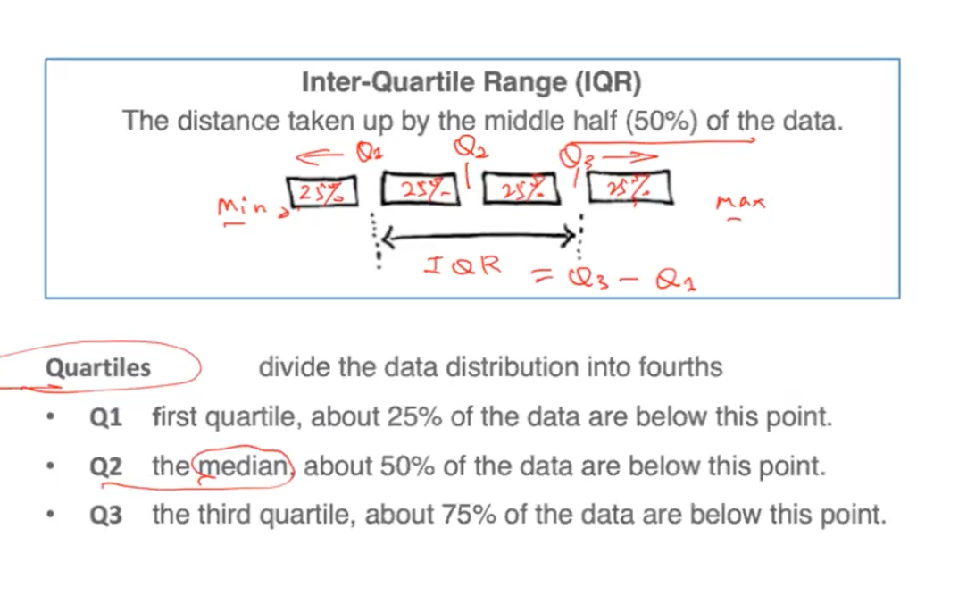

- Since the IQR sorts the data and measures the middle 50%, it’s not heavily influences by these extreme values on the lower or higher end (basically measures the range covered by the middle 50% of the data)

- Divided the data into 4 parts with a roughly an equal amount of observations in each part. Then want to measure how far apart the lower 25% and the higher 25% is, so **IQR = Q3 – Q1**

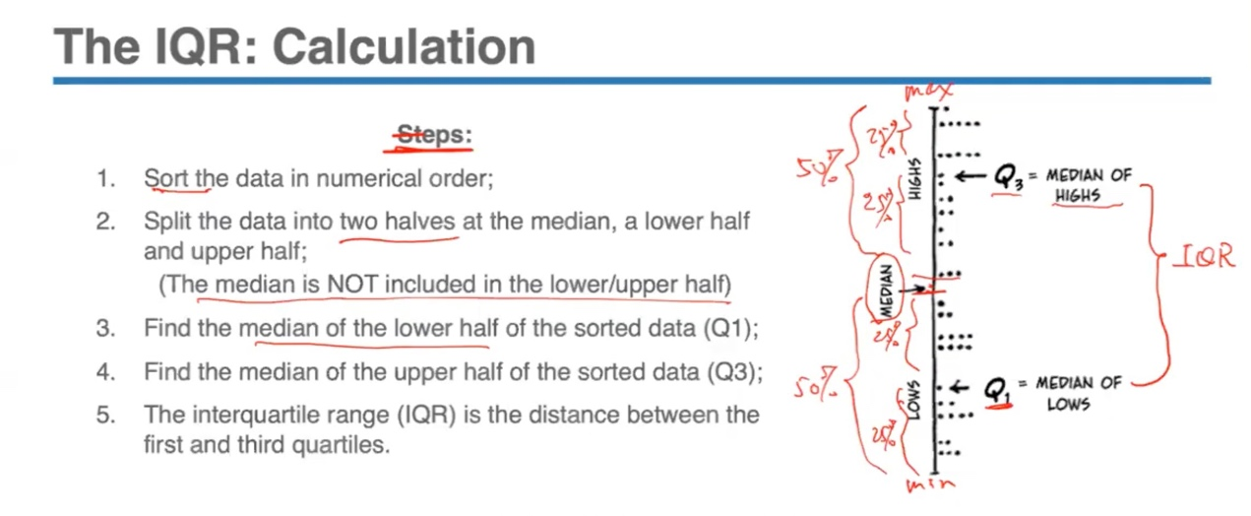

**3) The Standard Deviation**

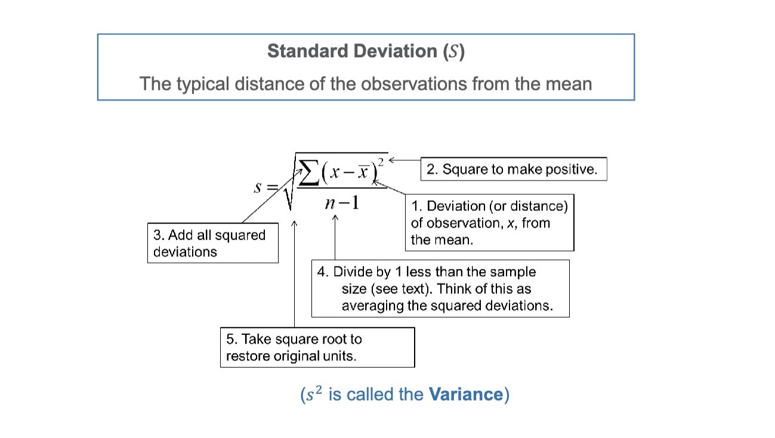

- The reason we’re squaring these deviations is because if we do not square them, when we sum/add them all up in the next step, they cancel each other out. (sum will = 0)

- Dividing by n-1 is like averaging the squared deviations.

- The figure inside the square root is called the variance s2 = (Σ (x - x̄)2 / n – 1). This is just the square of the standard deviation.

- In symmetric and unimodal data, when mean is good measure of the centre, the standard deviation is a good measure of the spread. But if mean is heavily influenced by the extreme values in the data set, even standard deviation will be affected.

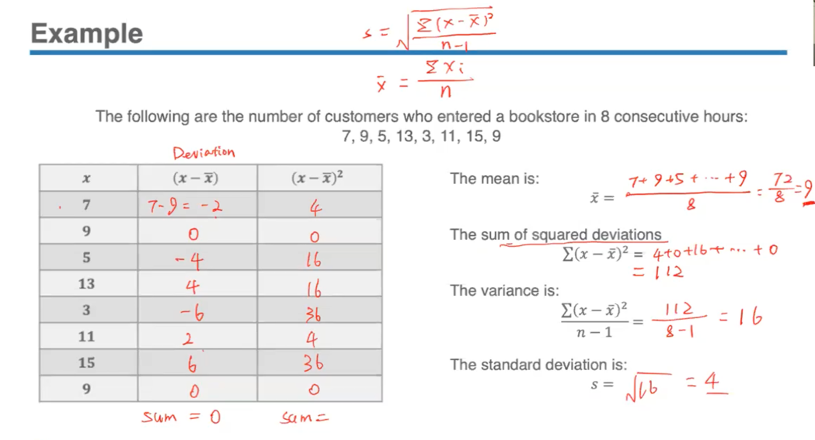

- Means that typically speaking the number of customers that enter into a bookstore is the average, around 9, but this value can differ within 4 customers of 9 (standard deviation). So, standard deviation tells us how much variability we expect to see. The further the observation is from the mean, the larger the square deviation it is and that will increase standard deviation.

**Five-Number Summary**

The combination of all five numbers is called five-number summary:

*minimum, Q1, median, Q3, maximum*

* The extremes (min and max), give the range covered by all the data
* The quartiles (Q1, Median, Q3), together provide the IQR.
* *The 1.5 IQR Criterion for Outliers*  
  An observation is considered a potential outlier if it is:  
  - Below Q1 - 1.5(IQR)  
  - Above Q3 + 1.5(IQR)

- The Five-Number summary provides a quick numerical distribution of both the center (median), the range (maximum – minimum), and the spread of the data (inter-quartile range from Q1 to Q3)

- Just by looking at these 5 numbers, we can obtain a lot of information about the distribution- the typical value, how large the variability is, identification of potential outliers.

- All this information can be represented visually by using a boxplot which graphically represents the distribution by displaying the 5 numbers.

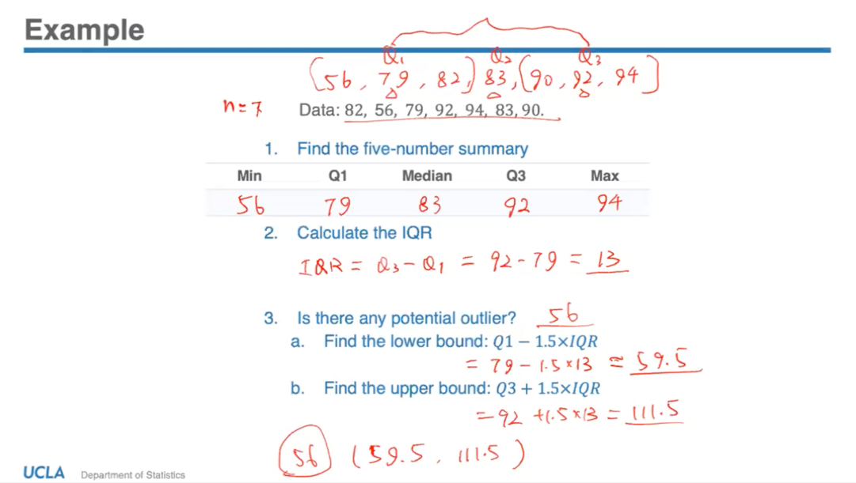

**Box-and-Whiskers Plot**

1) first draw vertical line segments at the 3 quartiles (Q1, Q2 and Q3) – this is the main part of the boxplot.

2) Then draw a box from the base Q1 to Q3 and we can see that the IQR is the length of the box.

3) Then sketch some horizontal line segments from the ends of the box to the minimum and maximum values that are not potential outliers. These line segments are called whiskers (lower and upper).

4) To determine where we extend the whiskers to, we need the 1.5 IQR criterion to help us identify this value in the data set. These whiskers extend to the largest and smallest values in the data set that are not potential outliers. So if any values are beyond or outside of the lower or upper whisker, we call them potential outliers.

5) Remember that in deciding the value of the lower and upper whisker, we are using the upper and lower bound criteria calculated using the 1.5 IQR, but this has to be an actual value in the data. For ex: in the previous example, the range of (59.5, 111.5) will help us decide where we extend our whiskers to. 59.5 is not an actual value in the data set, so we would extend our lower whisker to a point that is the lowest observation but which is not an outlier - 79. 56 would be the outlier. We do not extend the upper whisker to 111.5, but to the largest value in the data set – 94.

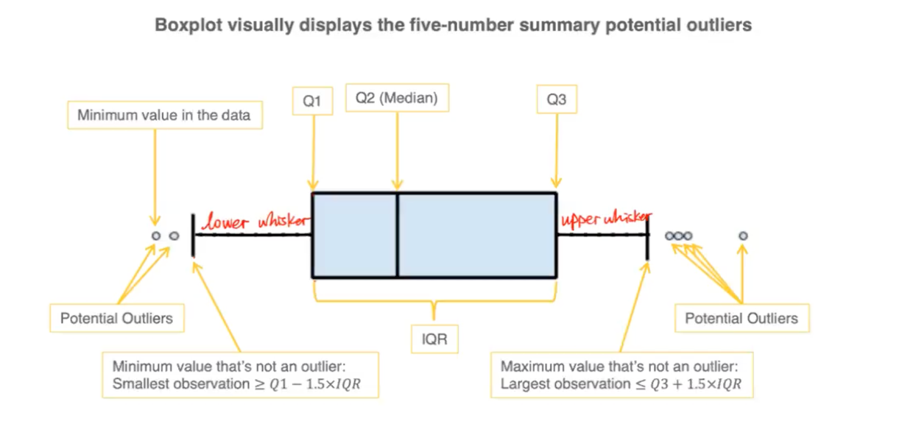

**The Empirical Rule**

- The IQR is related to the median, but a rule that can applied to find outliers using standard deviation and the mean is The Empirical Rule (called that since it’s based on observations as means of forecasting data).

- For distributions having bell-shaped curve that are unimodal and symmetric, we can apply the Empirical Rule to get an idea of approximate percentage of data within some standard deviations from the mean.

- The more unimodal and symmetric a distribution tends to be, the more accurate the approximation tends to be. So this rule cannot be applied to extremely skewed distributions with lots of outliers.

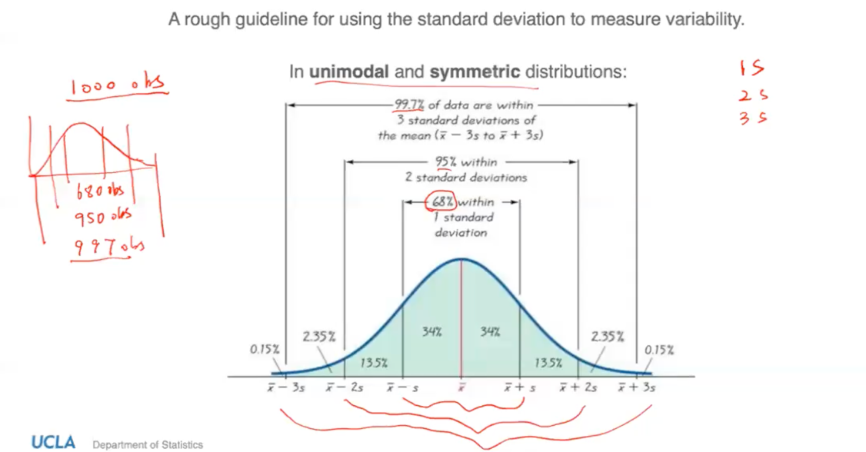

**LECTURE 3.1:**

The Empirical Rule:

* Applied to distributions with unimodal and symmetric shapes with a bell-shaped curve in order to get a rough guideline for using the standard deviation to measure variability (how the data and observations are distributed).
* These observations are approximately within the range of 3 standard deviations from the mean:

68% within – 1 standard deviation (x̄ - s to x̄ + s)

95% within – 2 standard deviations (x̄ - 2s to x̄ + 2s)

99.7% of data are within – 3 standard deviations of the mean (x̄ - 3s to x̄ + 3s)

The Empirical Rule Exercise Question:

1. *Find the pulse rate ranges for the middle 68%, 95%, and 99.7% of the data.*

Sample = 200 students, mean = 75BPM and standard deviation = 8BPM

Applying the empirical rule,

* The middle 68% of the data will fall between (67, 83)

within the one standard deviation range x̄ ± 1s = 75 ± 8 (means that most of the students, about 68%, have a pulse rate that will range from 67 to 83)

* The middle 95% of the data will fall between (59, 91)

within the two standard deviation range x̄ ± 2s = 75 ± (2 x 8)

* The middle 99.7% of the data will fall between (51, 99)

within the third standard deviation range x̄ ± 3s = 75 ± (3 x 8) (means that almost all of the students will have a pulse rate between 51 and 99)

1. *What % of students have pulse rate larger than 59 BPM?*

* 59 BPM is located at 2 standard deviations below the mean (75 – 8 x2)
* Need to find the area to the right of 59.

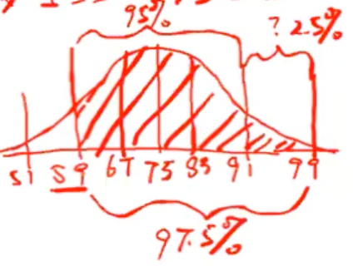

* The amount of observations covered in the range (59,91) is 95% out of the 200
* We know that the entire range covers 100% of the observations, so if we deduct the middle 95%, then left with 5% of the distribution. And since it is symmetric, each side covers 2.5% of the distribution, thus the right tail of the distribution will have 2.5%.

95% + 2.5% = 97.5% of students will have pulse rate > 59BPM.

By symmetry, we also know that 97.5% of students will have BPM < 91.

1. *Is a pulse rate of 57 unusual?*

(Can measure using IQR method, but here given only mean and standard deviation so need to work with that)

* We know that it is 18 BPM less than the average (75) and even further than 2 standard deviations below the mean (59). Thus more than > 97.5% of students will have pulse rate greater than 57. Thus 57 is not a very common observation since most observations would be within 67 to 83 by BPM.

🡪 Guideline: Normally, if a data point is more than 2 standard deviations away from the mean, then we can classify it as an unusual observation or an outlier.

**Z-Scores**

*How usual/unusual is this observation?*

* Depends on the context of the data, the units of measurement and the objects being measured.
* Can’t compare directly 2 values if they’re on different scales or units, so would be convenient to get rid of the units through ‘standardization’. Instead of using actual units like inch, miles, degrees etc. can measure the distance in ‘standard deviations’.
* Statisticians often consider data values that are more than two standard deviations away from the mean as “unusual” or “rare”.

After standardizing, call these units Z-score 🡪 how many standard deviations away an observed value is from the mean. This way, can compare observations in one group to those in another, even if they’re in different scales. Also, the sign of the Z-score indicates the position of the observation relative to the mean.

*Formula:*

**Z = (x̄ - x)/ s**

*Properties:*

* No units
* A negative z-score – the data value is less than the mean
* A positive z-score – the data value is higher than the mean
* The magnitude of z-score (absolute z-score) implies the ‘unusualness’ of the observation.

x̄ - x < 0 🡪 Z < 0

x̄ - x = 0 🡪 Z = 0

x̄ - x > 0 🡪 Z > 0

| Z | 🡪 indicates the distance/unusualness between the observation and the mean. The larger the magnitude of the absolute Z score is, the more unusual an observation is.

So, if | Z | > 2 (above/below mean) 🡪 a potential outlier

Z-Scores Exercise Question:

Suppose the distributions of SAT scores and ACT scores in a class are unimodal and symmetric, it’s given that:

* SAT score distribution: mean = 1100, standard deviation = 200
* ACT score distribution: mean = 21, standard deviation = 5
* Student A scored 1300 on the SAT, and Student B scored 27 on the ACT.

*Which student’s score is more impressive?*

* We know that A scored 200 points above the mean in SAT, and B scored 6 points above the mean in ACT.
* To see which is more impressive in statistical terms, need to compare which score is more unusual and which has a larger Z-score.

A: Z = 1300 – 1100/ 200 = 1

B: Z = 27 – 21/ 5 = 1.2

🡪 Both have positive signs and are above average, but B > A 🡪 1.2 > 1 so since the Z-score of B’s is larger than A’s it is more impressive.

The Empirical Rule and Z-Scores:

* According to the empirical rule, 95% of observations will fall with two  
  standard deviations of the mean.

🡪 95% of observations will have a z-score between -2.0 and 2.0.

* When a distribution is symmetric and unimodal, as a rule of thumb,  
  a z-score higher than 2.0 or lower than -2.0 could be considered as unusual.

🡪 The usefulness of z-scores depends on whether the mean is a good measure of the centre.

- Z-score can only be applied to distributions that are unimodal and symmetric; if the distributions are multimodal or highly skewed then not useful in determining what’s unusual.

To summarize a distribution:

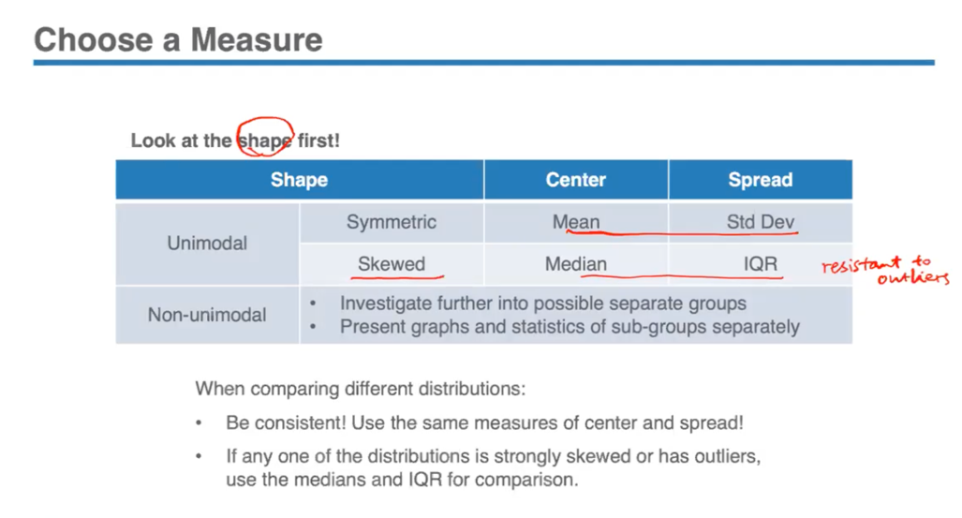

**Exploring the Relationship**

- When examining the relationship between two variables, we want to find out if one variable can explain or predict the change in the other variable.

- The variable that claims to have an effect is called the *explanatory/ independent variable* (X), and the variable that is being affected and we wish to find out is called the *response/ dependent variable (Y).*

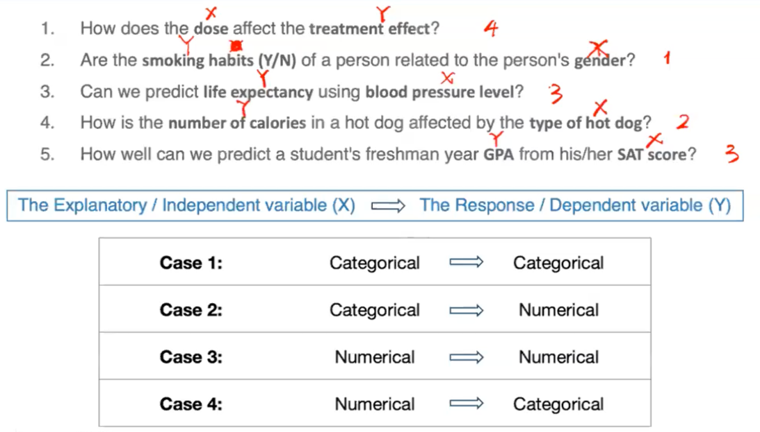

*1) Categorical 🡪 Categorical*

- A two-way table can be used to summarize categorical variables to study the relationship between these 2 variables.

- The graphical tool that can be used to supplement the two-way table is a side-by-side bar chart to compare the distributions within the group and among groups. This a way to also visualize the conditional percentages – the % of the count converted to % by dividing the total number of that group. Ex: 7/10 = 0.7 is the conditional % of female group shown in first blue bar in chart. Within each group, the conditional % sum up to be 1.

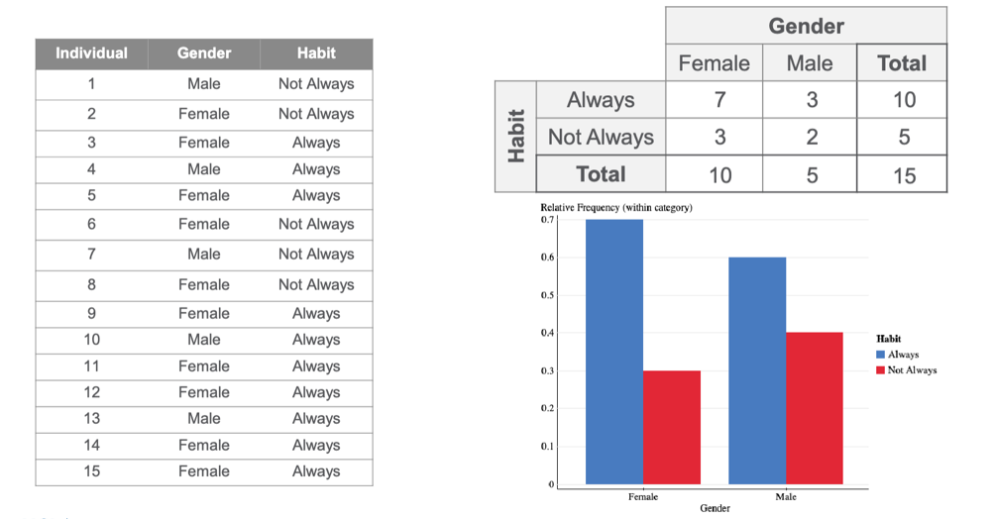

*2) Categorical – Numerical*

- To graphically represent this type of data, can use a side-by-side boxplot.

- To supplement the graph with some descriptive statistics use the five-number-summary.

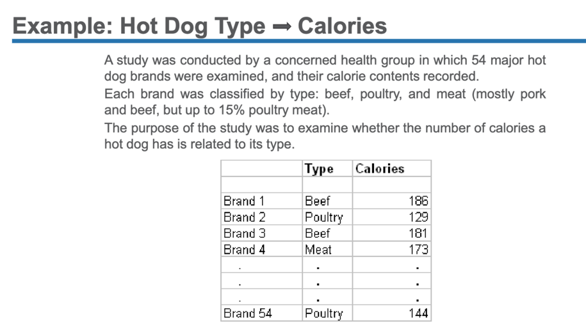

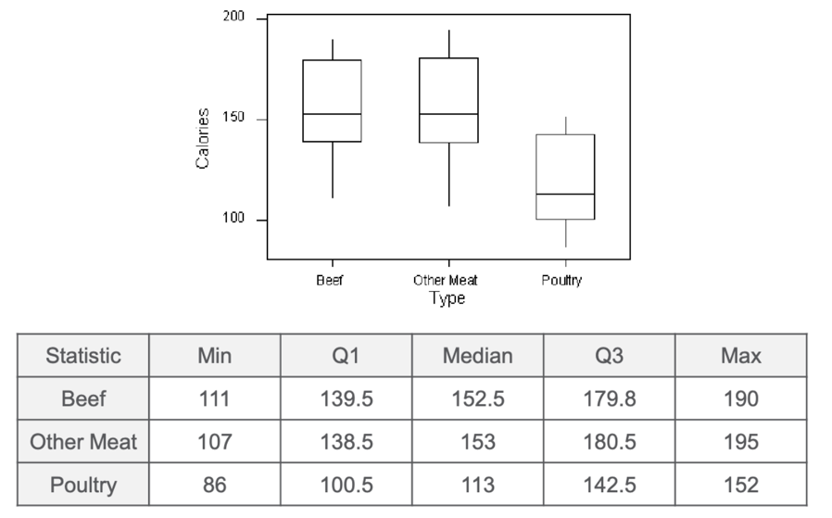

*3) Numerical 🡪 Numerical*

- Primary tool for examining these two variables is a scatterplot. Plot the value of the explanatory variable on the horizontal (X) axis and the plot the value of the response variable on the vertical (Y) axis. Each dot represents an observation from the data set. The two axes don’t have to be on the same scale since the 2 variables may not have the same scale, and they thus also don’t have to start from 0.

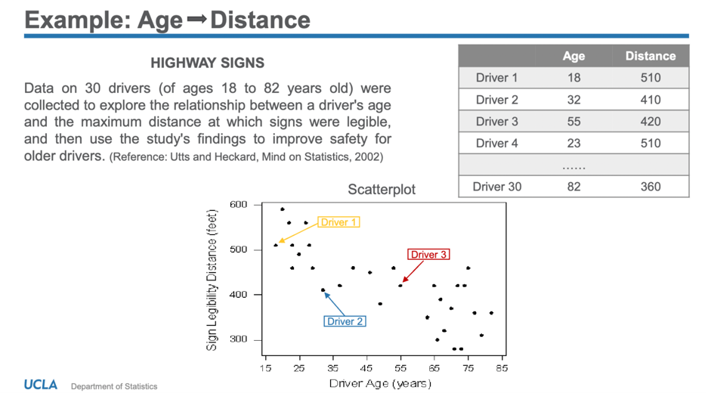

**LECTURE 3.2:**

**Interpreting the Scatterplot:**

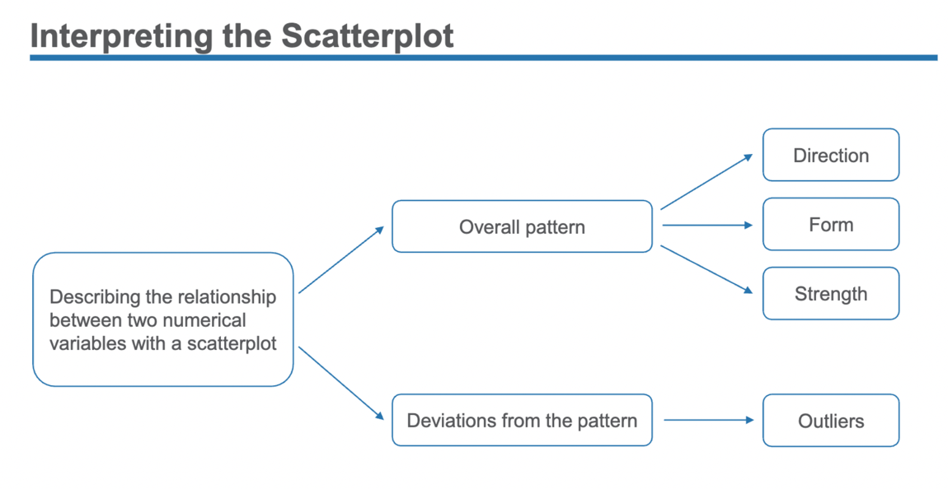

Direction:

The Direction is the general tendency of the scatterplot as you scan from left to right.

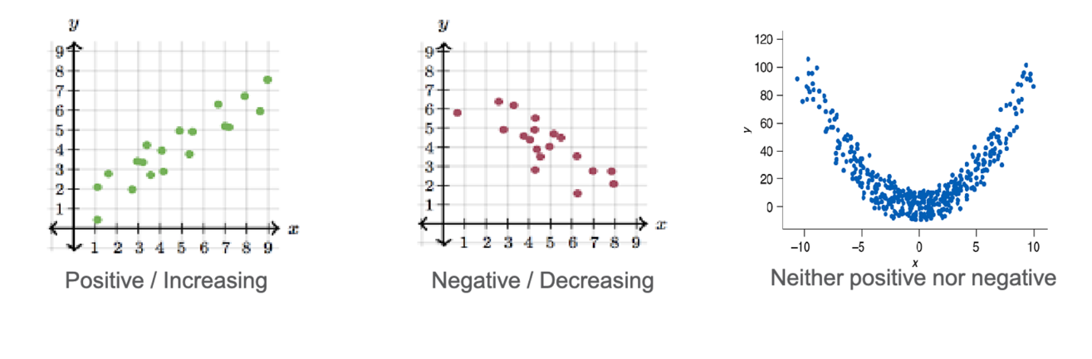

Form:

Linear

* The points scattered about a line, in a generally consistent, straight form. Linear relationship is the simplest form- linear because they scatter about in a single line.
* Linear form increases / decreases at the same rate.

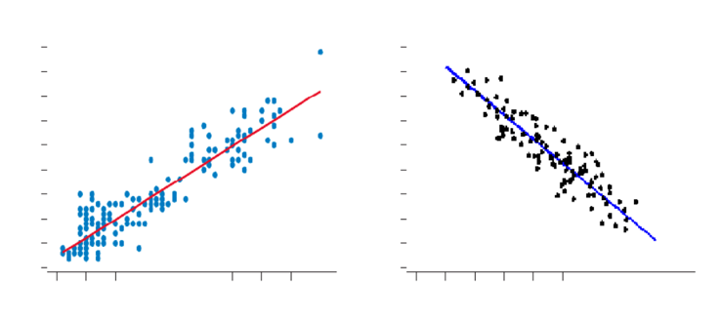

Non-linear

* Patterns that are more complex and can’t be modelled by a straight line. If the form is non-linear or appear as clustered points can reach wrong conclusions if apply the same as linear ones.
* The increase/decrease rate changes depending on the values of the variables.

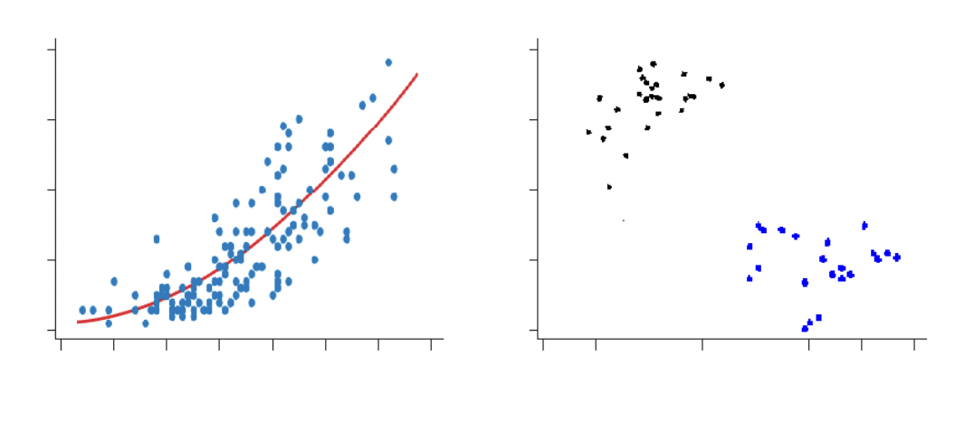

Strength:

The strength is described by the amount of scatter in the scatterplot (vertical spread). Scatter is the spread of the points in the vertical direction.

* Small amount of scatter, or little vertical variation indicate a *strong* association; can call it a ‘strong positive/negative linear association’.

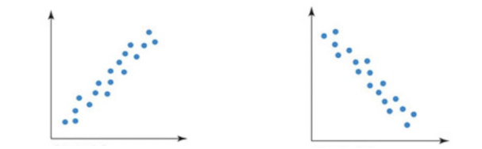

* Larger amount of scatter, or vertical variation indicates a *weaker* association; greater amount of spread in the vertical direction. If there’s too much scatter, there can be no association or relationship between two variables since it’s too varied.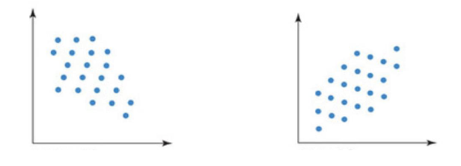

Outliers:

* Need to check if there’s any set of data that deviates from the pattern of the rest of the data; can deviate in magnitude but follow the same direction.
* Need to be investigated and the reasons behind it, since this can affect the linear pattern of the data and thus affect the technique of analysis used for the data.
* Different outliers in different situations have different ways of being dealt with.

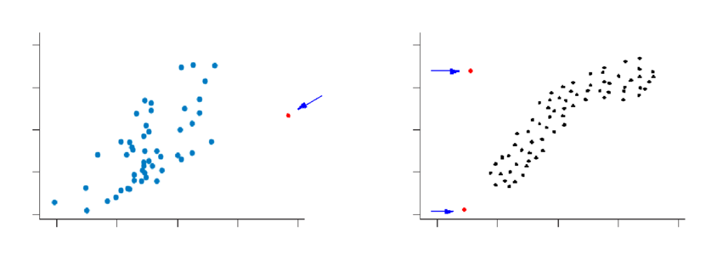

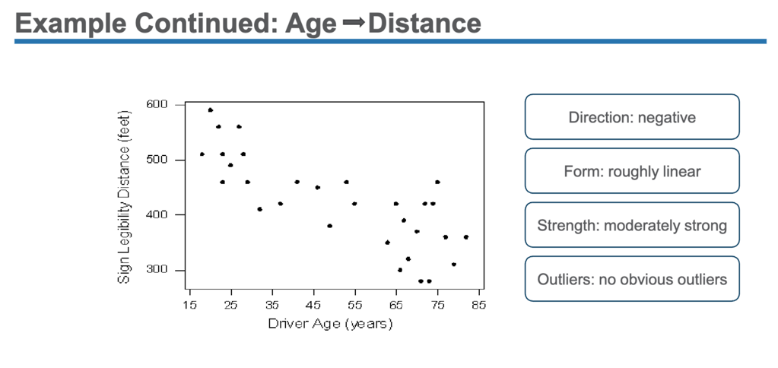

Measure of Association:

* Data sets in scatter plots need to be supplemented with a proper scale or numerical measure to accurately quantify the magnitude or strength of association.
* Different measures used for this, particularly for linear relationships.

**The Correlation Coefficient**

The numerical measure for linear association used is called *Pearson’s Correlation Coefficient (r)* 🡪 a numerical measurement of the *direction* and *strength* of a linear relationship

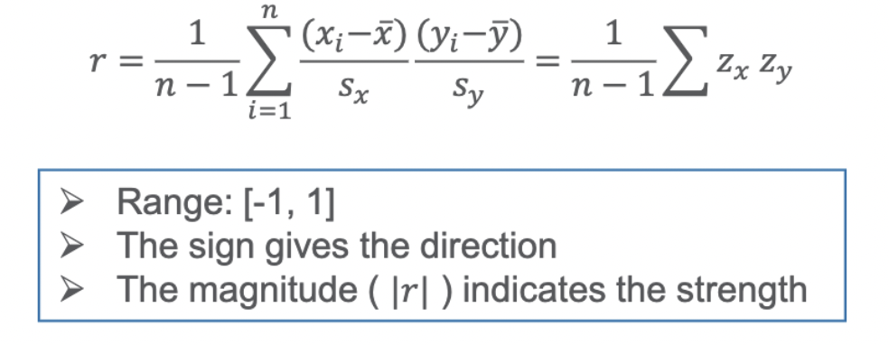

🡪 value of correlation coefficient is between -1 and 1 including both: Range: [-1,1]

🡪 the sign gives the direction; + value indicates positive direction and increasing trend, and – value indicates negative direction and decreasing trend

🡪 the magnitude ignoring the sign (|r|) – absolute r value, is to indicate and quantify the strength; the larger the magnitude is the larger the association. The closer the values are to -1 or 1, the stronger the association is and in between is weaker.

Weak: -0.5 to 0.5

Moderate: -0.5 to -0.7 or 0.5-0.7

Strong: -0.7 to -1 or 0.7 to 1

0 linear correlation (weak) would mean that the points scatter randomly about the graph and there’s no specific direction, trend or pattern in the data points

🡪 The correlation coefficient makes sense only if the relationship is *linear* and both variables are *numerical*.

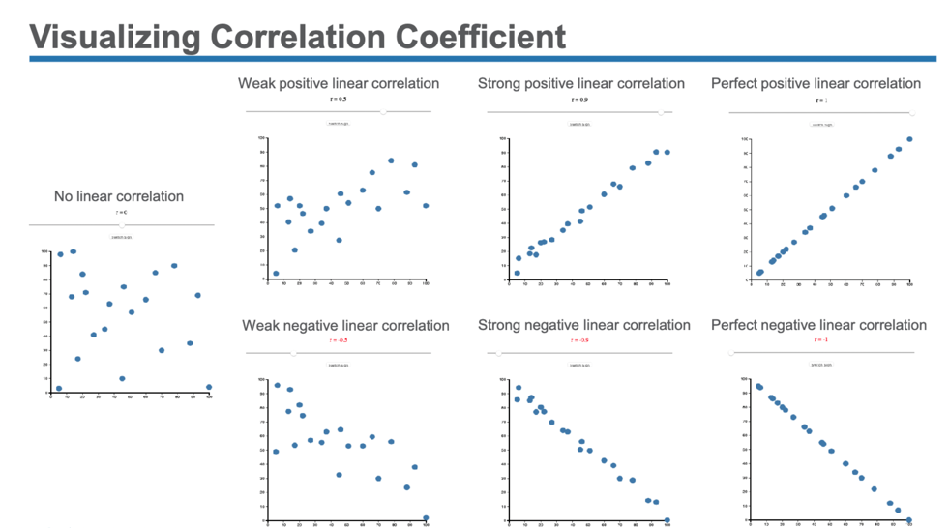

**Properties of the Correlation Coefficient:**

*Property 1:* Unitless

* The correlation does not change when the units of measurement of either one of the variables change. Only difference would be the values on the vertical scale changes, but the change doesn’t reflect on the trends or direction.

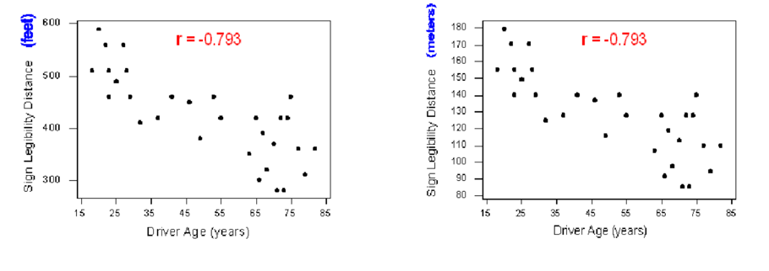

*Property 2:* Applet: Correlation

* The correlation measures only the strength of a linear relationship between two variables

<https://www.statcrunch.com/applets/type2&corbyeye>

True or False?

1. Two variables has a correlation coefficient of 0.9. It indicates a very strong linear association.
2. Two variables has a correlation coefficient of 0.1. It indicates not much association.

Both are FALSE. This may appear true at first but a closer analysis of the data points, indicate that there are cases that indicate non-linear association. Thus, this statement of correlation coefficient is useless for assessing or interpreting any sort of non-linear relationships and could reach wrong conclusions for data that have changing patterns/trends with strong association. Thus, the scatterplot and data need to be checked to see if a linear pattern is followed or not.

1. False because the correlation coefficient cannot accurately display the shape or if it's linear of the graph.

2. False because the correlation coefficient cannot accurately display the shape of the graph.

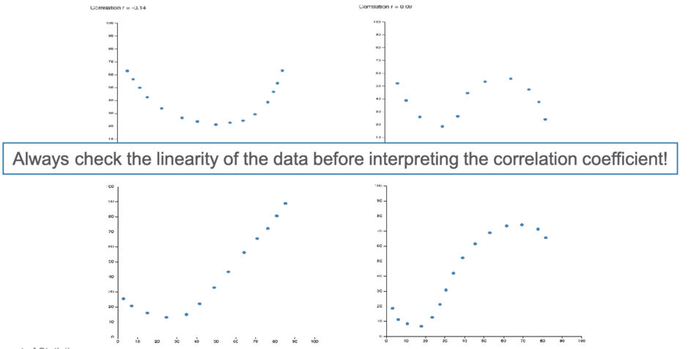

*Property 3:* Applet: Correlation

The correlation is heavily influenced by the kind of outlier, which is not consistent with the pattern of the relationship.

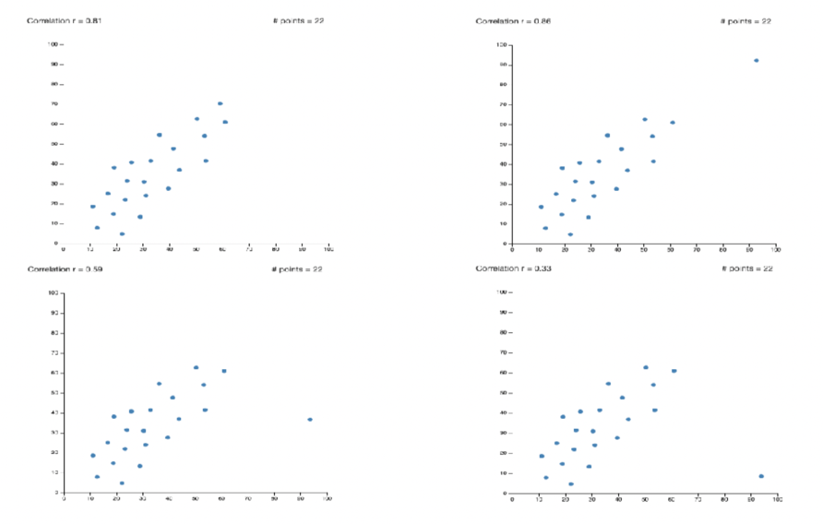

Visualizing Correlation Coefficient:

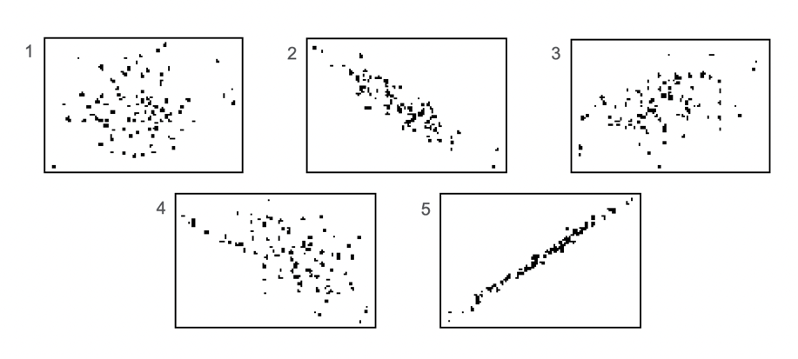

1. B) 0.100 🡪 Would be close to 0, less linear association
2. C) -0.897 🡪 Negative trend, form is linear, strong negative linear association, r < 0
3. A) 0.436 🡪 Weak positive linear association
4. E) -0.575 🡪 Negative, roughly linear and weak association since significant vertical displacement
5. D) 0.995 🡪 Very strong positive linear association, r close to 1

🡪 For a plot with a straight horizontal or straight vertical line, that means one variable is always at the same rate. For horizontal, y does not change with x and for vertical, x has no variation with y.

**Linear Regression**

* A method or technique to analyze linear relationships. First before applying techniques, need to make an assumption that the trend can be summarized with a line. Then need to determine the form that line takes.
* The *regression line* is a statistical model that summarizes the linear trend of observations. It also represents our predictions for any new or future observations.
* The equation for a straight line has the form:

y = a + bx

y – the response variable; x – the explanatory variable; a – the intercept; b – the slope

* The slope measures the steepness or incline of the line and then can find any two points on it and measure that. Ideally, the line should be a concise and accurate description of the data if we want to summarize it.
* Thus need to find: which line best fits the data?
* Criterion: The line with the smallest sum of squared residuals minimize – least squares regression line. (Residuals represent vertical deviations, so need to fit this into the criteria for “Best” fit)
* The mathematical expression of the regression line: y = a + bx

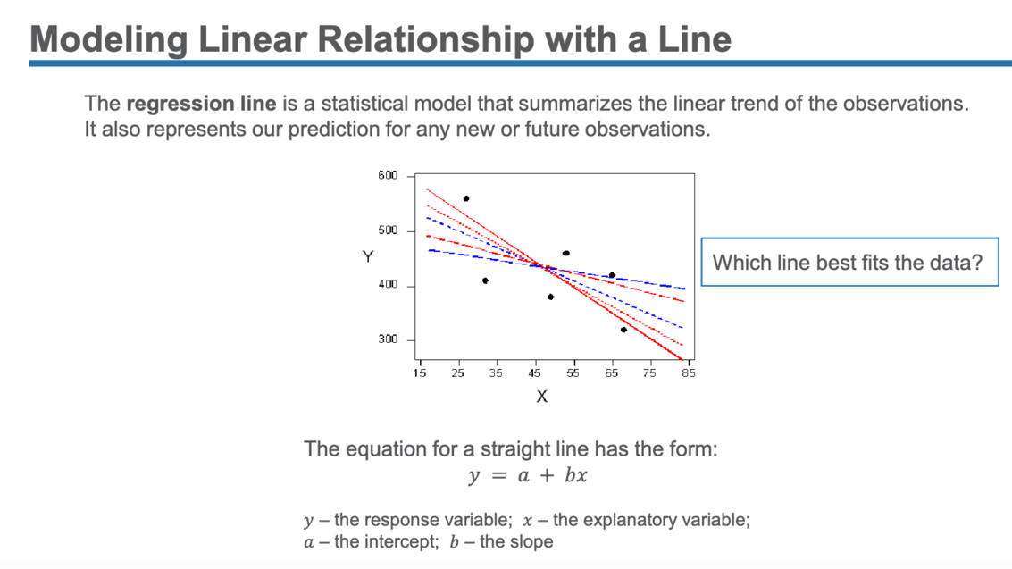

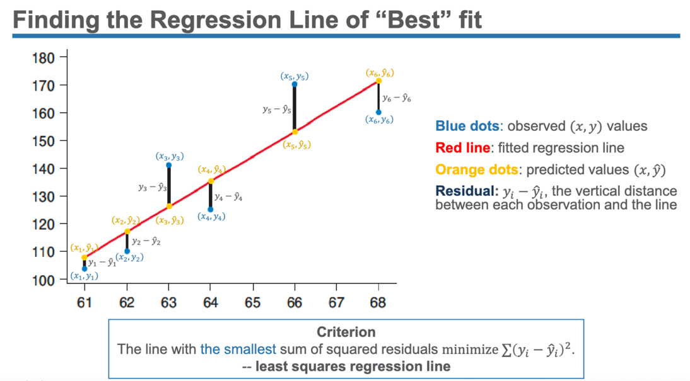

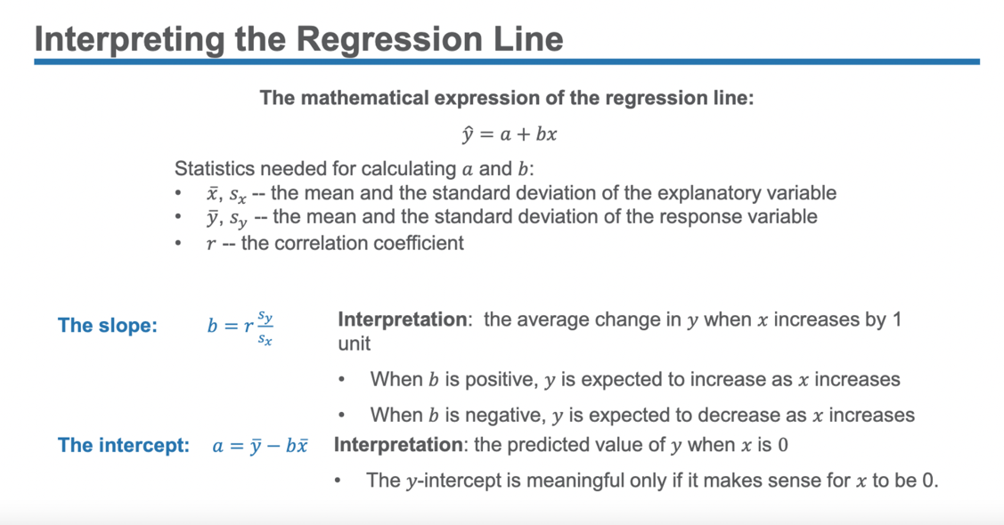

- If r > 0, b > 0 OR r < 0, b < 0 (the slope)

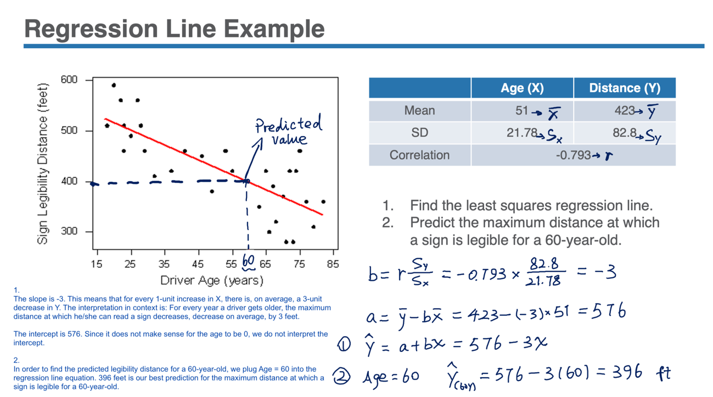

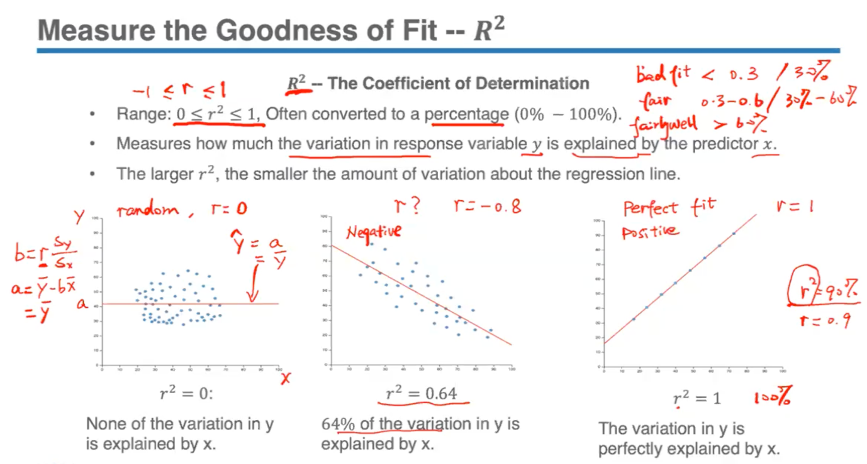

- The higher the % for such a linear model, then the larger the amount of variation can be explained by the explanatory variable.

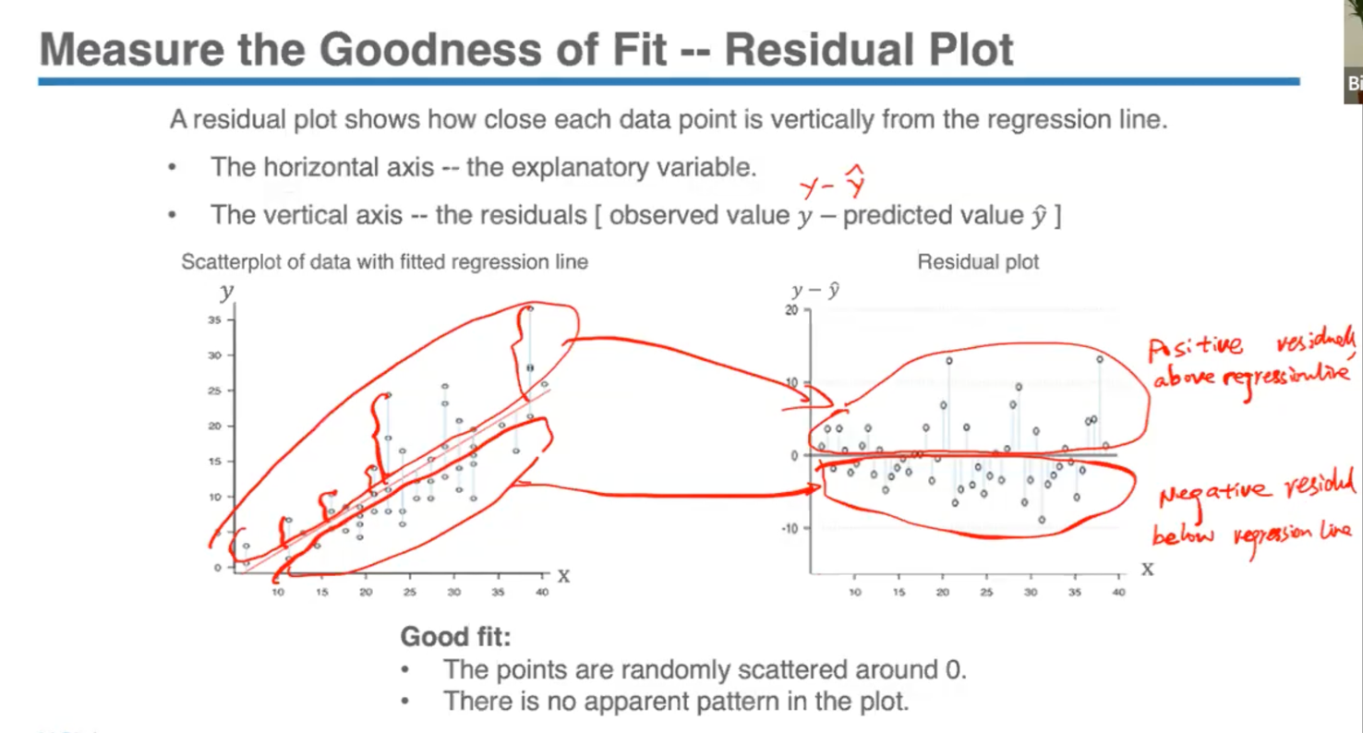

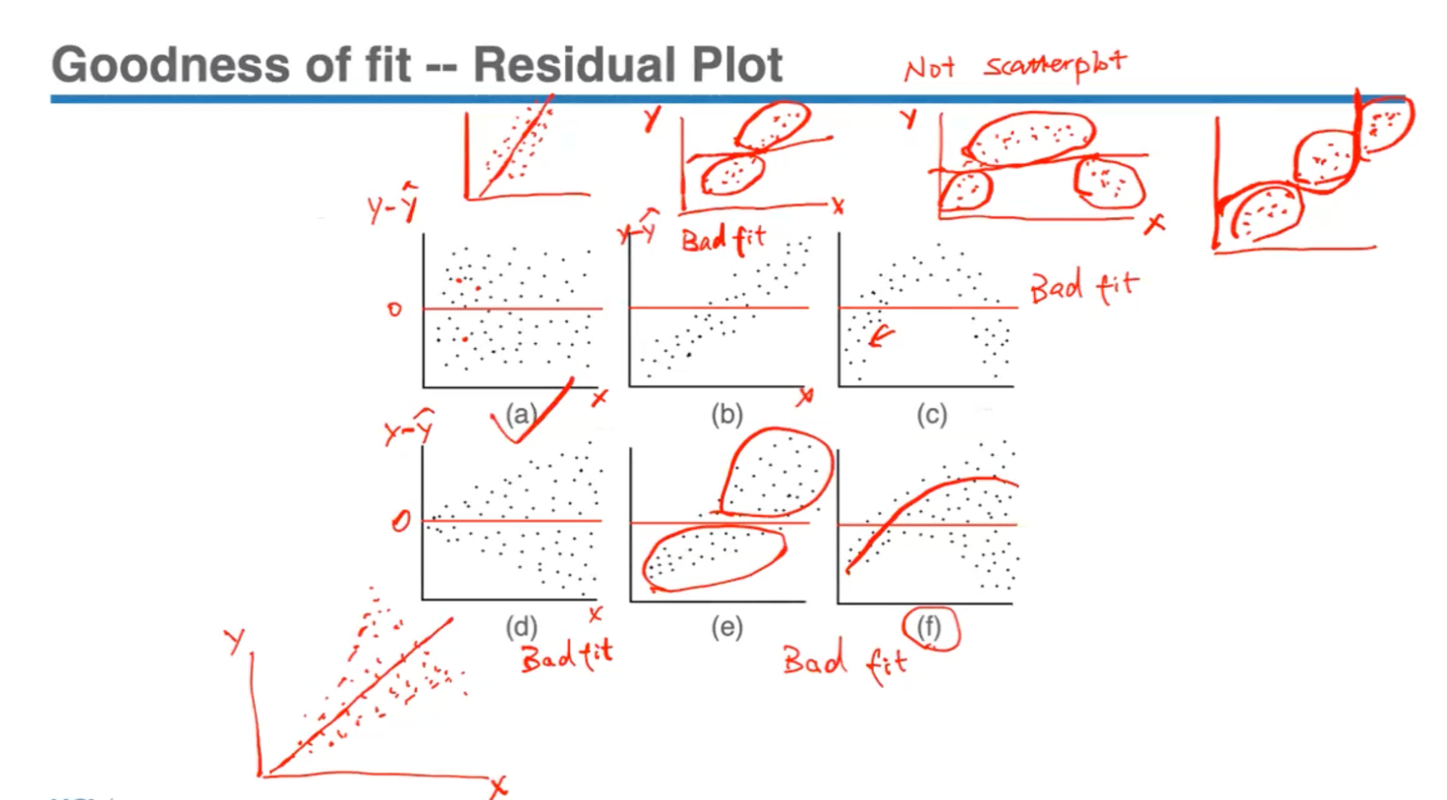

When we evaluate a linear model, we look at its r squared value, the residual plot and use these 2 tools to assess the goodness of it. For a good fit, points should have no pattern and be randomly scattered around 0.

**LECTURE 4.1, 4.2 and 5.1 are all in PPT form!!!!**

**MIDTERM REVIEW:**

- Mode (category of highest frequency) will be the largest piece in a pie chart and highest bar in a bar chart

Ordinal variable can be confused with Numerical variables

- Dot plots are ideal for smaller data sets; for large data sets/ large scale pattern or less detailed information, histogram is a better option

- If a longer right tail, then right skewed distribution and if longer left tail, then left skewed distribution.

- For modality if no obvious peaks then uniform, or unimodal for one peak, or bimodal/ multimodal data for two or more peaks (this indicates different groups of data have been categorized together)

- Mode is the easiest measure to identify for numerical center but it may not be unique and it may not exist, so not used as a common measure of central tendency.

- Mean is sensitive to extreme values but Median is not; both are common measures of central tendency.

- If there are outliers in a data set, then the range is not an accurate measure of spread. Then use Inter-Quartile range and Standard Deviation.

- For IQR, first find median of whole data set (Q2) to split data into 2 halves. Then, find Q1 which is the median of the lower half of the sorted data. After that, find Q3 which is the median of the upper half of the sorted data set. The IQR is the distance between Q3 and Q1 (Q3 – Q1).

- Standard Deviation calculates the average distance between the observations and the mean.

- Five Number Summary can help us identify potential outliers.

- Using the standard deviation and the mean, can find out the empirical rule and z-scores but only for symmetric and unimodal distributions.

- Explanatory variable is X (horizontal axis) 🡪 Response outcome Y (vertical axis)

- Overall pattern – direction, form (linear or nonlinear), strength

- Correlation coefficient is useful only when we know that it’s a linear relationship. Correlation coefficient close to -1 or 1 tells us that it’s a stronger linear relationship. A correlation coefficient of 0 does not mean that there’s no correlation, it could mean a strong non-linear association.

- When we apply a linear model🡪 first check plot to ensure it’s linear only then can make predictions. Also remember association does not mean causation since confounding variables can affect this association.

PROBABILITY BASICS HERE

*6th November, Monday*

**LECTURE 6.1**

Combining Events:

2 common ways of combining events:-

1) Event A or B both occur

2) Event A or B occur

- When mapping this in a Venn diagram, the rectangle represents the entire sample space, the circles represent a particular event (a collection of possible outcomes). Can have many different events with some having common outcomes and some not. Venn diagrams illustrate how we can combine these events.

- *The Union:* “A or B” consists of all outcomes that are in A, B or both. It is *inclusive* since the shaded part is the entire area covered by event A and B together.

*- The Intersection:* “A and B” consists of only those outcomes that are in both event A and event B. In the diagram, this would be the overlapped area of A and B. Basically, it is the collection of all the common outcomes in A and B.

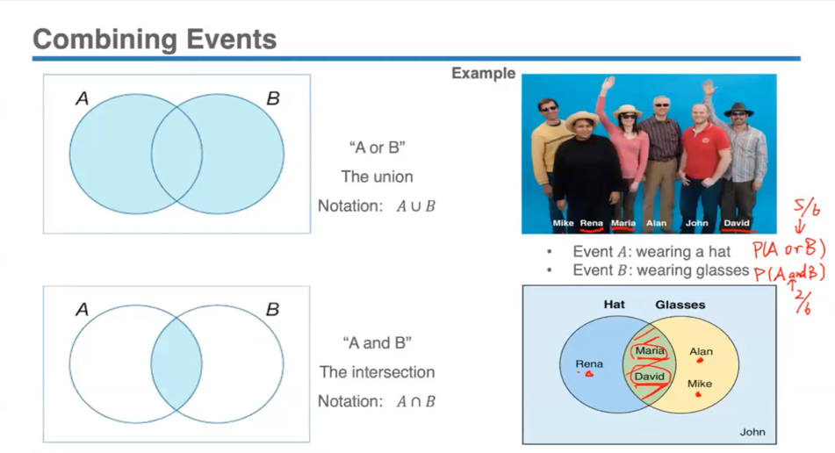

Probability of Combined Event:

*RULE 4: General Addition Rule*

For any 2 events A and B, the probability of the union is equal to the sum of the 2 individual probabilities minus the probability of the intersection.

**𝑃(𝐴 OR 𝐵) = 𝑃(𝐴) + 𝑃(𝐵) − 𝑃(𝐴 AND 𝐵)**

Since individual probabilities have been added together, the probability of the overlapped area has been counted twice. Thus, subtract the probability of intersection of A and B to avoid the problem of double counting

Events have no outcomes in common 🡪 *Mutually Exclusive / Disjoint events*; *Impossible* for these events to happen at the same time.

- Since they have no common outcomes, in the diagram the circles/events will have no overlap with each other.

* “A person is married” vs. “A person is single” (can’t have both at same time)
* “The student passed the exam” vs. “A student failed the exam”

- Only if event A and event B are *mutually exclusive*, then  
**𝑃(𝐴 OR 𝐵) = 𝑃(𝐴) + 𝑃(𝐵) [since *P(A and B)* = 0**]  
**𝑃(*A1* or 𝐴2 or ... or 𝐴𝑛) = 𝑃(𝐴1) + 𝑃(𝐴2) + ⋯ + 𝑃(𝐴𝑛)** (for a series of mutually exclusive events)

Fair dice- each of these combination of numbers would be equally likely to occur.

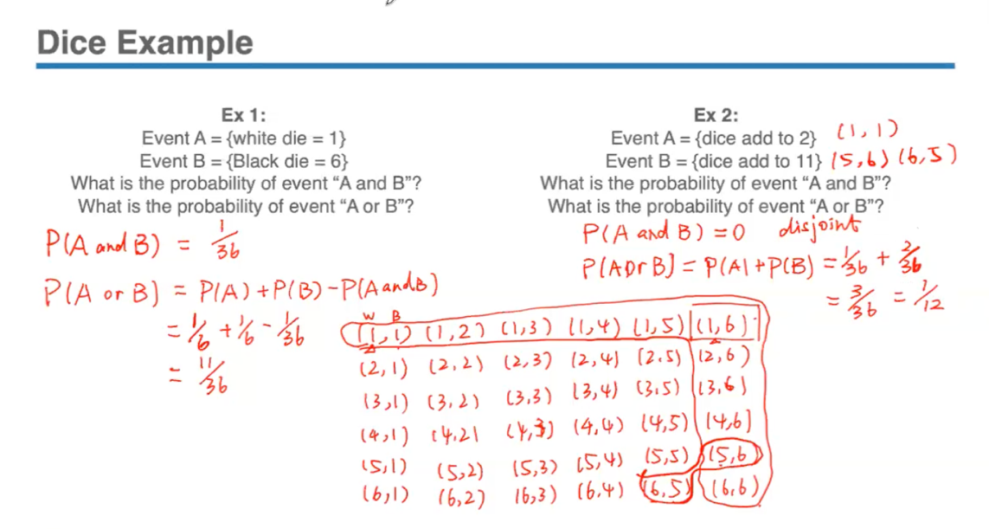

Randomly select- each person has an equal chance of being selected; can treat each individual in this sample as an equally likely outcome.

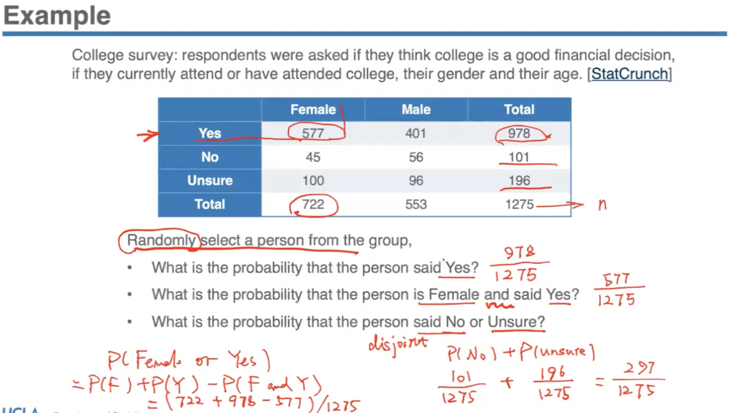

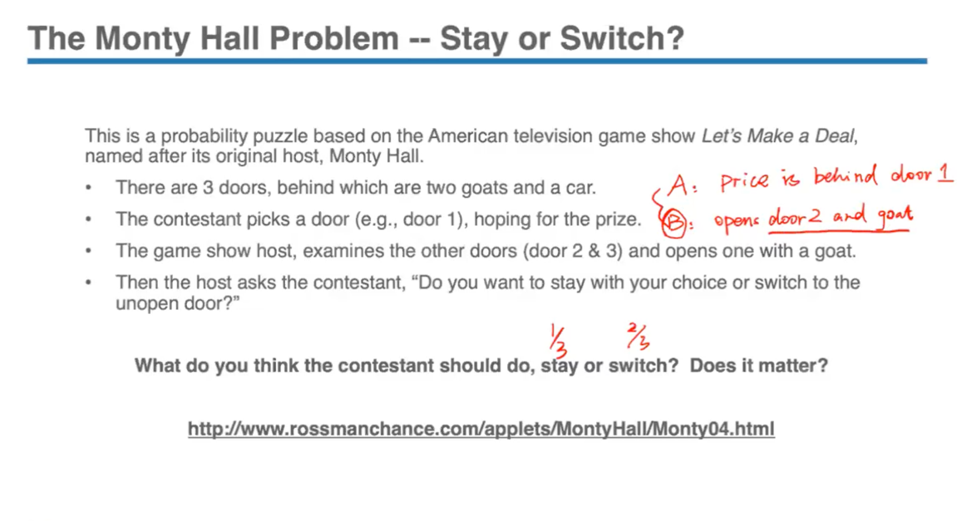

How to find the probability/ likelihood? One way is to use the theoretical approach where the information can be used for calculations, but haven’t learnt all the probability rules yet especially if the two events are related. However, using the simulation/applet, can use the empirical approach to do some simulation and find out the empirical probability:

- If we use the repeat ‘stay strategy’ for 1000 times, then the graph which calculates cumulative probability out of the 1000 times, shows that the probability of winning with this strategy is about 34%.

- Now if we use the repeat ‘switch strategy’ for 1000 times, it gives a 66% probability of winning.

So for empirical, based on experience, we can say that by switching to the other door gives you a higher winning chance- almost twice as high as if you stayed with your current choice.

- The theoretical probability of switching to the other door is 2/3 and staying is 1/3, which matches with the applet results. Thus can use empirical probability to help us understand the theoretical probability to verify or to estimate.

- By saying that the choice of strategy matters, is actually indicative that the 2 events are related. By knowing the information of event B, can change your belief. Originally when picking a door, your chance of getting a prize will all be equal to 1/3. However, once given some information, that can change your belief of whether the prize is behind your original pick or the other one.

Conditional Probability:

- Is an essential concept in statistics. It means that the knowledge of something happening will change your belief on another/certain event. Thus, it affects the likelihood or probability of the other event.

- If 2 events are associated, then the chance of one event happening will be different if we have some knowledge about the other associated event.

Ex: The probability of rain P(rain) that is seen on a weather app depends on many other factors. If the probability of the other event or factor changes, then it will also affect the probability of rain. So, they will change accordingly because all these factors are related or associated.

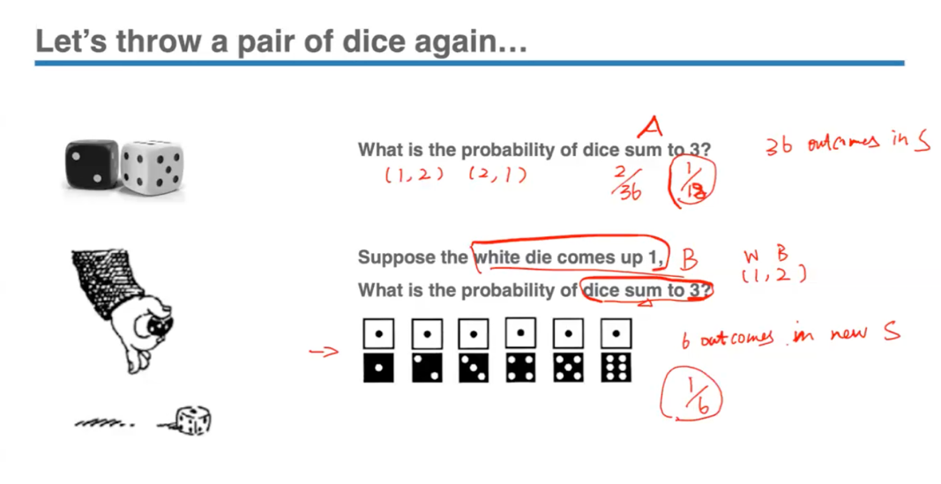

*1/6 will be the conditional probability, since this is the probability calculated by conditioning on something, some other event.*

Conditional probability can also help us understand the association between two variables. Example will check whether there’s really an association between these 2 events on the Titanic- person’s class and survival rate. If there is indeed an association, we would expect the probability of a person who survived as a first class passenger to be different from the probability of maybe a second or third class passenger that survived.

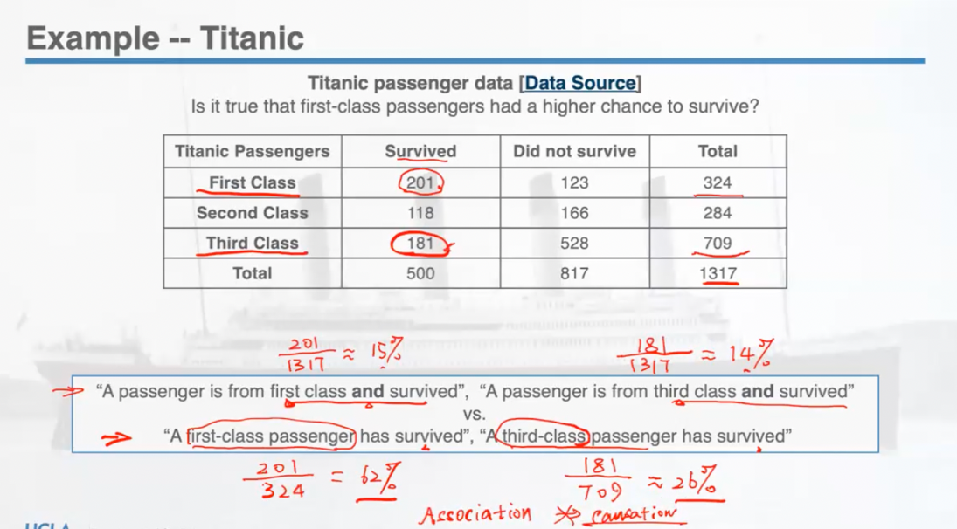

- The second method is a better way to look at it because due to the class sizes not being accounted, there is a negligible difference between the two percentages obtained from the first method. However, there’s a big difference among the comparisons after taking the size of each class into consideration which indicates a totally different story (denominators change). So, can see the information on the person’s ticket class changed the probability of the event happening.

- However can any causal conclusions be drawn just by looking at these percentages? Can it be said that if you got a first class ticket, you would be able to survive? No, because an important fact is association does not imply causation since there are many other factors that should be considered for ex: in first class there may have been more women and children. So without evaluating all the factors, we cannot make any causal conclusions- can only say we observed an association.

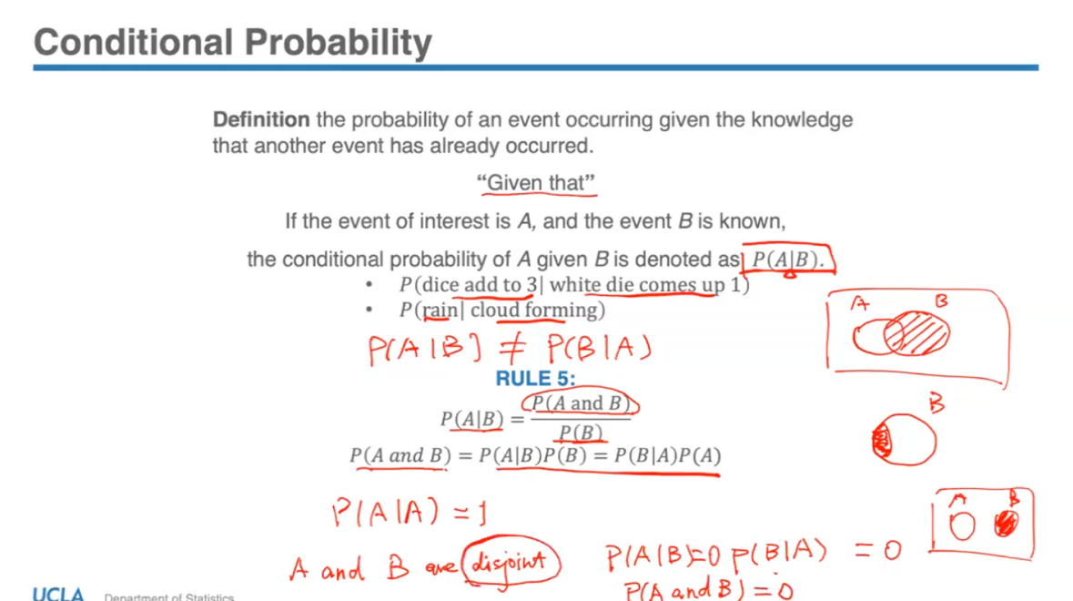

*8th November, Monday*

**Lecture 6.2**

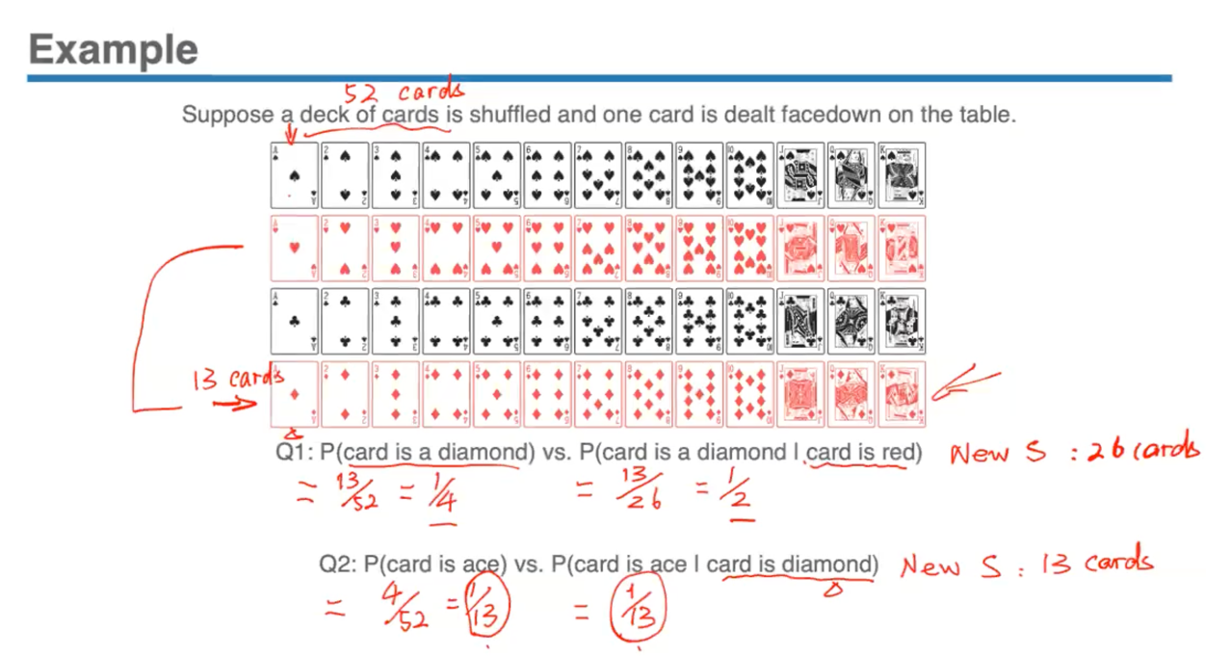

- Since the deck of cards is randomly shuffled it means that if we draw a card, each of them will have an equal chance of being picked so we can use the ‘equally likely outcome’ rule.

- In Q2, suppose we are given the information that the opponent’s card is a diamond, it will not help you determine whether this person will have a higher chance of getting an ace since both the probabilities of getting ace are the same- 1/13. This tells you that the events are not associated.

When events are associated, the conditional probability changes.

Independent Events:

Two events are considered independent if the knowledge of one event having occurred does not affect the probability of the other event occurring (these events aren’t associated).

🡪 Example: coin toss (trial by flips are independent; knowing if you got H/T on previous event doesn’t determine outcome of next flip)

- When events are independent, conditioning of some other event on the independent event will not change the probability. Thus, don’t need to worry about conditional probability for independent events.

If 𝐴 and 𝐵 are independent, then  
**𝑃(𝐴|𝐵) = 𝑃(𝐴)  
𝑃(𝐵|𝐴) = 𝑃(𝐵)**

*RULE 6:* *Multiplication Rule* for series of independent events   
For two independent events A and B,  
**𝑃(𝐴 and 𝐵) = 𝑃(𝐴) 𝑃(𝐵)  
𝑃(𝐴1 and 𝐴2 and ... and 𝐴𝑛) = 𝑃(𝐴1) × 𝑃(𝐴2) × ⋯ × 𝑃(𝐴𝑛)**

For ex – probability of getting heads on n flips:

*P(H1 and H2 and ….. and Hn) = P(H1) x P(H2) x … x P(Hn) = (1/2)5*

Through substituting formulas, it can also be:

**𝑃(𝐴 and 𝐵) = 𝑃(𝐴|𝐵) 𝑃(𝐵) = 𝑃(𝐴) 𝑃(𝐵)  
𝑃(𝐴 and 𝐵) = 𝑃(𝐵|𝐴) 𝑃(𝐴) = 𝑃(𝐵) 𝑃(𝐴)**

***🡪*** *Disjoint / Mutually exclusive events can never be Independent!* This is because if we know that A happened, then we know that B will never occur. But knowing about A tells us something about B, therefore they can never be independent.   
🡪 *Non-disjoint events may or may not be independent*. To verify their independence, we will have to verify whether the conditional probability is equal to the probability of itself. A and B may have outcomes in common, but whether they are associated or not cannot be determined.

Can verify independence through :  
1) P(A|B) = P(A)

2) P(B|A) = P(B)

3) P(A and B) = P(A)P(B)

*Proving disjoint events can never be independent:*

Two disjoint events A & B.

P(A|B) = P(A and B)/ P(B); but P(A and B) for disjoint events = 0

so = 0/P(B) = 0 ≠ P(A)

Similarly P(B|A) = 0 ≠ P(B)

- 2 events are independent means that knowing about something does not tell you about another event, does not increase or decrease your belief about the other event.

- Associated events are those where knowing about one event can increase/decrease the probability of another. Ex: Not paying cell phone bill 🡪 Cell phone service suspended

- Assumption of independence is very important in statistical inference since it is related to the quality of sample data and when we are sampling, we assume that the individuals are independently drawn with an equal chance; there is an assumption in statistical inference where we assume an independent process.

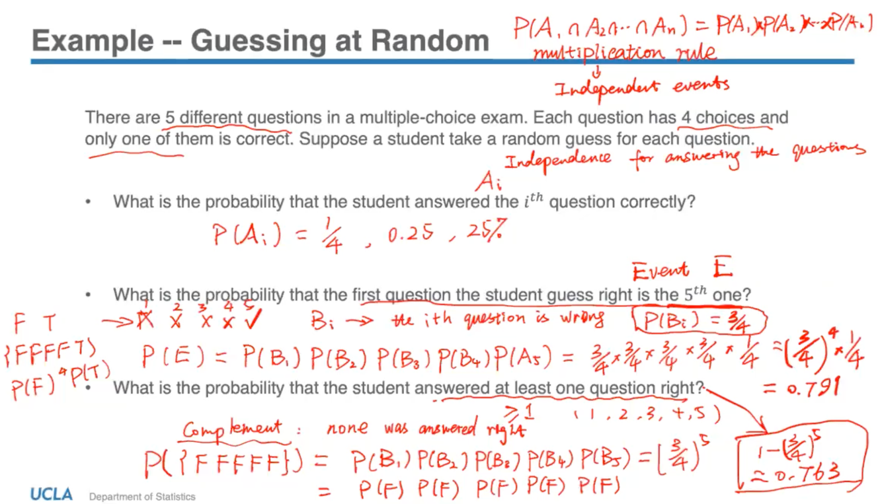

- For the last question, since it would be tedious to list out all the different combinations of at least 1 question being right, it’s an easier approach to use the *complement rule* which is useful to apply when the probability is very difficult to calculate by looking at it the other way round. So, the complement event would be that the student answered less than one question right which means that none of the questions were answered right.

Example with Conditional Probability (associated events):

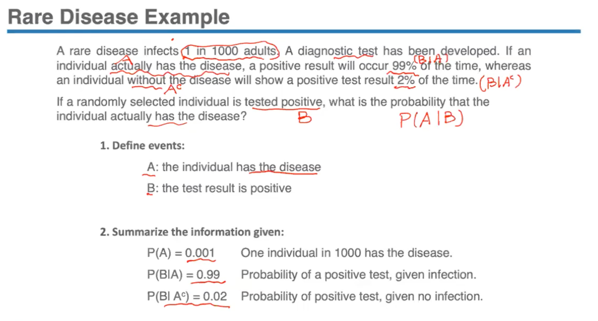

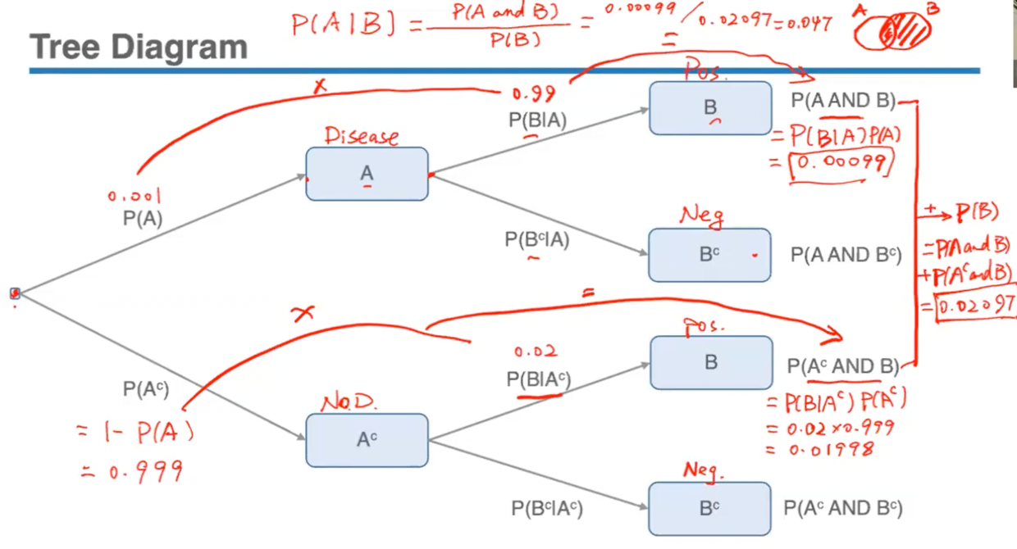

- Tree diagram is a simple way to represent events after events as a sequence and is particularly useful since it records all possible outcomes in a clear manner after selecting an event.

- To Find: The probability of those who actually have the disease given that their test result is positive.

- In the diagram:

P(A and B) = P(A).P(B|A) = 0.001 x 0.99 = 0.00099

P(Ac) = 1 – P(A) = 1 – 0.001 = 0.999  
P(Ac and B) = P(Ac).P(B|Ac) = 0.999 x 0.02 = 0.01998

P(B) = P(A and B) + P(Ac and B) = 0.02097

Therefore,

P(A|B) = P(A and B)/ P(B) = 0.00099/ 0.02097 = 0.047

🡪 This is less than 5%, which indicates that since it’s a very rare disease, despite the high accuracy of the test (it’s 99% accurate for those who have the disease), less than 5% of those who tested positively actually have the disease. This is also called a ‘false positive paradox’.

Empirical Probabilities:   
- Probabilities based on carrying out some random actions, experiments, or by observations. Thus, they can change from experiment to experiment unlike the theoretical probabilities which depend on the nature of the situation. So, this type of probability varies.

- Relative frequencies based on observations, historical data or experiments/simulations.

*Sources:*

1) *Observed data:* (in this case, can calculate the relative frequency as the empirical probability)   
Example:  
• Observe whether there are no empty seats when you board the bus  
→ Empirical probability of no empty seats on the bus  
= number of times there are no empty seats / number of times taking the bus  
• Find the past records of successful hits of a softball player  
→ Empirical probability that the batter will get a hit  
= the number of successful hits / number of attempts

- But finding empirical probabilities through observation can be slow and requires a long time of recording, therefore might be easier to rely on simulation which can be carried out rapidly.

2) *Simulated data:* (need to design the simulation to find the approximate probability of a certain situation)   
• When the situation is too complex to find a theoretical probability  
• When finding empirical probabilities is too slow and laborious  
• Generate outcomes of a random experiment to find empirical probabilities.

Designing Simulations:

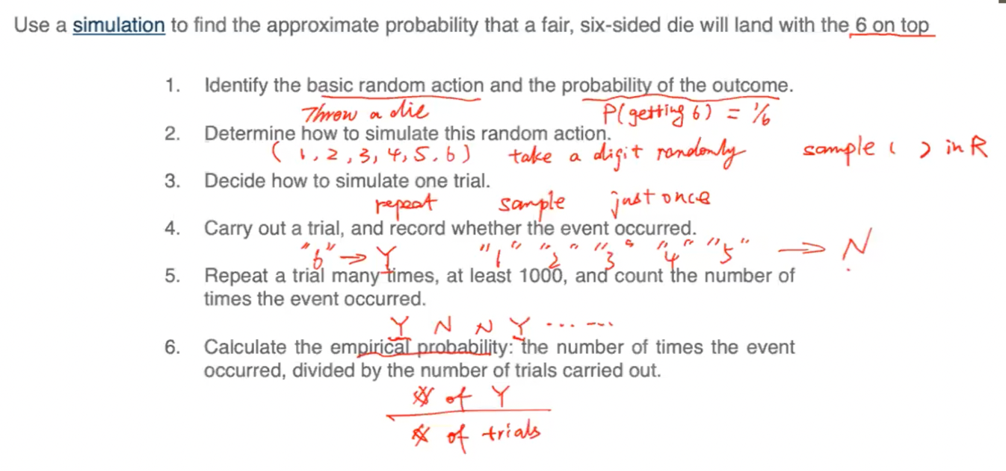

- In a simulation, we’re able to repeat this experiment many times to estimate the empirical probability and also get an idea of how the empirical probability varies.

Simulation Example:   
*How would we design and carry out a simulation to estimate the probability of getting 2 heads in 3 flips of a fair coin?*

*Which of these methods is a valid simulation?*  
A) Assign the digits (0, 1, 2, 3) to "heads”, while the digits (4, 5, 6, 7, 8, 9) to "tails”. In each trial, randomly select a digit from the range 0 to 9, repeat this process three times, and record whether you obtain two of the four digits (0, 1, 2, 3). Repeat this trial 10,000 times.  
B) Assign the odd digits to “heads”, and the even digits to “tails”. In each trial, randomly select a digit from the range of 1 to 9, repeat this process three times, and record whether you obtain two odd numbers. Conduct this trial 10,000 times.  
**C) Assign the digit 1 to "heads" and 0 to "tails." In each trial, randomly select a digit from 0 and 1, repeat this process three times, and record whether you obtain two '1's. Repeat this trial 10,000 times.**

- To know whether it’s a valid simulation, will need to consider if the probability calculated from the simulation correct and need to make sure that the simulation matches the components of the real life experiment.

- In an experiment, should have several components:

1) Basic random action 🡪 coin flip (fair coin will have 50/50 chance of H/T)

2) Trial 🡪 3 coin flips (1 trial will have 3 flips)

3) Event (of interest) 🡪 2 heads out of 3 flips

- Key of designing this simulation is to find an easier to carry out random action with the same probabilities as the theoretical one. P(T) = 50% or ½ and P(T) = 50% or ½.

- In option A, P(H) ≠ 50. Since each digit represents the outcome of a coin flip, out of digits 1-9, 4 digits represent head; P(H) = 4/10 and P(T) = 6/10 which does not match what we expect from a fair coin (50/50).

- In option B, odd digits (heads) = (1,3,5,7,9) and even digits (tails) = (2,4,6,8). Thus P(odd/H) = 5/9 and P(even/T) = 4/9. Again, this does not match th expected 50% from a real life experiment.

- In option C, 1 = heads and 0 = tails. P(digit 1) = P(H) = ½ or 50% and P(digit 0) = P(T) = ½ or 50% which is the expected result. Method C would be a valid simulation because it uses the least amount of numbers and assigns each outcome to only one variable, increasing the randomness.

The Law of Large Numbers (LLN):

- The reason why estimating theoretical probability from empirical works is because of an underlying mathematical theorem called the ‘Law of Large Numbers’. It tells you that if your simulation is designed correctly and the more trials we do, the closer we can expect our empirical probability to be to the true probability. As we approach infinitely many trials, then the theoretical and simulated probability approaches the same value.

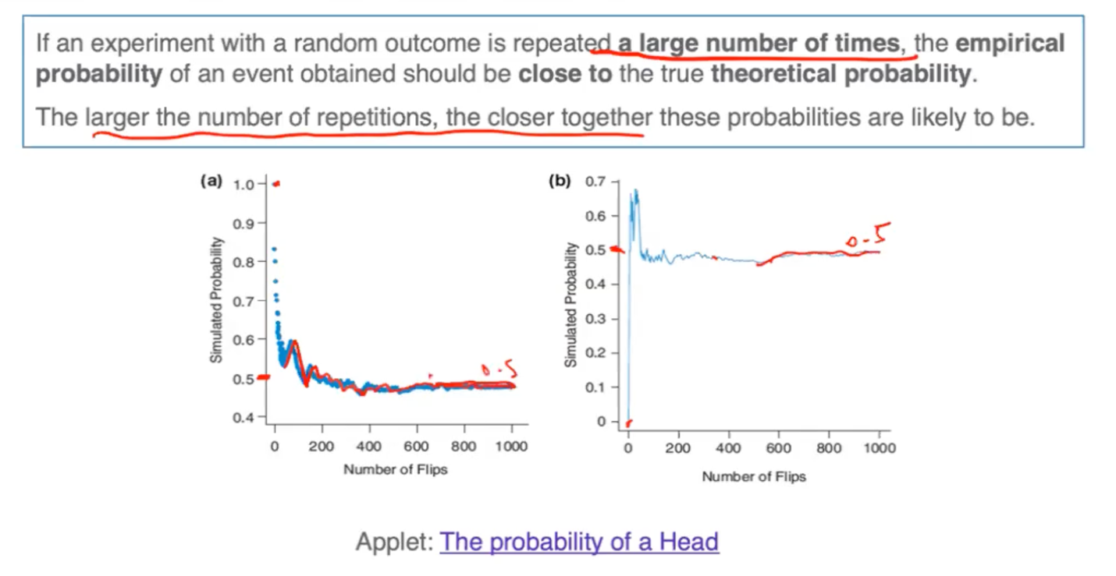

- Both plots A and B show the results of a simulation done with an applet, where it can be observed that the probability varies at first but then starts to stabilize and converge with the theoretical value of 0.5 for a fair coin, maybe after 800 flips. Despite their differences, after a large number of coin flips (trials), both settle on an empirical probability of 0.5, just as the law of large number predicts.

- With just a small number of trials, the simulated probability can be far away from the expected value, but it then changes with each additional coin flip. As the number of trials keep increasing, things tend to settle down. Thus, this theorem only deals with a large number of trials.

Notes on LLN:

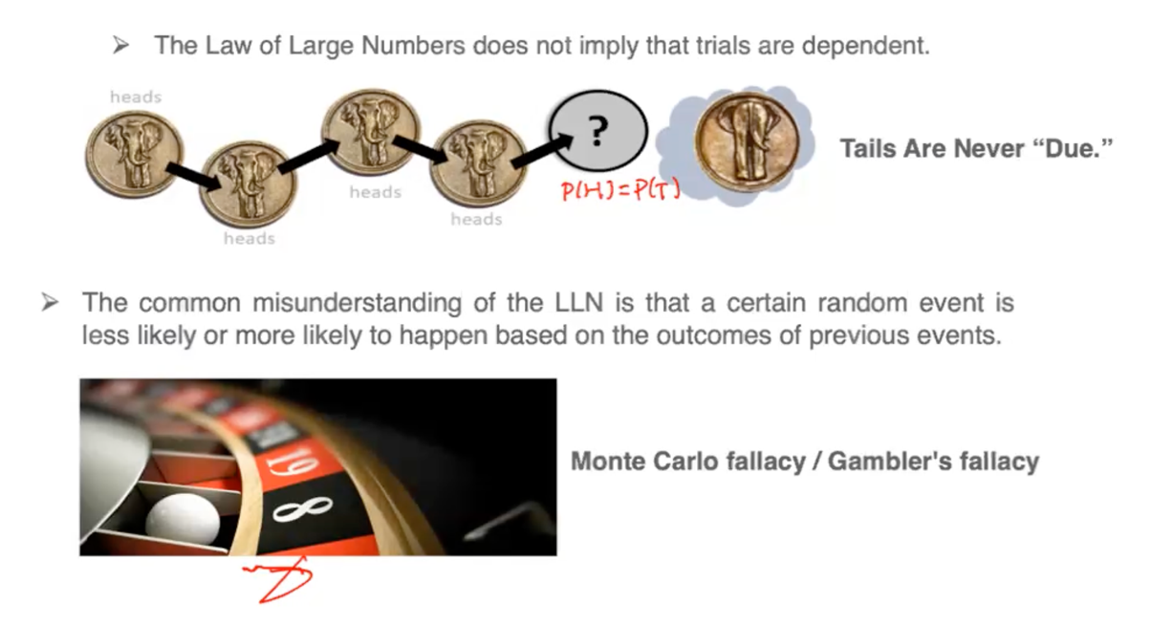

Not a Match?

What If My Simulation Doesn’t Give the Theoretical Value I Expect?

- Can check the following if simulation doesn’t meet expectation after numerous repetitions.

1. Your theoretical assumption is incorrect.  
2. Your empirical or simulated probability is just varying (purely due to chance)  
3. Your simulation is not a good match to reality -- check simulation design

*13th November, Monday*

**Lecture 7.1**

Probability Distributions

- Probability is a way to mathematically describe uncertainty for certain situations. Can calculate or estimate the probabilities of certain outcomes or events through basic probability rules.

- For a certain situation, there can be many different outcomes and each outcome could occur with a certain probability. We can describe the probabilities of all possible outcomes through *‘Probability Distributions’.*

*-* For example: When we throw a die, outcomes are 1 to 6 so in total 6 outcomes. Then, further could define variables to represent this which would be the number that appears on the top of the die when we throw it. So all the outcomes could be thought of as all the variable values to which we can then assign probabilities. These values together with the probability theoretically speaking would each be 1/6 for all of the values, so these values together with these assigned probabilities make up a probability distribution (used in statistical inferences).

- When these outcomes are numeric we call them random variables, which can take on many different values and is called ‘random’ because the outcomes are uncertain in the short run. For ex: when we throw a die, even though we know theoretically a number has 1/6 chance to occur, but the next number that would appear on top is unpredictable. But in the long run, will see a regular or predictable pattern for the distribution when the die is thrown many times.

- Depending on the different characteristics of variables can further classify a random numeric variable into 2 types: Discrete or Continuous Random Variable.

Random Variable

* **Map outcomes of random processes to numbers**

When the value of a variable is determined by a chance event, that variable is called a random variable (r.v.).

**1) Discrete random variable**: Numerical values that can be listed or counted (distinct or certain values only- when there’s a clear separation between them; could incidentally be many values but as long as they’re countable). Discrete random variables can either be finite or countably infinite (can be put in one-to-one correspondence with the set of natural numbers; even though the counting will take forever, you will get to any particular element in a finite amount of time).

- The number of phone calls you will receive during the day

- The number of bus lines that go to UCLA

**2) Continuous random variable:** Take any values within an interval and are often measurements like weight, height, time etc. (cannot be listed/ counted since they occur over a range- thus uncountably infinite no. of values). Thus more complicated to deal with due to the nature of such variable.

- The exact weight of a newborn baby (ex: can be between 5 – 8 lbs; any value in this range)

- The exact time it takes to commute to school by bus

*🡪 The category that time falls into depends on context and way of measurement.*

For ex: exact time for commuting time to school is continuous since there could be infinitely many values for the time 10-30 mins. But for ex if we’re talking about a year or day, we’re counting this in whole numbers and cannot have this in fractions for calendar years. So calendar year- 2020, 2021, 2022 is discrete (can’t have 2020.5 etc). When time is measured on a finer scale like for ex. your finishing time of a race in milli or micro secs then that exact time is considered a continuous variable.

Probability Distribution

* Probability distribution describes all the possible outcomes for a random variable (r.v.) and also assigns probabilities of occurrence for each outcome. So is a useful tool for keeping track of *outcomes* and their associated *probabilities*.
* Depending on the variable type, we take different approaches to display or analyze the probability distribution of the variable 🡪 Tables, Graphs, Equations
* The outcomes are random in the short run (if some variable is certain, then it is a deterministic situation and there’s no randomness; in the long run can see a pattern)
* Probabilities are assigned to all possible outcome
* All probability values must be between 0 and 1 (must agree with the probability axioms; cannot be negative or > 1)
* The sum of the probabilities (sample space) of all possible outcomes must be 1 for a valid probability distribution

Discrete Probability Distribution

- The probability distribution for discrete random variables can sometimes be generated empirically through repeated trials or a long-term observation record by looking at relative frequencies of each outcome and looking at how it’s distributed. Usually a graph and table are used together; for convenience let X or Y be the random variable.

- The table or graph of a discrete probability distribution is called ‘Probability Mass Function’.

- Variable is discrete because you can list all the outcomes of the no. of times a student changes majors and they are distinct numbers.

- For probability distribution to be valid, all the relative frequencies need to sum up to 1.

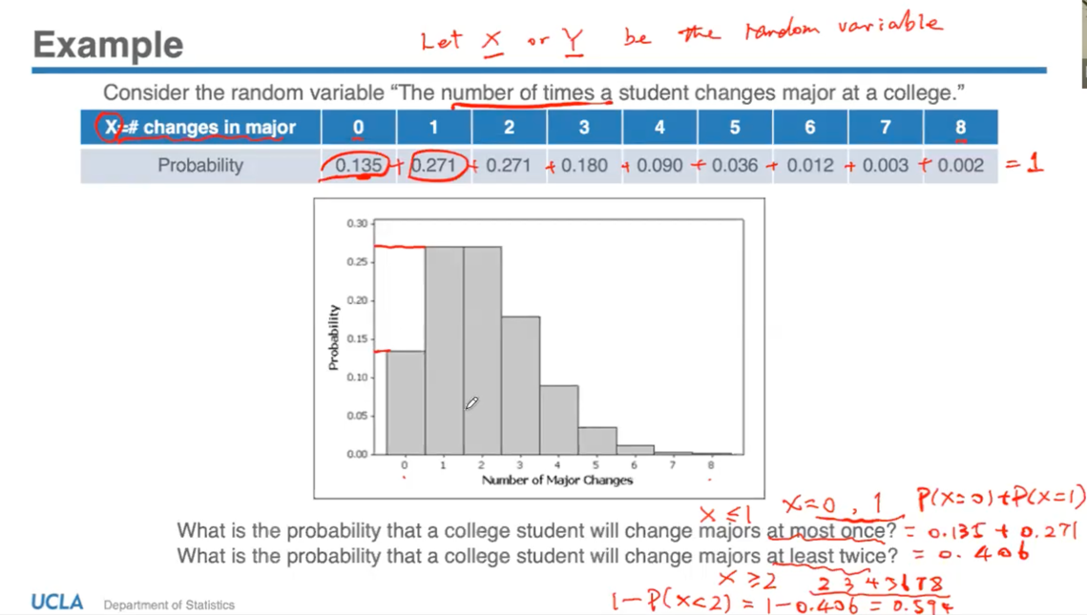

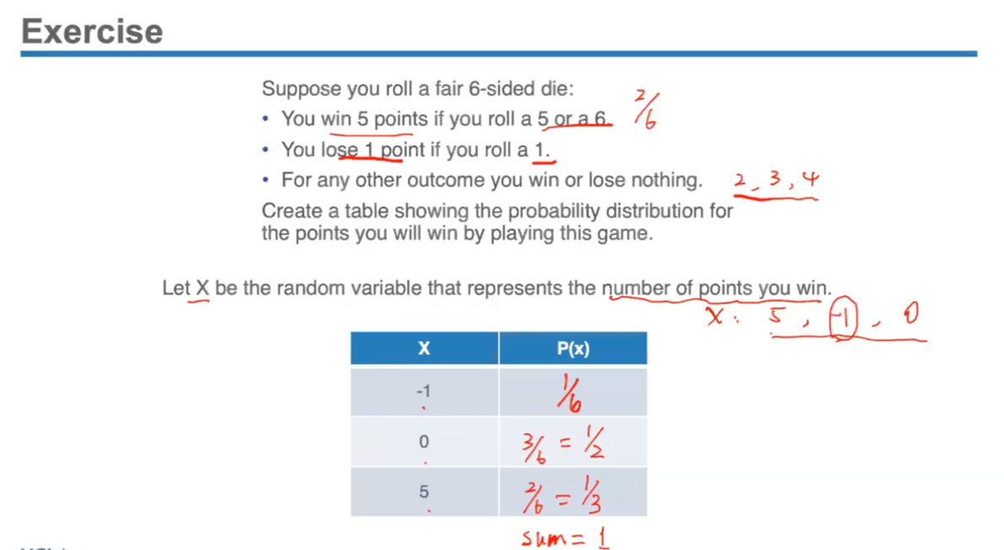

- In cases where it’s too hard to list out all the outcomes of variables, a table or histogram (would have infinitely many bars so impossible to construct a graph) might not be an ideal way to describe a probability distribution. Instead, a mathematical formula with equations can be used to describe the predicted relative difference.

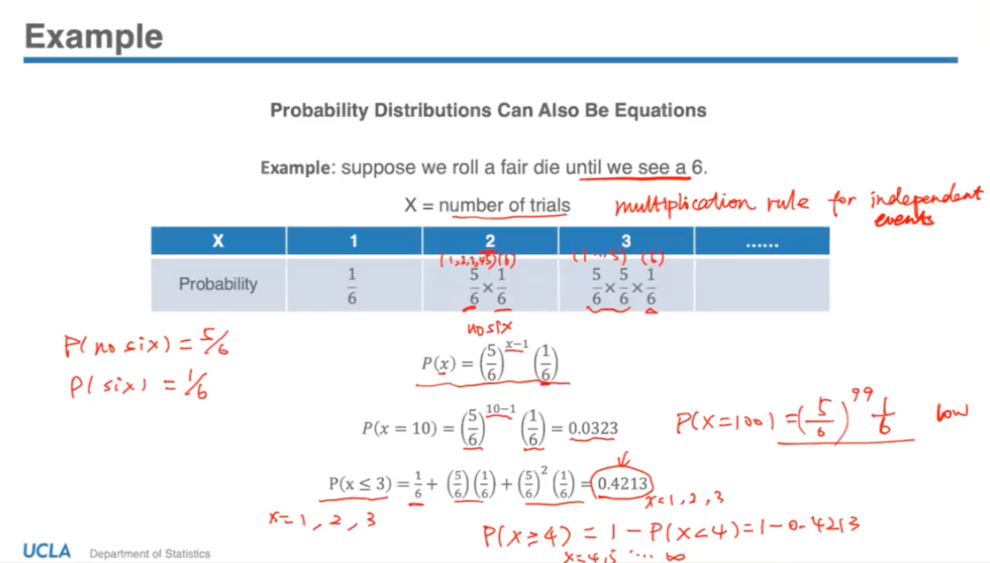

- The experiment is such that we keep rolling the die until we get a 6, then we can stop. X is a discrete random variable because we’re counting the no. of trials we have to conduct before we can stop the experiment.

- In theory, it is possible to have infinitely many trials although it’s highly unlikely that we still don’t see a 6 despite X increasing a lot. So the chances of this are extremely low, but it is possible and it does have a probability to occur.

- The last probability calculates the probability that you will need to conduct your trial at most 3 times. For this need to find the individual probability for x = 1, 2 and 3 and then summing them up.

Continuous Probability Distribution

- To deal with continuous random variables, it requires a higher mathematical level (involving calculus) than required for discrete random variables since all the outcomes can’t be listed.

- Can use a probability density curve to represent continuous probability distribution.

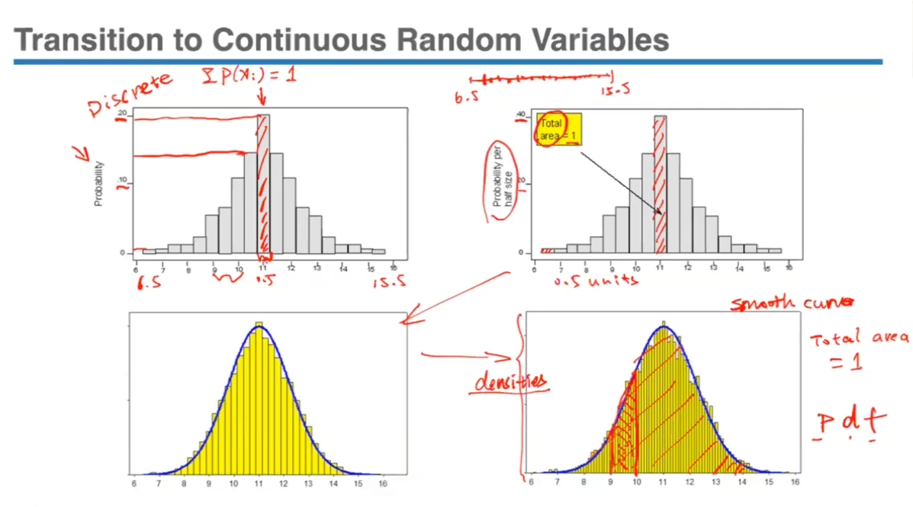

- Top left is the probability histogram of some kind of measurement in half units, which is listed as equal intervals going from 6.5 to 15.5. Takes only those whole half numbers into consideration, nothing in between (like 6.25, 7.85 etc.) so it is discrete.

- Now going to see how to make the transition to continuous random variable. These variables represent measurements that can take on any value within an interval, but the problem is we cannot assign these probabilities to each individual value. This is because if we consider a number line from 6.5 to 15.5, these variables can take any point on this line and it would be impossible to assign individual probabilities (as we did in the discrete graph above) because if we do so, there would be infinitely many values and the sum of probabilities would equal infinity not 1, which is a violation of probability distribution.

- The solution is instead of measuring the probability with the height of the bars, we can use the area of the bars to represent that probability. We know from the principle of probability distribution that the sum of probability values has to be equal to 1, therefore if we’re using the area as a representation of probability, then the total area = 1.

- Since it can be observed from the first graph that the width is in half sizes, calculated area will also be in half sizes. So in order to make the total area = 1 while still keeping the horizontal scale (6.5 to 15.5), we have to adjust the vertical scale by doubling the values (0-10-20 becomes 0-20-40). By changing the vertical axis, it doesn’t change the shape of the distribution.

- If we consider measurements in smaller and smaller units than 0.5 units (making the transition to continuous so that it can gradually be any point on the number line), the number of intervals increases and the width of the bars become narrower and narrower. So value range is divided into infinitely many intervals, and at the end, the graph approaches a smoother curve. Still need to be consistent with adjusting vertical axis so that total area = 1.

- This smooth curve obtained in the end is called the probability density curve (Pdf) since the vertical values no longer represent probabilities but densities. To find the probability of any variable taking a value (for ex between 9 and 10), need to find the total area of these rectangles under the curve between this interval.

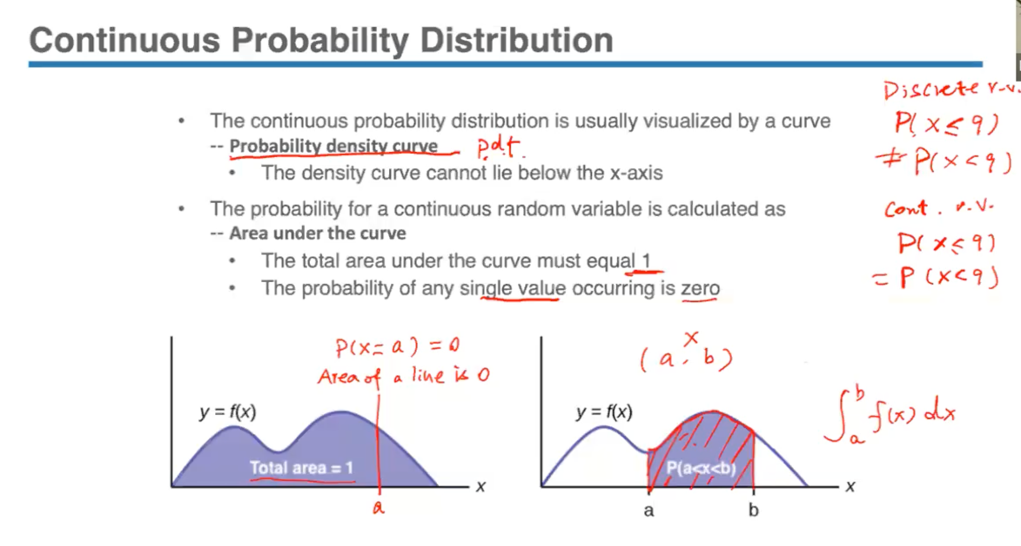

- In the case of discrete variables, strict inequality matters like if P(x ≤ 9) ≠ P(x < 9), but for continuous variables like length, height, width the probability by the construction will be the same (strict inequality does not matter) like P(x ≤ 9) = P(x < 9). The reason is by construction we’re measuring the area, so visually by looking at the density curve graph, the area under the curve up to and including a certain point is the same as the area up to and excluding that point. This is because for a certain point ‘a’, the probability of x being equal to that point P(x = a) is the area of this straight line (as area = probability here) and area is = 0, so this probability will also = 0.

- Rather than considering individual outcomes for continuous random variables, we’re interested in finding probabilities that occur over a range like from a to b.

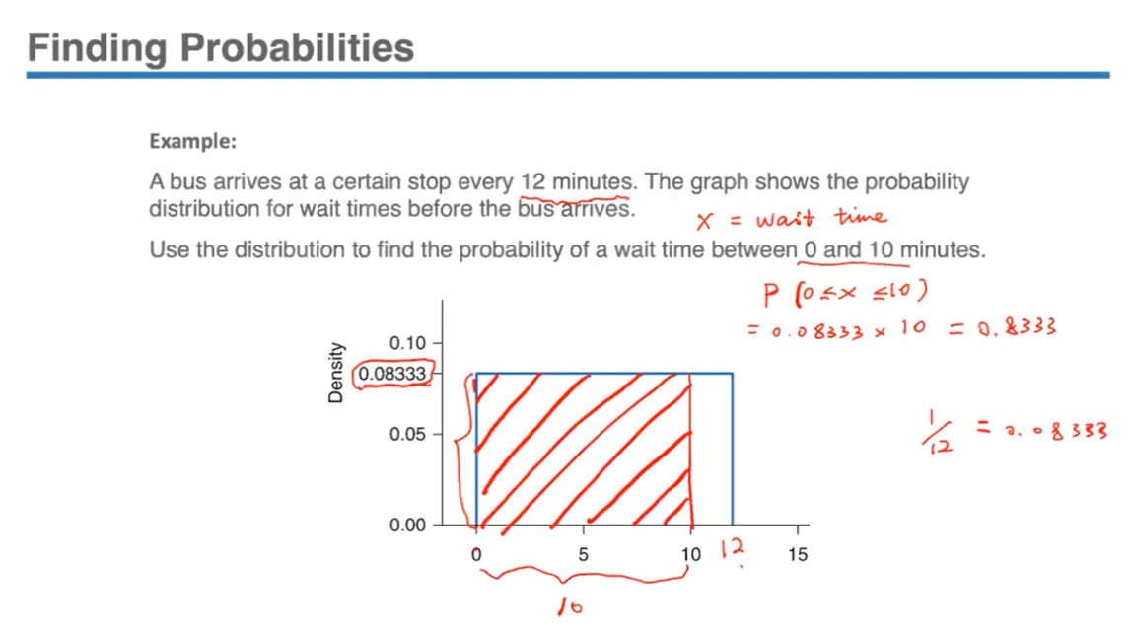

Normal Probability Distribution

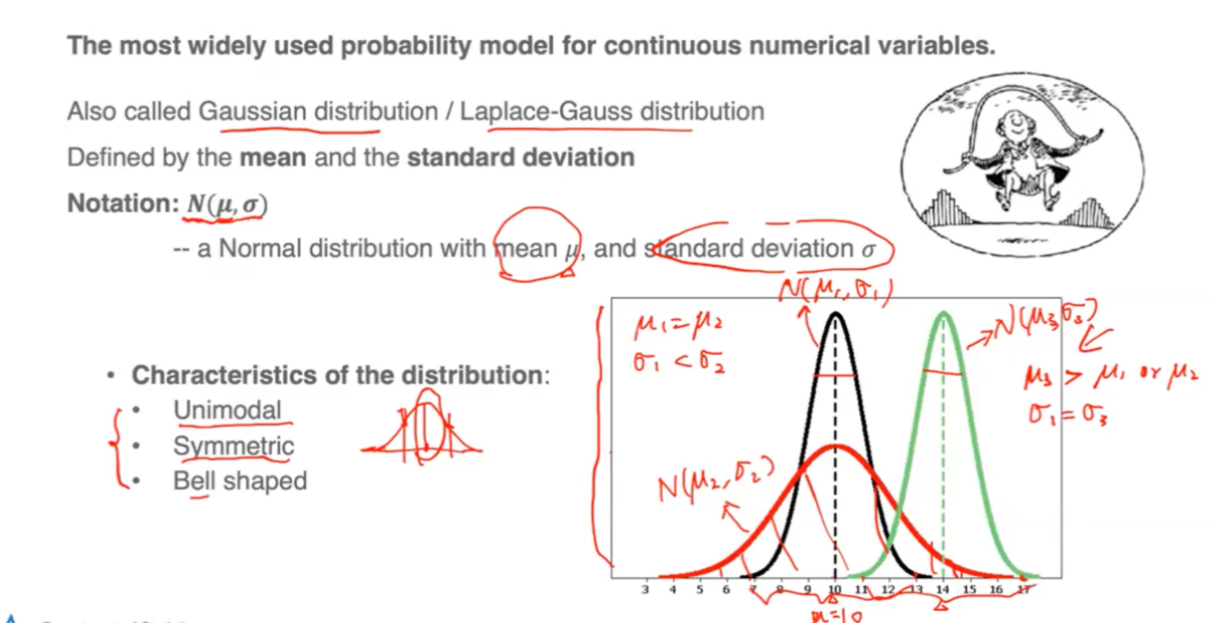

- Also a very important mathematical theorem, the Central Limit Theorem, also links the normal model to several key statistical ideas that are important for statistical inference.

- Unimodal means only one peak at the centre

- Symmetric indicates that the variable is just likely to take a value at a certain distance below its mean as it is to take a value at the same distance above its mean. So the left side will be a mirror image of the right side.

- Bell shaped curve indicates that the values closer to the mean are more likely and it becomes increasingly unlikely as the values spread out.

- Notation µ for mean and σ for standard deviation for normal distribution is used to avoid confusion with their counterparts of x̄ for sample mean and *s* for sample standard deviation.

The centre is represented by mean and spread by standard deviation, so these 2 values alone determine the shape and location of a normal distribution.

- To summarize the graph, a normal curve that is wide horizontally and low vertically like the red one, has a larger standard deviation and thus more area spread out from the mean. A normal curve like the black and green one that is narrow horizontally and tall vertically, has a smaller standard deviation and thus, more area clustered around the mean.

Finding Normal Probabilities:

- How do we find the probability for any range of data with normal distribution?

Can approach the probability question through 3 possible ways – pdf function (using integral techniques), computer technology (like R programming), and the Z-table.

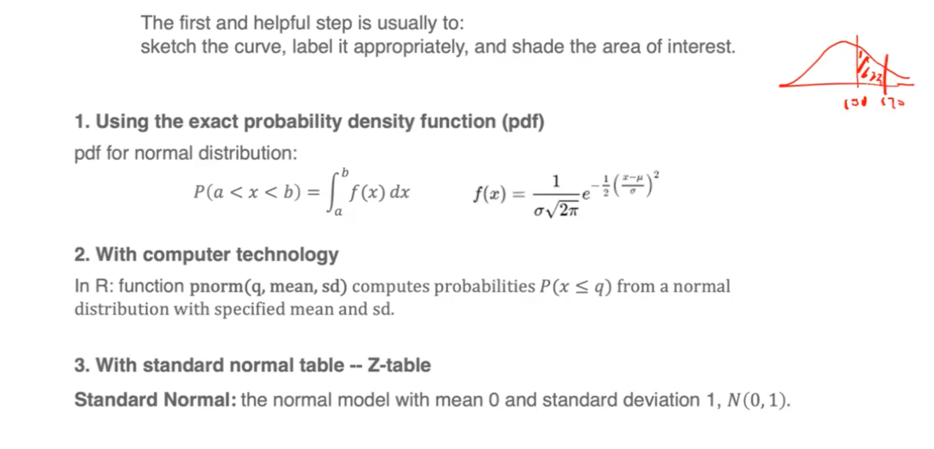

- The Z-table provides approximate probabilities when nearly all the possible values from a standard normal distribution (mean = 0, and sd = 1) - N(0,1). It is particularly useful because once a random variable is standardized to have a Z-score, then we can use a standard normal table to look up the probabilities associated with that specific Z-score and vice versa. This simplifies the calculation so we that we only need one single table.

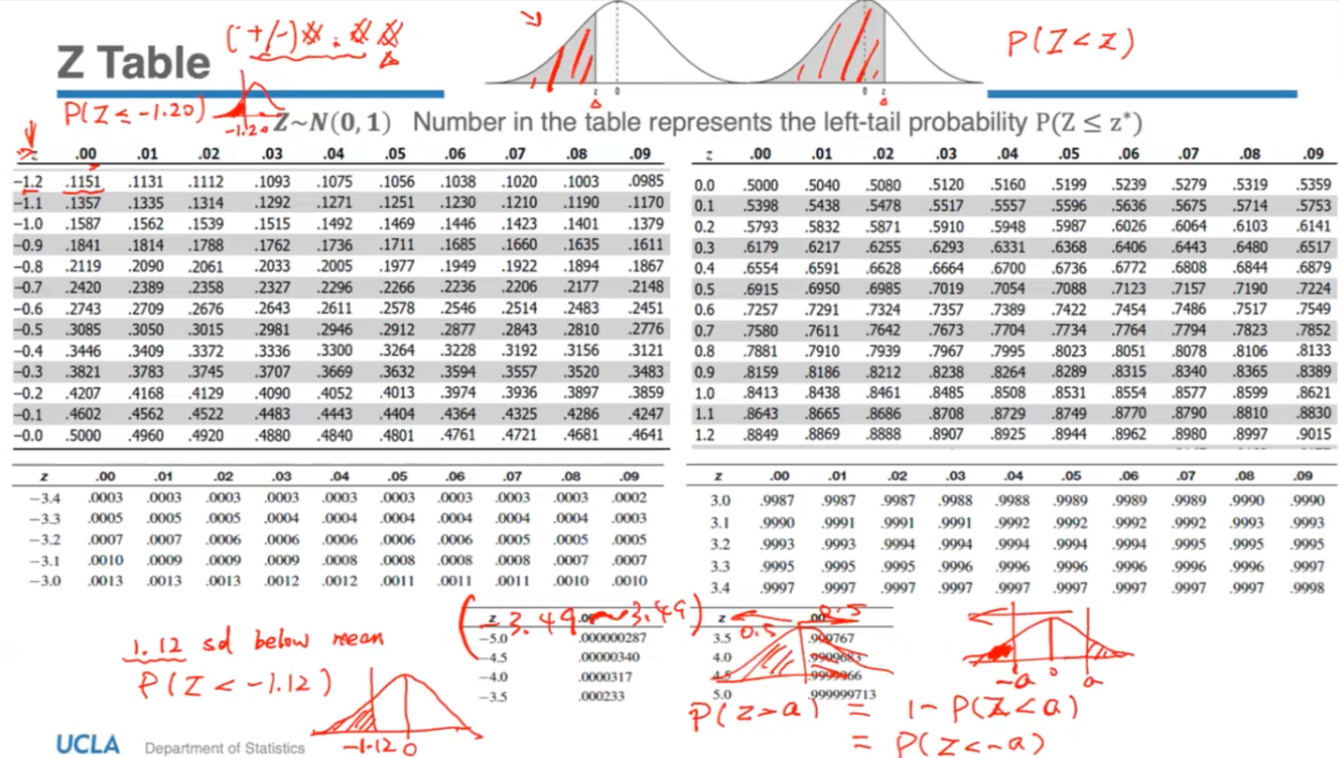

- By construction, the probability of the standard normal variable which we use Z to represent, is less than any value z, which equals the area under the Z curve to the left of that particular value z (as shaded in graph). The table provides the cumulative probability for standard normal distribution up to a given Z-score. If we are given any Z-score, you can find the left tail probability using such a table.

- It is the probability of a standardized normal variable z taking the value less than or equal to a particular value Z. When you get a Z-score, have to round it to the hundredth so the intersection of the column of the left margin and the row of the top margin gives the probability of the area under the curve up to that Z-score. All the entries in the above Z-table specify the left tail probability, the area to the left of a particular z value.

- Since normal curves are symmetric about their mean, it follows that a curve must be symmetric about 0 and the total area under a normal curve will always = 1. Thus, it follows that the area on either side of 0 will equal to 0.5. This symmetric property is also useful when solving probability problems like P(z > a). Since the table entries only provide left tail probabilities, two other approaches are needed to find right tail probabilities:

1) can use symmetric property: P(z > a) = 1 – P(z < a) (left tail probability)

2) can use the fact that area under curve = 1, so its equals to the left tail probability of -a since it is symmetric; P(z > a) = P(z < -a)

- Since the Z-table provides values within the range -3.49 to 3.49 and we know that the 3 standard deviation range covers almost all the area of the curve, if a z value is outside this range (more than 3 sds), can generally say that the probability is approximately 0 (almost negligible).

*15th November, Wednesday*

**Lecture 7.2**

Finding Normal Probabilities with Z-table:

- Suppose we don’t have a standard normal distribution, and have a regular distribution instead normal with a mean and a standard deviation of 5 and 10 – N(5,10). Then, the Z-table no longer provides probabilities for such a distribution (only applies to the standard normal distributions).

- Rather than constructing a separate probability table for every combination of mean and standard deviation, we just require an additional step to the standard table called ‘standardization or z-transformation’. This process converts all the values of any normal distribution to its Z-scores, which can then be referenced with the Z-table to find their respective probabilities.

- The first step is to determine the position of these normal values relative to their mean measured in standard deviations. Then, we find the corresponding Z-score in the table and calculate its related probability.

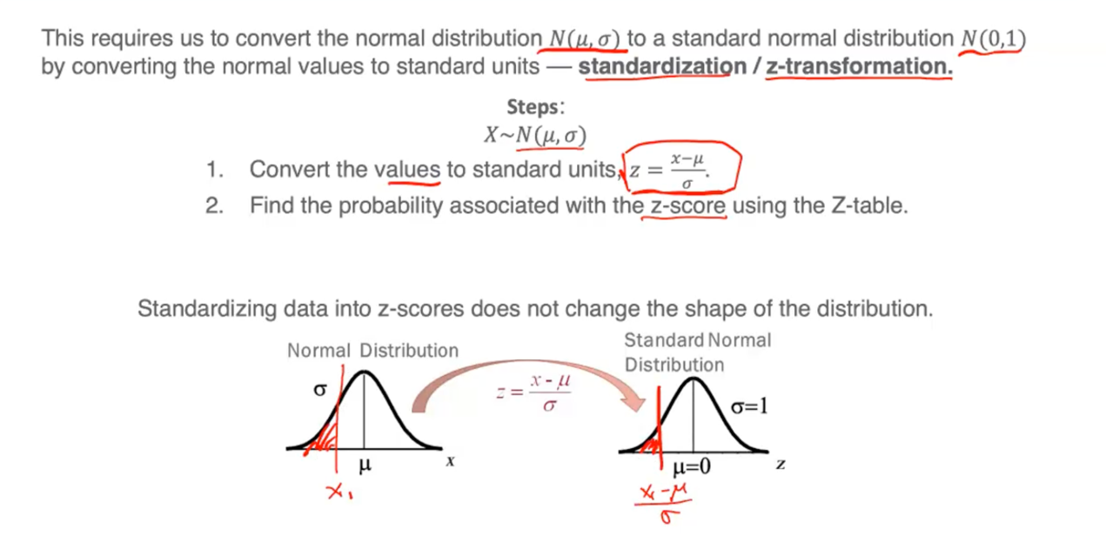

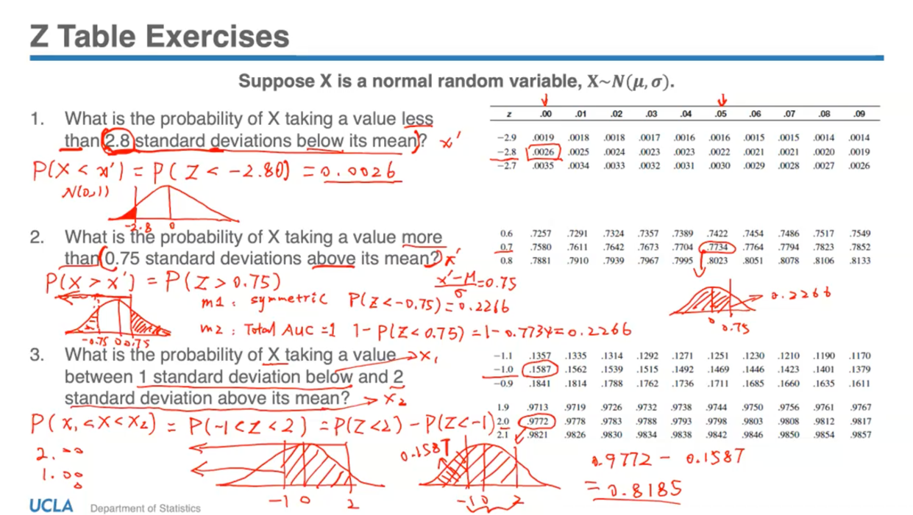

- ‘Below’ or ‘above’ the mean indicates the direction and sign of Z-score (+/-) and the distance in standard deviations indicates the magnitude.

- ‘Less than’ indicates left tail probability and all the possible area to the left of the Z-score, and ‘more than’ indicates a right tail probability.

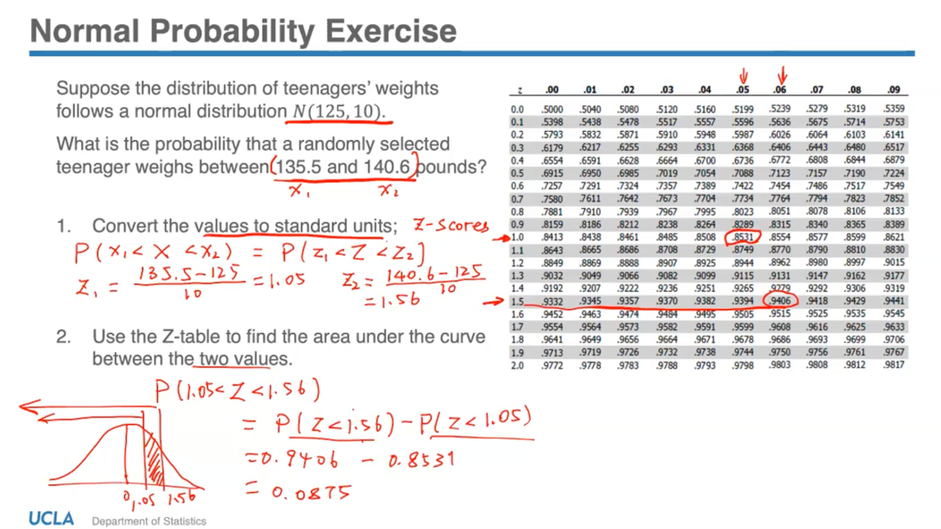

🡪 The above is one type of problem related to probability- given a certain value, how to find the associated probability. Another type of probability question related to normal distribution- if given a probability, how to work backwards to find the value or measurement that corresponds to that probability. This measurement used is ‘percentile’, which is used in growth charts etc. Qth percentile refers to the area to the left of that value under the curve.

Finding Percentiles:

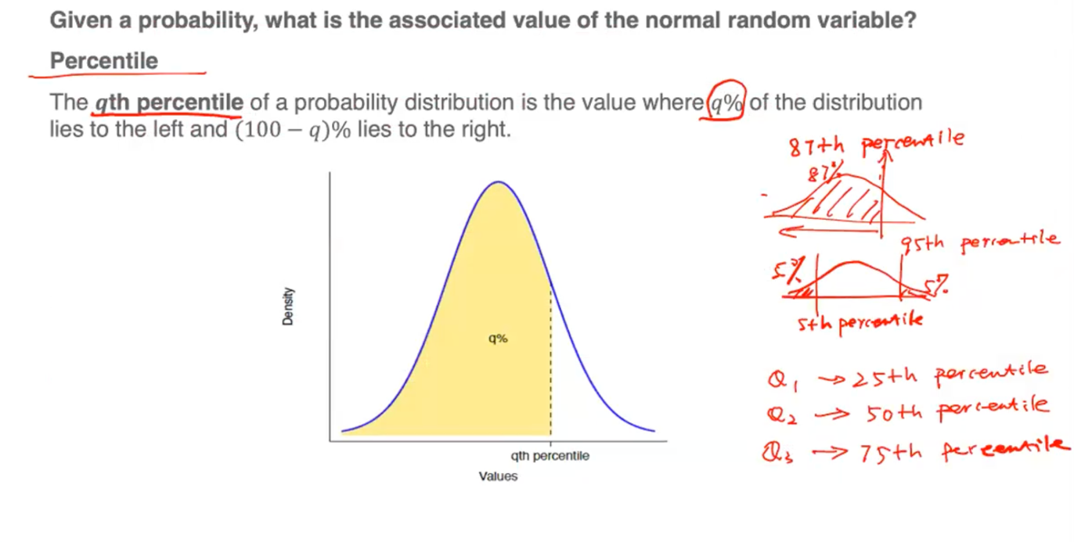

Finding Percentile Steps:

- 2 ways to find the percentile either with computer technology (using R programming) or with the Z-table, which involves first locating the given probability in the Z-table by looking for the closest entry in the table, and then finding the corresponding z-score in the left top margin. Then, we convert the z-score back into the original units by rearranging z formula.

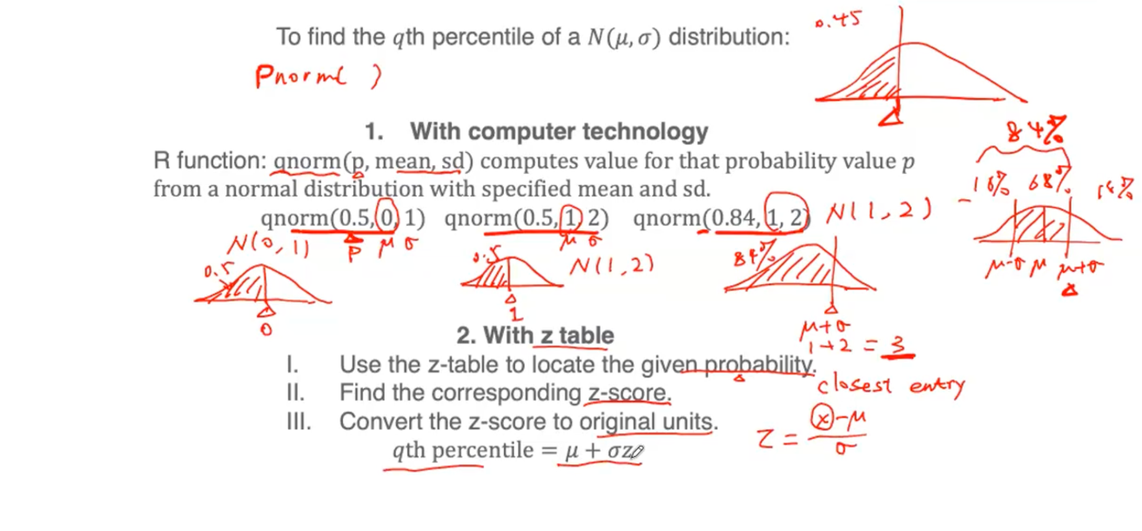

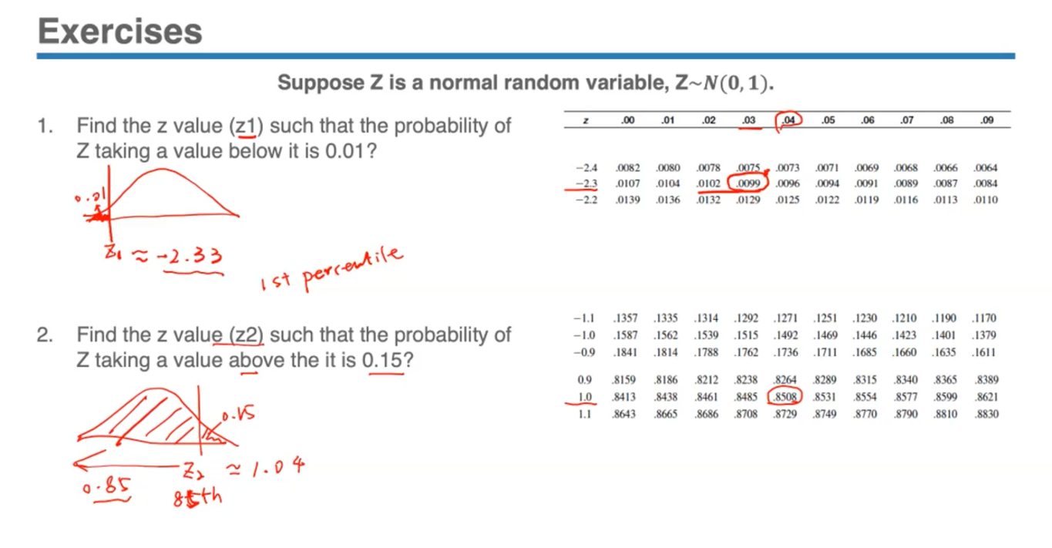

- For 2, it means that we found that 15% to be the probability that this variable would take a value of more than 1.04 standard deviations above this mean. Thus 85% percentile is 1.04.

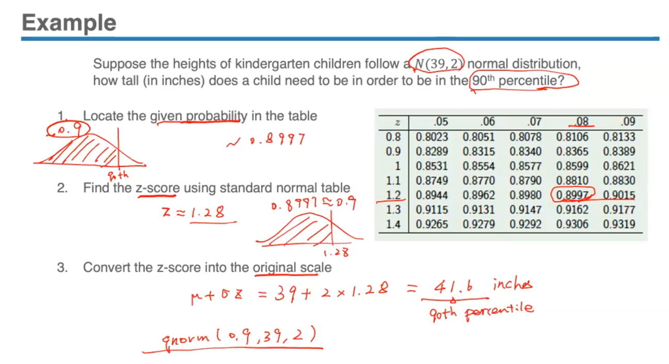

- 90th percentile = left tail probability of 0.9, so look for closest value to 0.9 in Z-table which is 0.8997 with a corresponding Z-score of 1.28. Converting this into the original scale with the formula will = 39 + 2 x 1.28 = 41.6 inches (the 90th percentile approximated using z-table).

*20th November, Monday*

**Lecture 8.1**

Sampling Distributions

- Important for proper understanding and transition to statistical inference. Focus is on relationship between the values of the variable for a sample and the values for the entire population from which the sample was taken – bridge between probability and statistical inference.

- Originally in Inference: Sample 🡪 Population is the goal, using some limited information to infer about the larger population. But here, we’re posing the reverse question- suppose we know what the population looks like, what can we expect the sample to be. If we have information about the population already and take many different samples, what does the behaviour of those samples indicate by observing their collected estimates (mean, sd, proportion etc.) and their respective distributions.

- If we repeatedly draw random samples from a population and obtain some estimates about this population, what will these estimates distribution look like? – sampling distributions

- Aim is to understand the behaviour of sample estimates and see if there is a pattern.

Sample Estimates

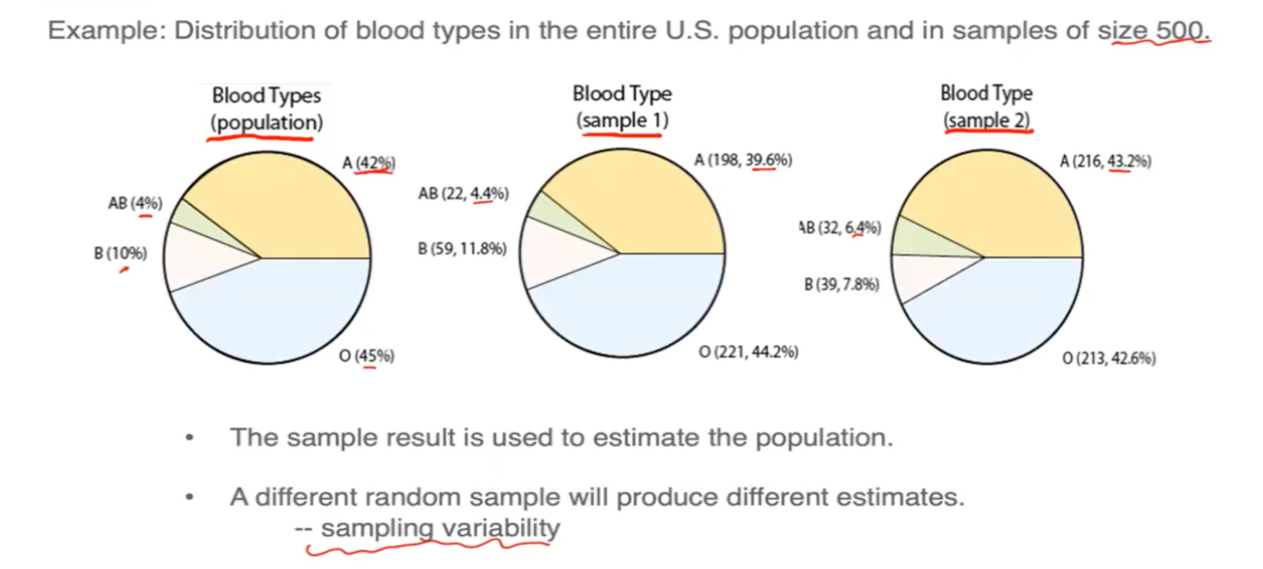

- Notice that the proportions obtained from the sample are slightly different from the population percentages. We cannot expect the sample to behave exactly like a population due to factors of randomness and uncertainty.

- Similar to the idea of a simulation which generates some set of random numbers with each time being likely to produce a different set of numbers, every time a random sample is taken with the same size and procedure, due to randomness there will be slightly different results. This is called ‘sampling variability’. A different random sample will produce different results and estimates.

- The percentages obtained from the sample to estimate the population are called ‘sample estimates’ when information about a population isn’t available.

- The Blood Types from population can be thought of as theoretical probability.

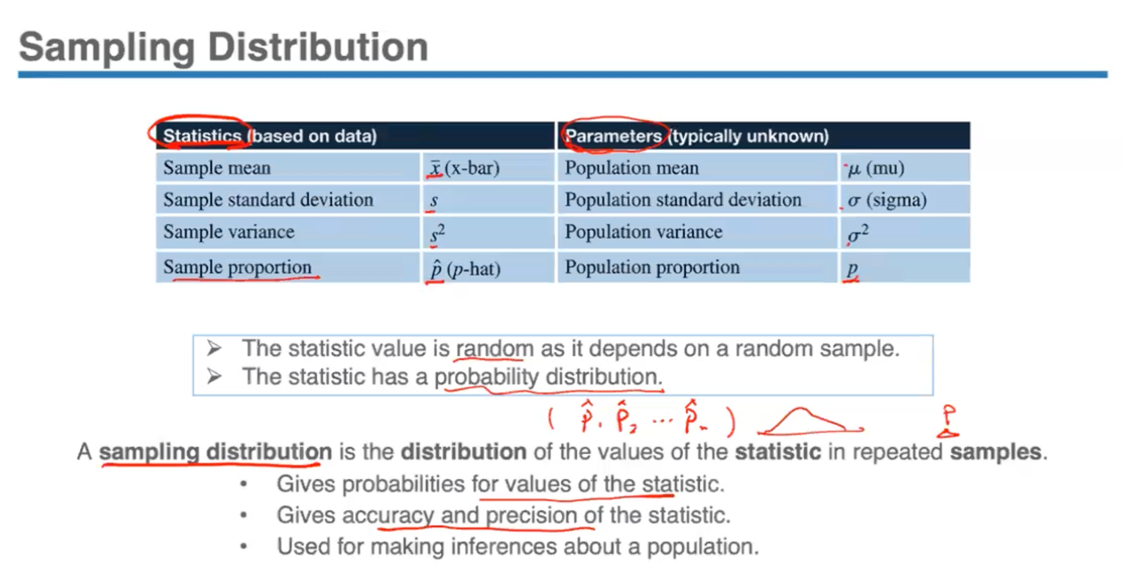

- The numbers that describe a population are called ‘parameters’, which remain the same for a population. Most are denoted by Greek symbols; population proportion/percentage is *p* (for ex: *p* = 42% A blood type in population).

- The numbers that describe a sample are called ‘sample statistics’. Most are denoted by lowercase alphabets; sample proportion is *p̂* (p-hat), used to denote the proportion of a sample with a particular characteristic or outcome (for ex: *p̂*1 = 39.6% A blood type in sample 1, *p̂*2 = 43.2% A blood type in sample 2). Can use these sample estimates to calculate corresponding population parameters.

- Sample statistics vary from sample to sample due to sampling variability. Since it is a random variable, it has a set probability distribution called ‘sampling distribution’. Used to observe the behaviour of sample estimates in order to find the relationship between these sample estimates and the true population parameter.

- Just like any probability distribution, a sampling distribution too has to satisfy all the properties.

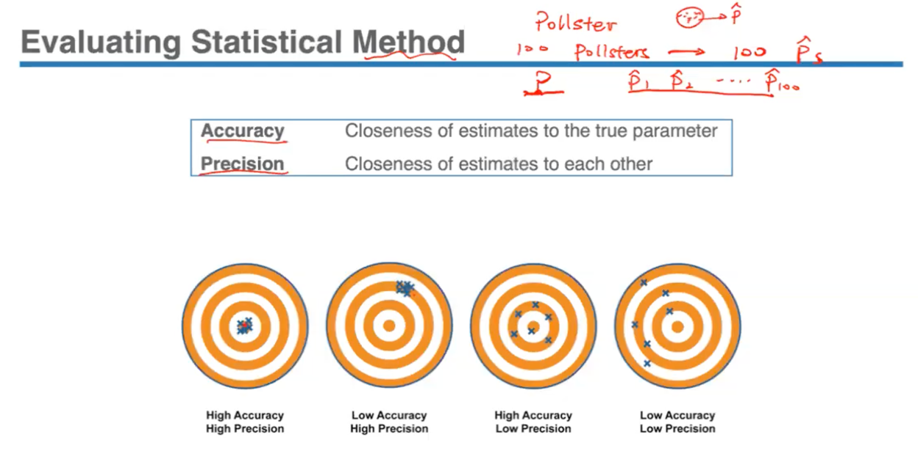

- To separate a good estimation of a population parameter from a bad one, instead of evaluating just a single estimate p-hat, we’re looking at whether we’re able to take repeated samples in order to evaluate the consistency of the method as a whole (does it give close or wide-range of values- aspects to evaluate).

- The 2 metrics for evaluation are accuracy and precision. While accuracy measures closeness to true parameter, precision measures consistency in estimates and larger/smaller spread among them. The goal is to have a method with both high accuracy and high precision.

Bias and Standard Error

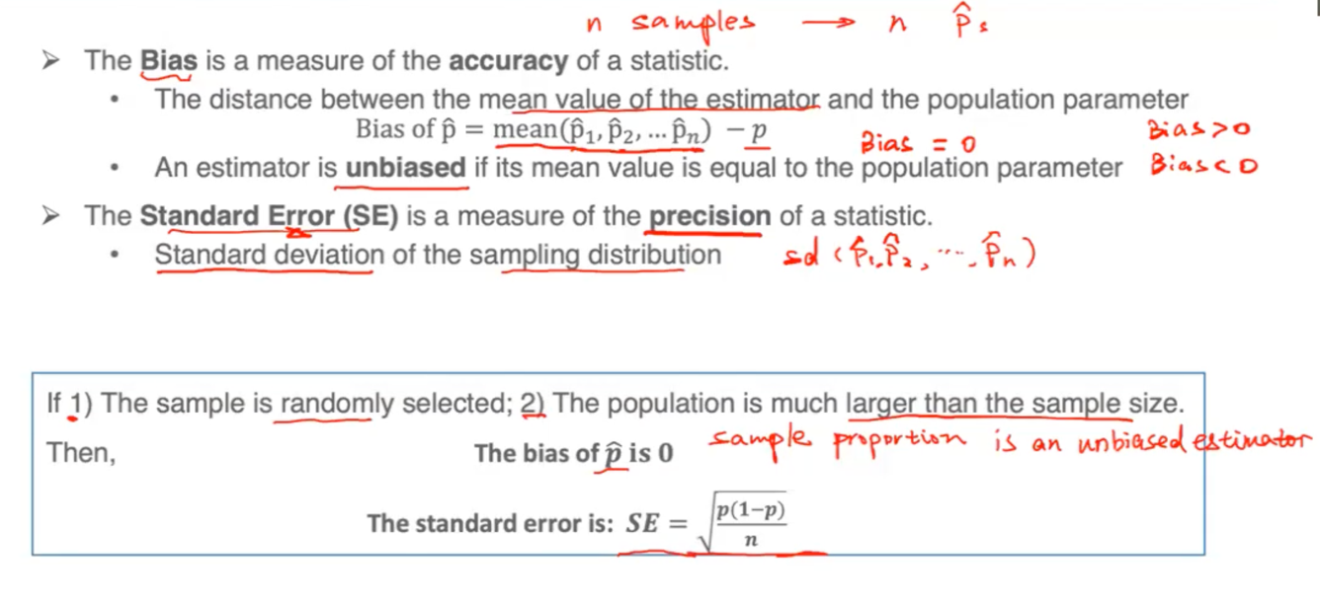

- Since bias measures accuracy, needs to tell us how far these estimates are on average to the true parameter.

- When the distance of the mean of all sample estimates from the true parameter is small, this indicates a small bias and vice versa. Smaller bias = higher accuracy.

- Both bias and precision are measures of what would happen if we could repeat the sampling procedure many times.

- Bias indicates typical outcomes of sample estimates repeated again and again – if bias = 0, typically get the correct value. If bias = 0.3, then it means that the estimate will typically be 30% higher than the true value. If bias is < 0, then estimates will consistently give a value lower than true parameter.

- Precision helps determine how different these estimates could be from each other.

- Once these two conditions are satisfied and bias of p-hat = 0, can estimate standard error of the sample distribution using the formula (if we know the population proportion p).

Simulation Example

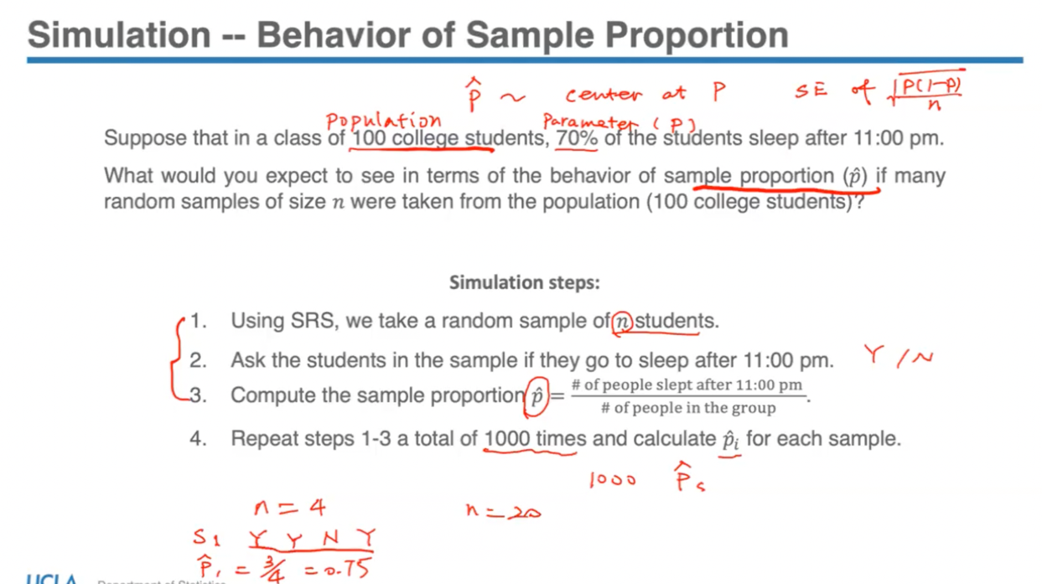

- Simulation is to verify the 2 facts 🡪 the sampling distribution of p-hat is distributed with its centre at the true parameter p, with a standard error = sq. root of p(1-p)/n

- Reason for repeating the procedure many times (ex: 1000) is due to the effectiveness of the law of large numbers so that we get estimates that are close on average to the true parameter.

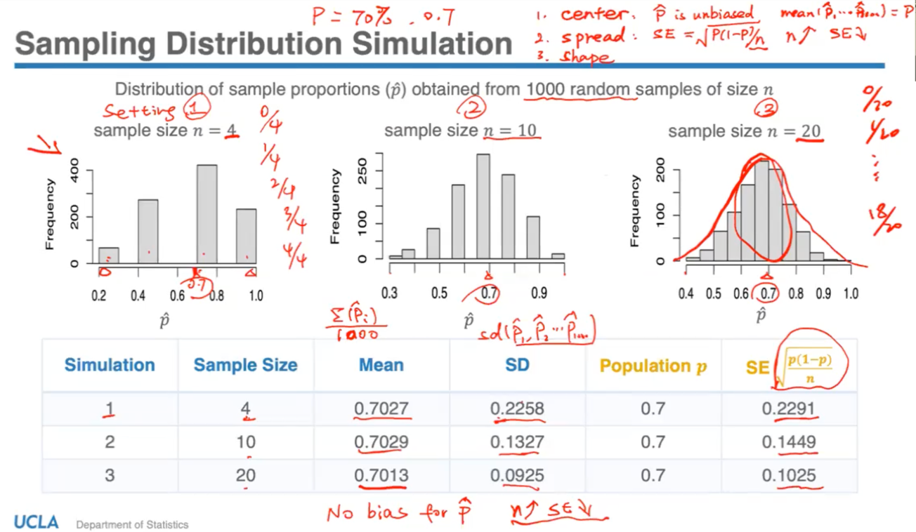

To summarize the behaviour of any random variable, we focus on 3 features of the distribution 🡪 centre, spread, and shape

1) Centre:

- We expect p-hat to be an unbiased estimator, so verify this by taking the mean (average) of all these p-hat values and expect this to be equal to the true parameter, which is 70%.

- From the table, can be observed that the p-hat sample proportion is an unbiased estimator of the population proportion since all the means obtained from the different samples are close to the true value of 0.7 – meets the expectation of centre

2) Spread:

- Can see how the sample size plays a role in the spread of the population as well. It can be observed that for a small sample size of n = 4, values tend to spread far from the centre and each other. On increasing sample size, range of p-hat values becomes smaller with more values close to the centre of 0.7. Thus for larger samples, we have sample proportions not too far from the population proportion.

- Standard error can also indicate the same. Since the true value p is unchanged, spread depends on sample size – the larger the denominator (sample size) is, the whole value of the number will decrease. Thus when we increase sample size, standard error will decrease – standard deviation of sampling distribution decreases; smaller standard deviation = smaller spread.

- Since we don’t have all the 1,000 estimates for each sample size to carry out actual standard deviations, the theoretical facts of taking true estimate p and calculating standard error with this, will give an approximate to the true standpoint distribution if we actually carry out a simulation.

3) Shape:

- Shape of distribution is expected to be bulge in the middle and taper towards the ends so that it’s somewhat normal, but it can be observed that for smaller sample sizes, the distribution doesn’t look really normal.

To summarize:

- Values of p-hat vary randomly, but the distribution has a pattern centred around the true parameter p no matter how small the sample size is. It’s unbiased regardless of the sample size, and the standard error decreases as we increase the sample size so that there is less variability among the estimates (better precision), and the shape becomes closer to a normal distribution as we increase the sample size.

- Thus as we have a larger sample size, we’re able to include more variability from the population therefore our estimates should have more precision, making the distribution gradually more like a continuous random variable distribution (larger step of size in histogram, more distinct p-hat values and thus more bins; spread decreases).

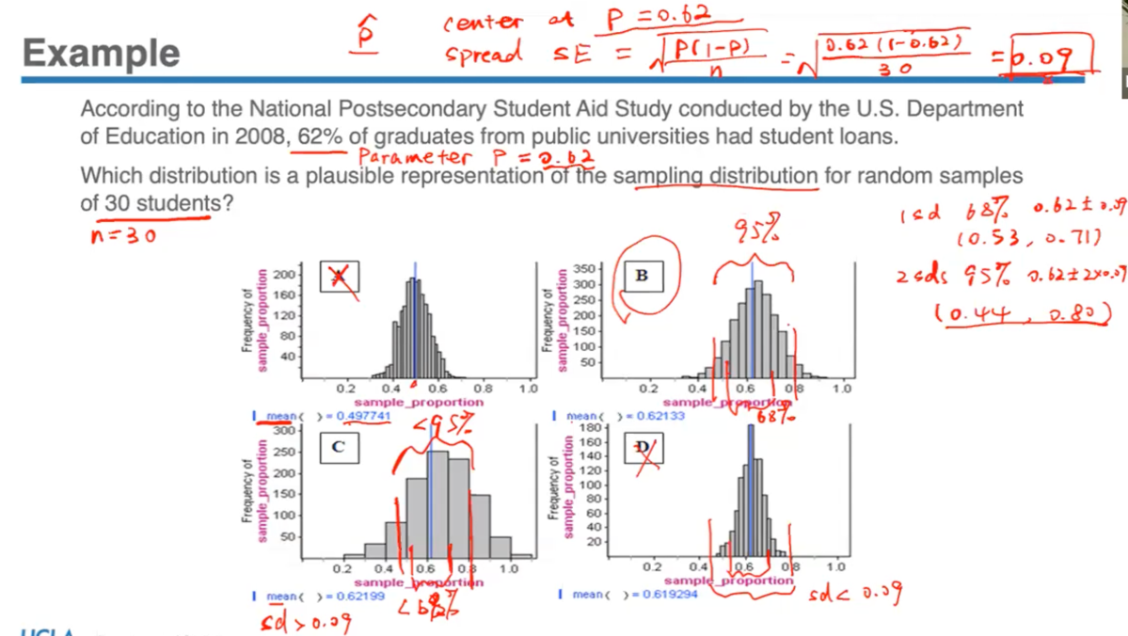

- Should expect p-hat to have a sampling distribution with centre 0.62 and a standard deviation of 0.09. Should also expect the shape to be close to a normal distribution with sample size 30. Can use empirical rule of 68-95-99.7 to check the standard deviation.

Central Limit Theorem (CLT)

- This theorem is the reason why studying the normal distribution is so important. The simulation results revealed that shape of the sampling distribution changes upon increasing the sample size, and the sampling distribution thus looks more like a normal curve for larger sample sizes. But when there’s no way to conduct a survey or draw samples repeatedly, it would be very convenient to have a method to approximate the sampling distribution, and then use that to infer about the population and make inferences. This method is the CLT.

- It has several versions, but the one that applies to estimating proportions requires 3 basic conditions to be met. If the conditions are satisfied, then the sampling distribution of the sample proportion is close to and can be approximated by a normal distribution, which has a centre/mean equal to true parameter p and a standard deviation that can be calculated with a formula.

- For the third condition, we want the population size to be much larger (at least 10 times bigger) than the sample size because we sample without replacement.

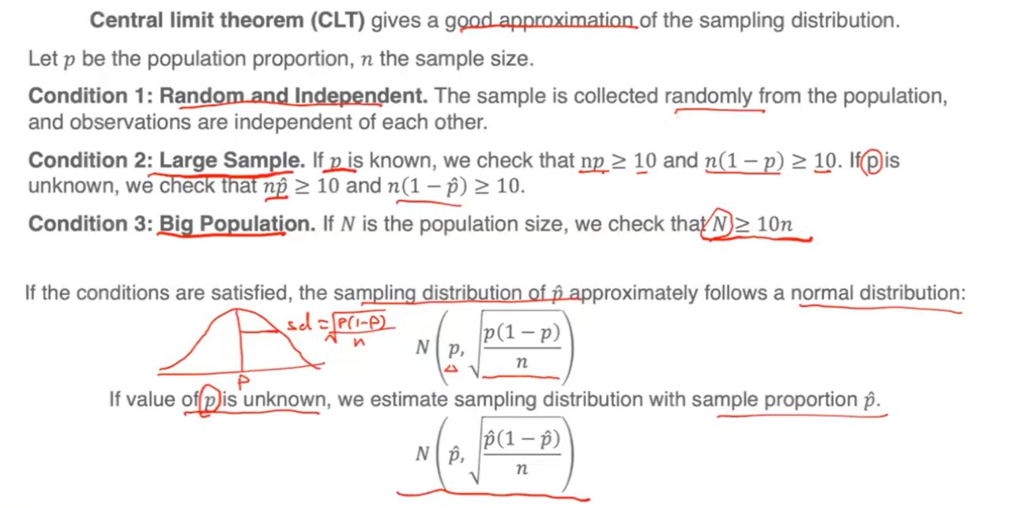

- What if a population distribution is not normal to begin with, for ex it is bimodal?

🡪 Regardless of a true distribution, the Central Limit Theorem shows that the average of samples (values) drawn from the distribution will always be approximately normal. Furthermore, the bigger the sample size the narrower the distribution of the average becomes, and closer the mean of the sample gets to the true mean of the population.

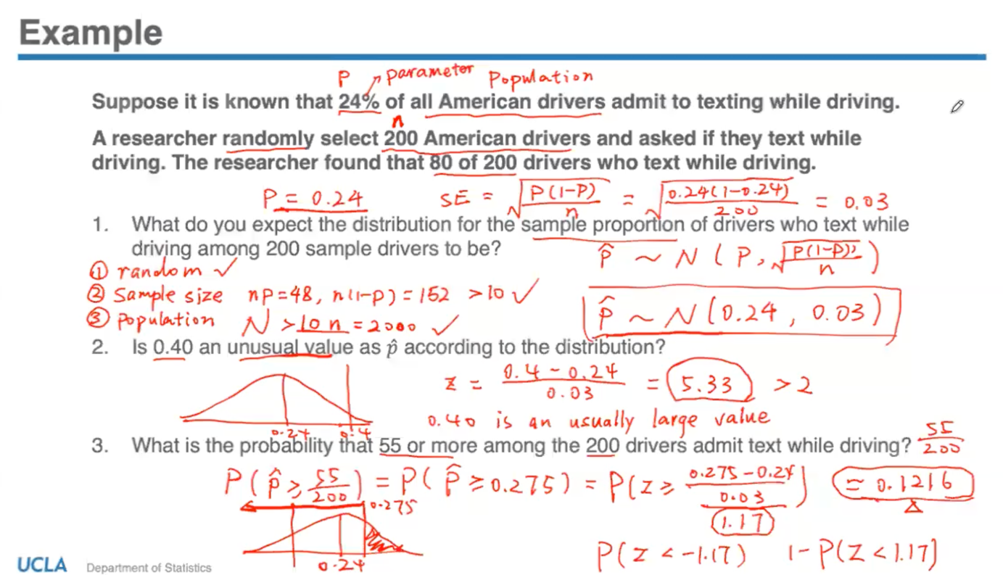

- After verifying the CLT conditions, can conclude that the sampling distribution of p-hat is approximately normally distributed with a mean of 0.24 and standard deviation of 0.03

*p̂* ~ N(0.24, 0.03)

- Since 5.33 is a lot more than 2 standard deviations away from the mean of 0.24, it is an unusually large value.

- In the 3rd part after using the formula to calculate z-score, we get 1.17 which then corresponds to the value of 0.1216.

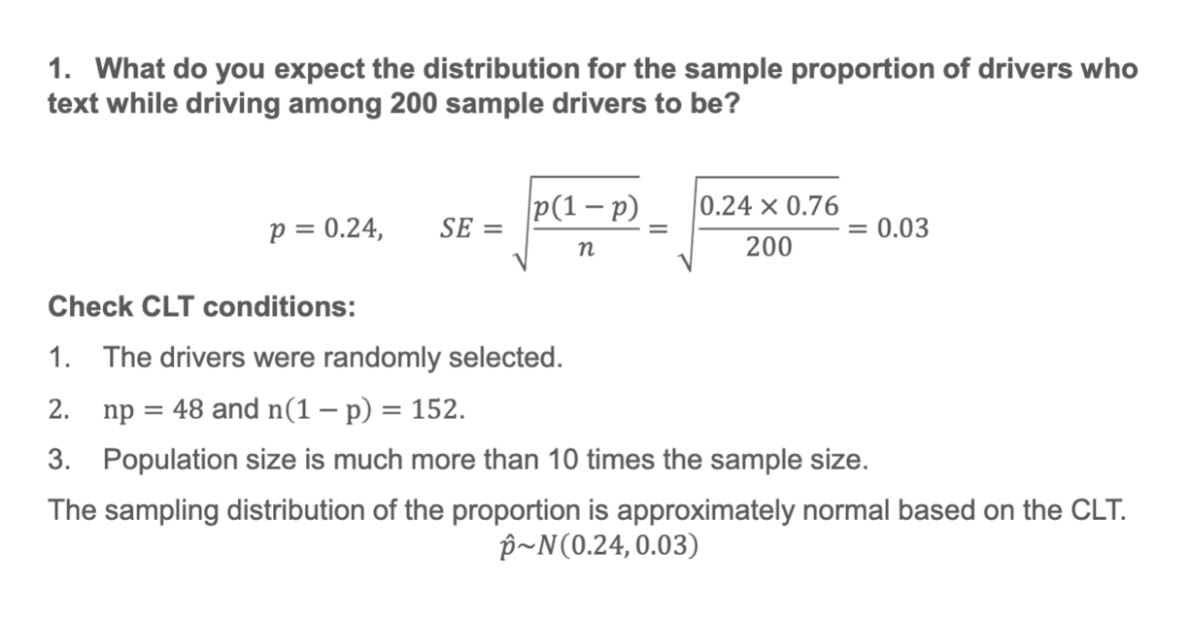

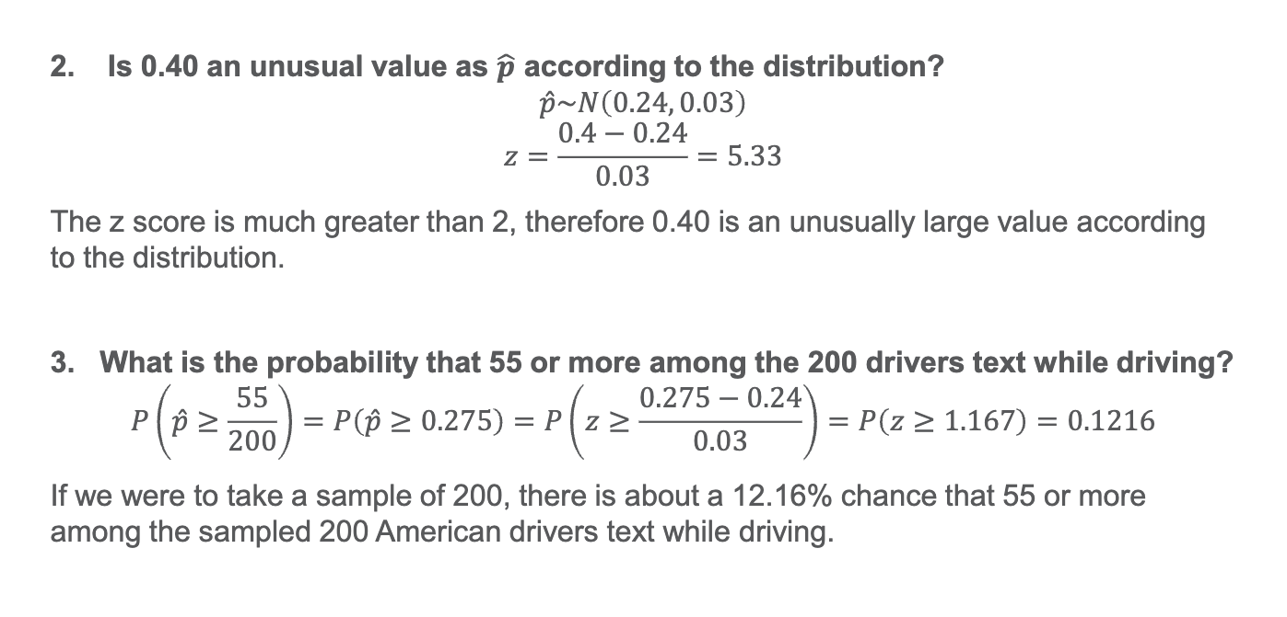

*27th November, Monday:*

**Lecture 9.1**

Statistical Inference

- The process of inferring something about the population based on what is measured in the sample is called statistical inference.

- There are 3 forms of Statistical Inference:

**1. Point Estimation:**

Estimate the population parameter with a ‘single number’ calculated from the sample, in order to provide a single best guess about the population parameter.

- Use *p̂* to infer about population proportion p, x̄ (calculated from sample) to infer about population mean (mu), or sample standard deviation s to infer about the population standard deviation (sigma).

- Due to randomness, point estimate is not likely to be exactly the same as the true value because a single value can’t determine how good or bad the estimate is without knowing the population parameter. Thus, limited usefulness with point estimator because we’re not able to quantify the estimation error

**2. Interval Estimation:**

- Estimate the population parameter with an interval of values that is likely to contain the true  
value of that parameter (and state how confident we are that this interval indeed captures  
the true value of the parameter).

- Addresses the issue of point estimation, since the idea behind it is that instead of providing just a simple point estimate, we enhance it by supplying information about the size of the error attached through an interval of plausible values for the population parameter. Also state confidence about estimation through revealing size of the error that could be made.

**3. Hypothesis Testing:**

- We have some claim about the population, and we check whether or not the data obtained  
from the sample provides evidence against this claim.

- Not providing values that we think are plausible values for the true parameter, instead using the sample data as evidence to support claims.

Point Estimation

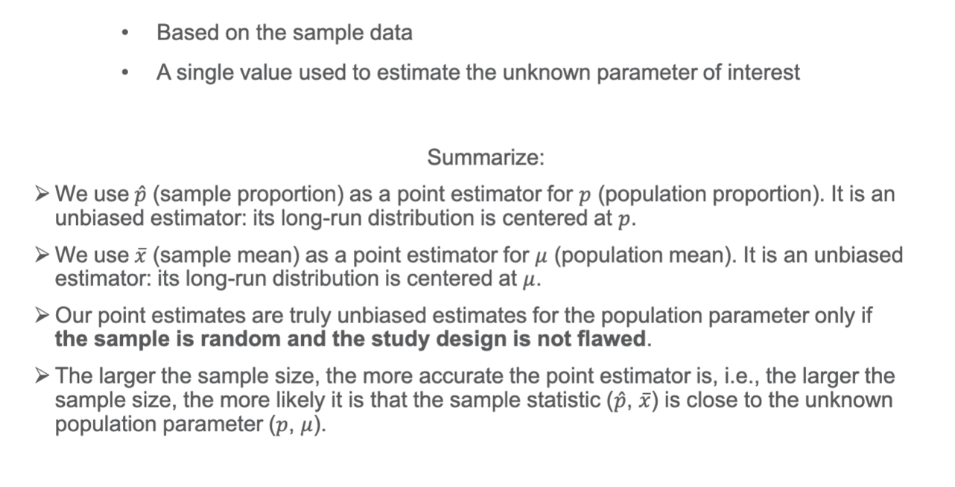

Interval Estimation for Population Proportion

- How we can construct an interval of values (Pa, Pb) using *p̂* obtained from sample, which might contain the true population parameter *p*. Idea is to enhance point estimator *p̂* with attaching the estimation error.

- If there is a certain distance between *p̂* and *p,* can describe the distance starting at either value, for ex: *p* is 1 sd above *p̂* is the same as saying *p̂* is 1 sd below *p*. According to empirical rule, can say that there’s a 68% chance that the sample proportion *p̂* falls within 1 sd of the population proportion *p* – describing distance of *p̂* from population parameter *p*.

- Since *p̂* is a random variable (since we’re taking random samples), it makes sense to use probability language to say that there’s a ‘68% chance’ to describe its probability distribution.

- But if we want to describe the population parameter *p*, can no longer use the probability language since *p* is a parameter and fixed value (as long as population doesn’t change), so need to rephrase to ‘68% confident’. We don’t use chance or probability to describe this population proportion since it’s fixed – there is only uncertainty about sample estimates.

- In interval estimation, we want to allow some margins before and after the point estimate.

- Can observe that the interval (0.22, 0.34) does cover the parameter 0.24. If we use a 4% margin instead of 6%, interval will become (0.28 +­/- 0.04) = (0.24, 0.32).

- Can observe that the confidence is also related to the interval since using a smaller margin might not be able to capture population proportion.

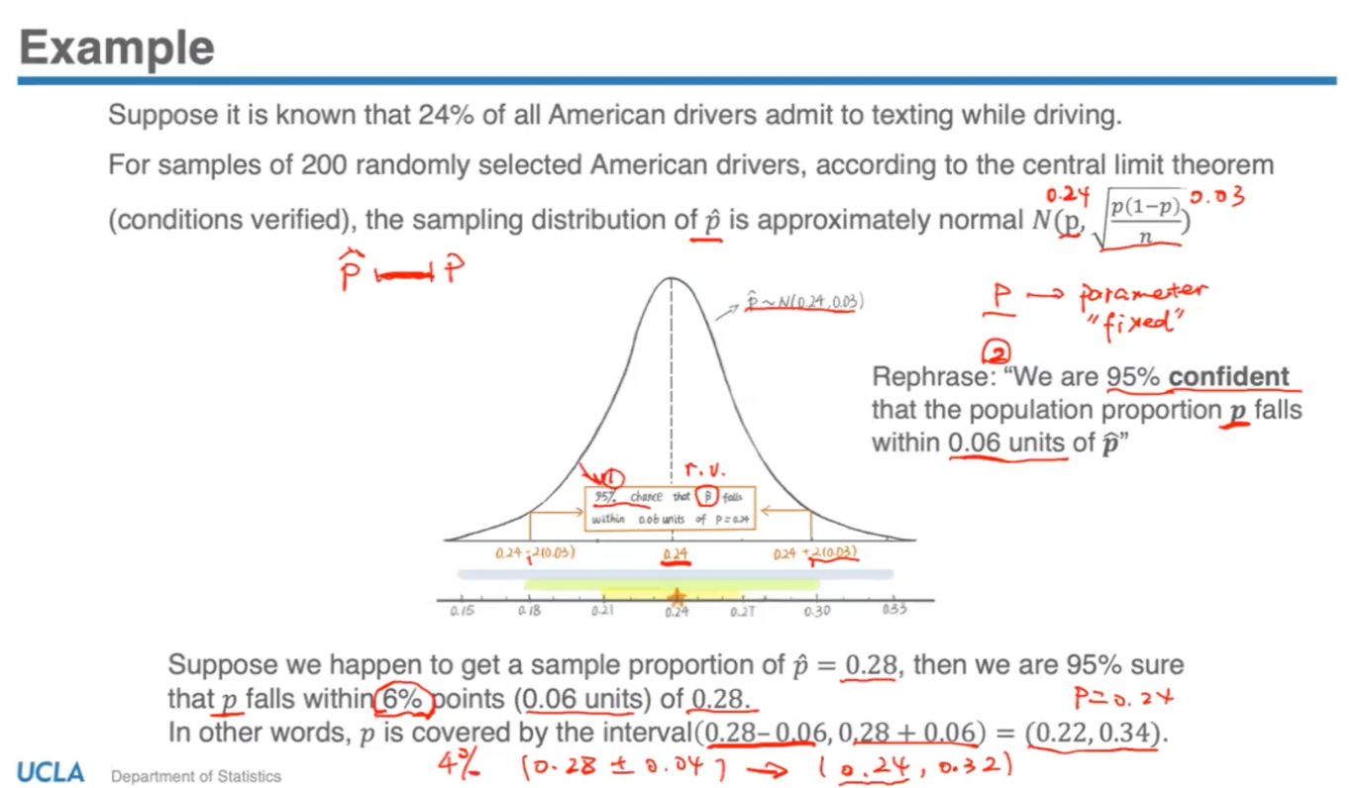

Confidence Intervals

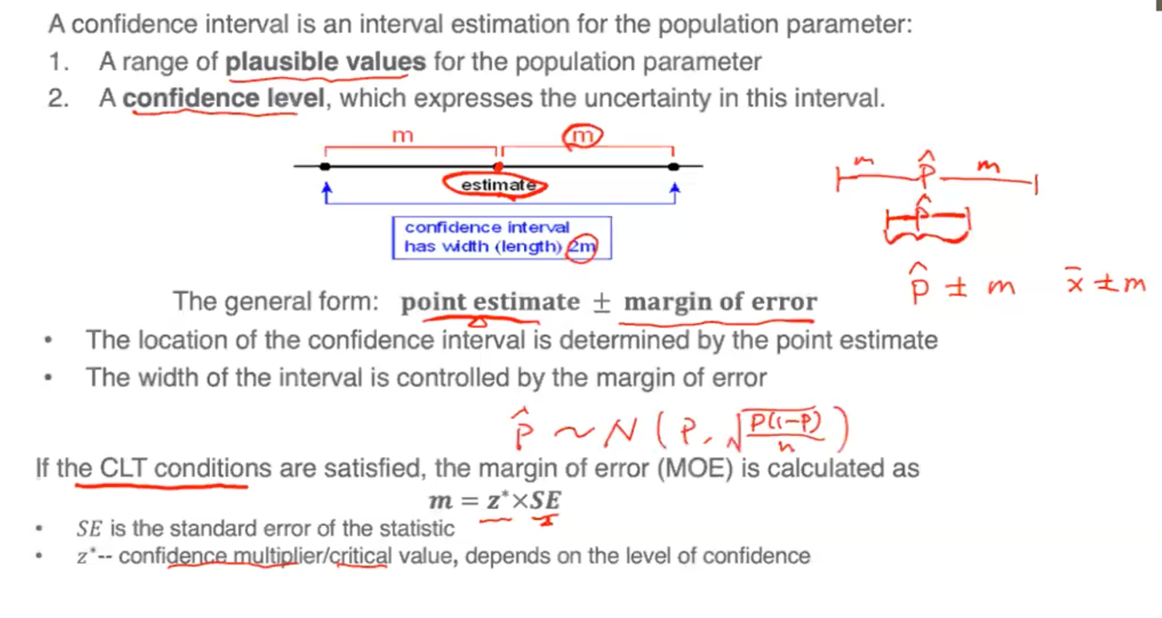

- Can develop a general formula for interval estimation, called a confidence interval which is a range of values centred around our best guess.

- The radius of the interval is the margin of error denoted by ‘m’, placed on either side of point estimate *p̂.* Thus, width of confidence interval = 2m.

- Margin of error can be thought of as precision of the interval. Large margin of error = low precision (wide range of values). Smaller margin of error = more precision, since reduced range of values for population parameter.

- Margin of error calculated as the product of two components: **m = z* x SE**

1) Confidence multiplier/ critical value (z*) – which is the number of standard errors we want to include in the margin of error; selected according to level of confidence we want the interval to have

2) Standard error (SE) – calculated based on the normal distribution approximation sq. root of p(1-p)/n.

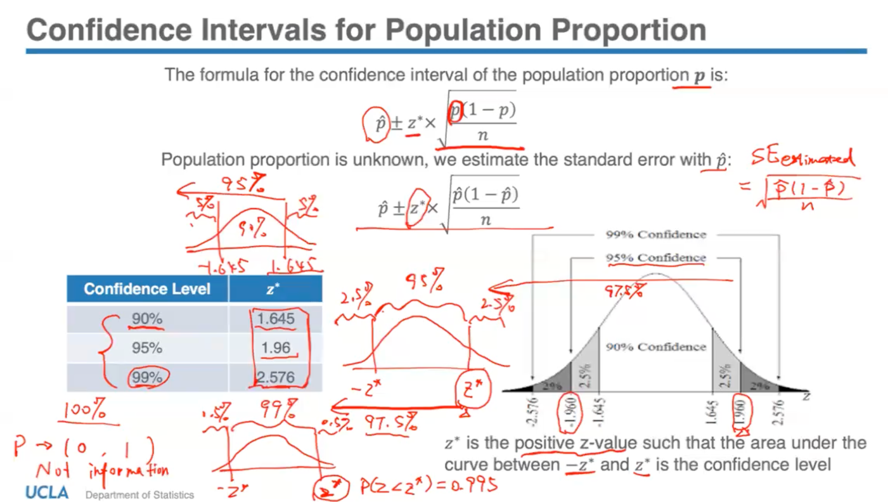

- Let the area between -z* and z* = 95%, therefore to find z* through Z-table (which gives accumulated or left-tail probability), need to find the z* value such that the entire area to its left = 97.5%. That is, left tail probability of -z* + 95%; by symmetry, each side is 2.5%.

- Then, need to go to Z-table and find the closest probability to 0.975 and the corresponding Z-score of 1.96 would be the z* value for the confidence level of 95%. This is the most commonly used level of confidence.

- Can observe that as the confidence level increases, z* value also increases. Intuitive explanation is that the more certain we want to be, then then more plausible values the interval has to include (in order to account for that extra certainty).

- Aim is to maintain a relatively high confidence, but also provide a relatively precise interval so that we can gain useful information. P is always a number between 0 and 1, so cannot look at 100% confidence level since this isn’t informative or precise at all.

Confidence and Interval Precision

- 68% CI will be the most precise among the 3 because it provides a smaller range for population proportion. So smaller margin of error can be useful, however with smaller interval there is a higher chance of making a mistake since there’s less confidence.

- The 95% CI with 2 standard errors gives a good balance between high confidence and a reasonable margin of error, so most commonly used.

- Is there a way to reduce the margin of error without reducing z*, thus maintaining the same confidence? Yes, by increasing denominator n in SE formula. Having a larger sample size n will decrease standard error SE but not affect z*. Thus, same level of confidence level but higher precision. On an intuitive level, if the point estimate is based on a larger sample n, then it will be more reliable and we’ll have more faith in it.

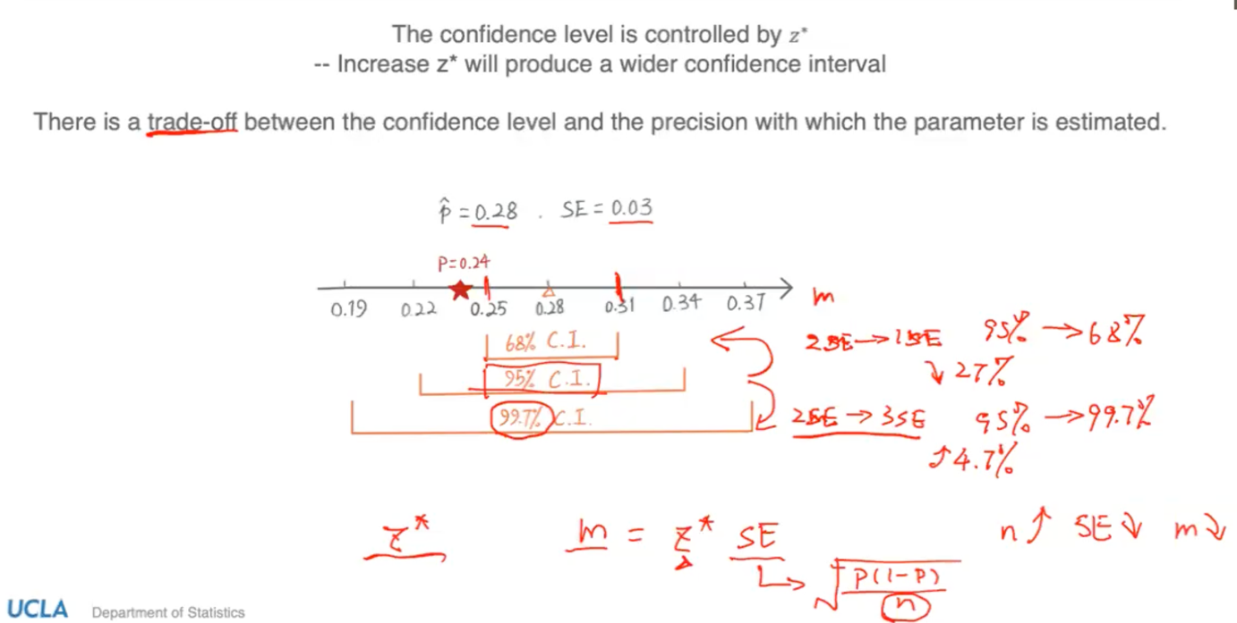

Determining Sample Size

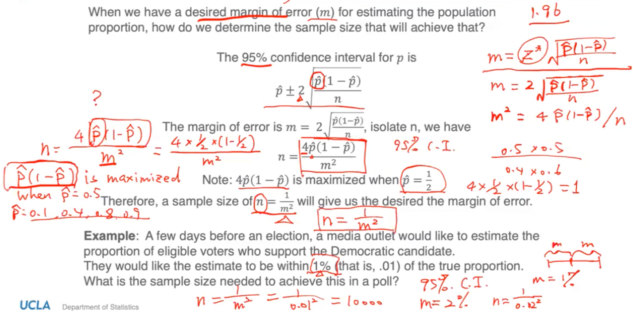

- When we have some level of flexibility in determining sample size, we can set a desired margin of error for estimating p, and then find a sample size to achieve that.

- Commonly asked question by researchers before designing a study is “How many people to include in the sample if the interval estimate has a certain precision?”

- Since we don’t have a sample yet, don’t have *p̂* and thus need to rearrange confidence interval formula to isolate n.

- The ‘conservative approach’ to this is by setting *p̂* = ½ or 0.5. It’s called conservative because the expression in the numerator is maximized when *p̂* = 0.5. This will give a sample size of n= 1/m2.

- Solving the exercise using the 1/m2 formula, it indicates that 10,000 is the sample size that is large enough to get a 95% confidence interval with a margin of error of 1%.

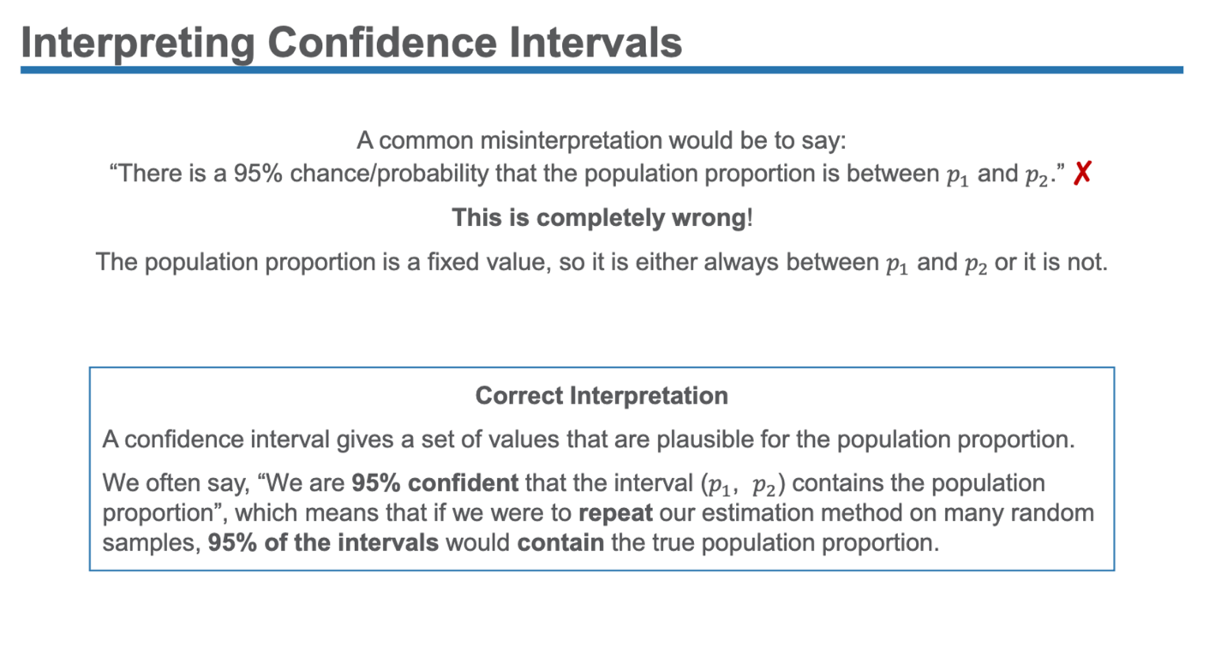

- This means that our confidence is in the process and estimation method, not in the single interval. For a single interval, it either contains the true *p* or not.

- Confidence interval can be thought of as the success rate since it tells you how often your interval estimation method is successful at capturing the true parameter.

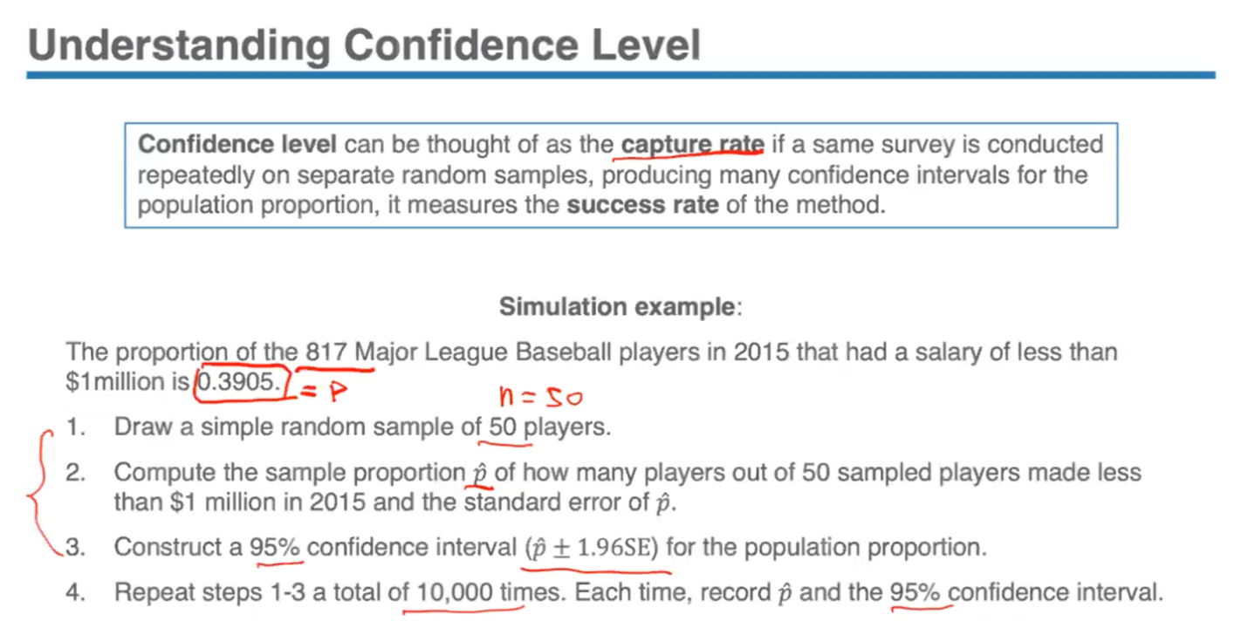

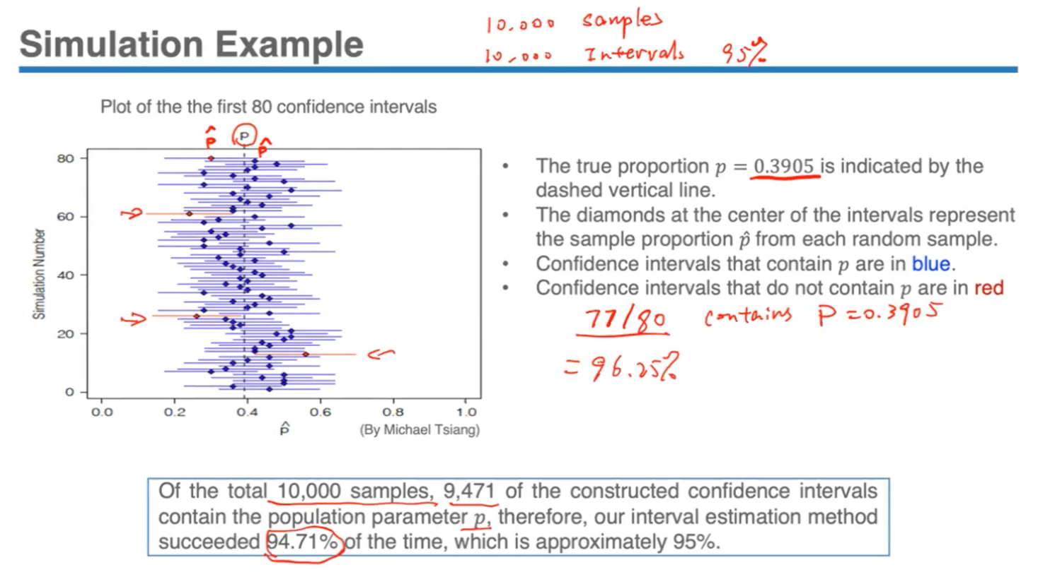

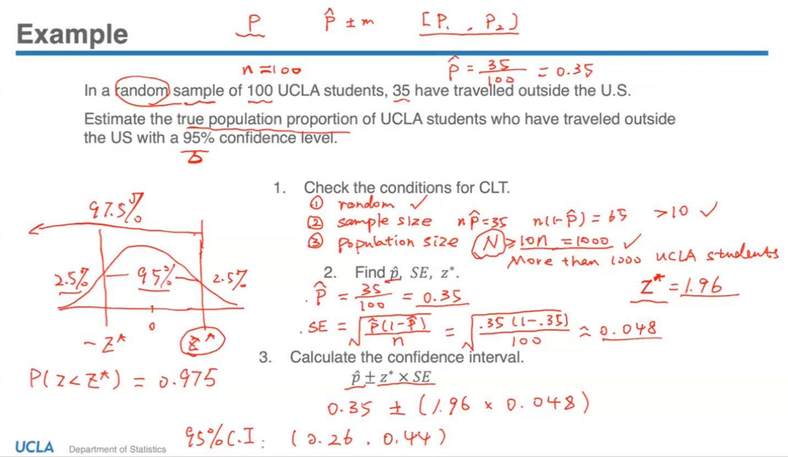

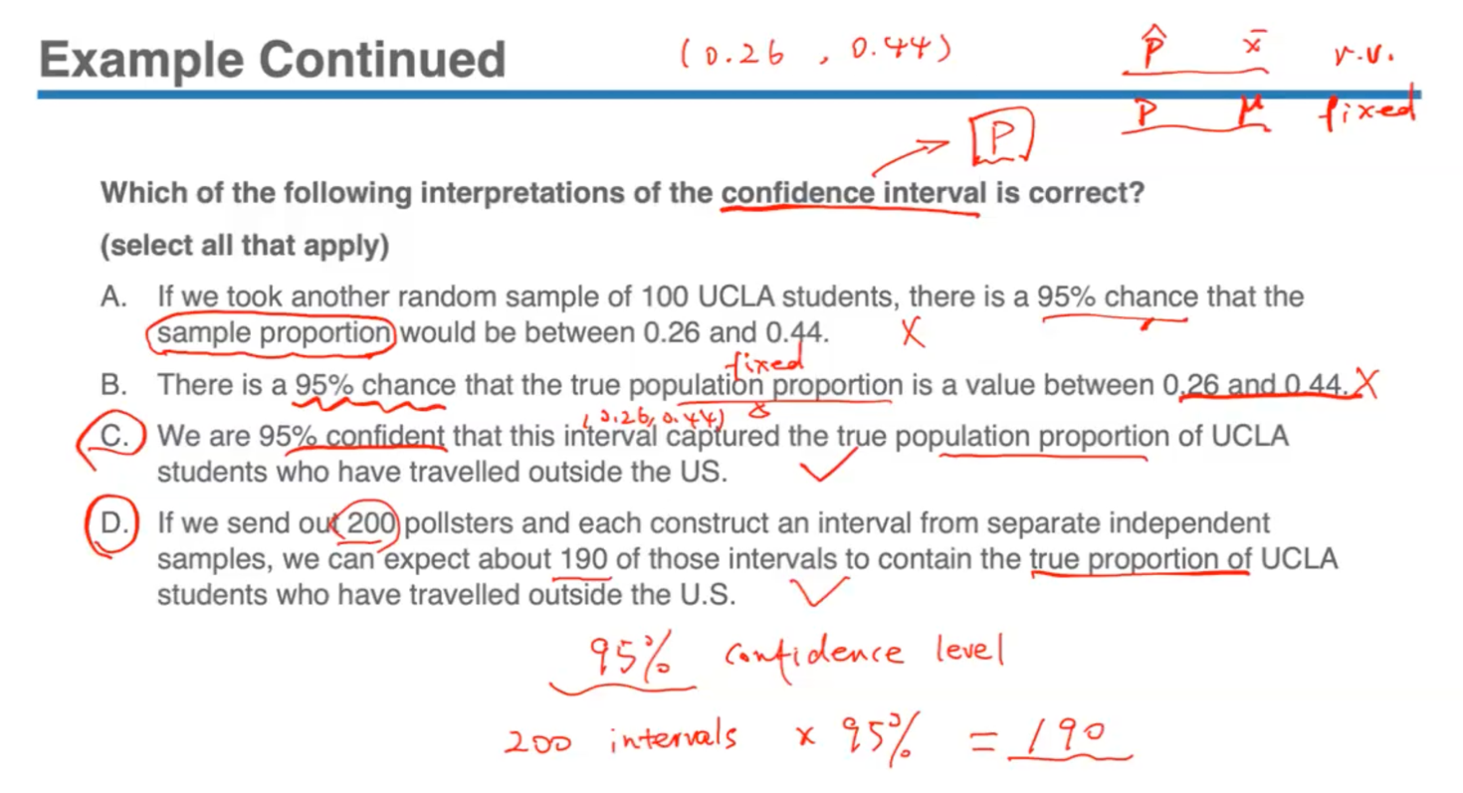

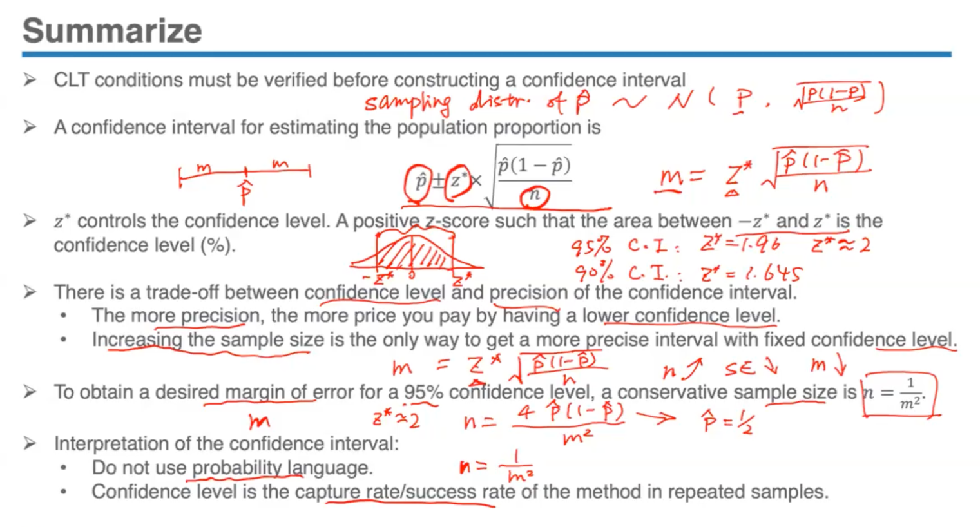

*29th November, Wednesday:*

**Lecture 9.2**

Ingredients of Hypothesis Testing

- Different from other methods of statistical inference since those aim at estimating an unknown parameter, but the logic behind this method is totally different.

- It answers a more specific research question like is the population proportion p = 0.6 or is the population average mu = 3. Usually the researchers had some hypothesis in mind and then they want to use the data to test the assumptions. So the result is, it is not suggesting some relevant values about the population parameter but suggesting a statistical conclusion to the question – provides a method to help researchers make a decision between claims and about the population based on the information obtained from the sample.

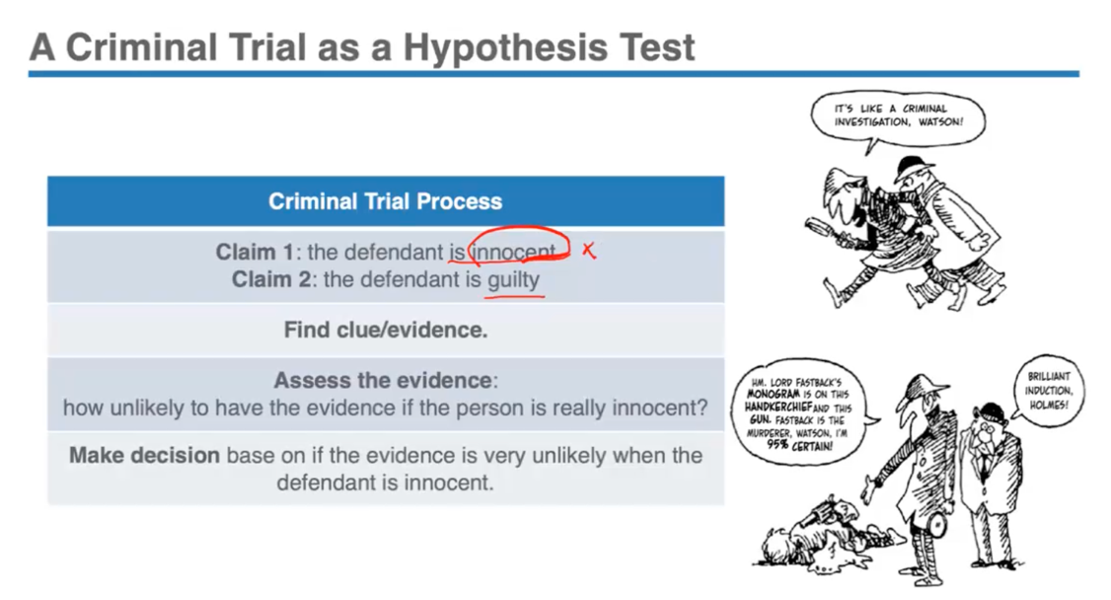

Hypothesis Testing

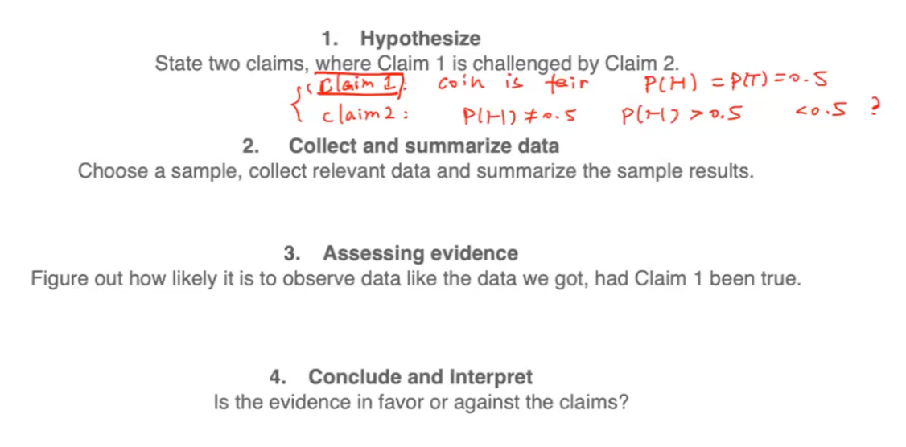

- We call these claims hypothesis, and then we follow a testing procedure to make a decision between these claims. Our statistical evidence is to be found in the data we collected, only when statistical evidence is beyond a reasonable doubt, where we reject the first claim.

- Due to sampling variation, the sample statistic may deviate from the value of the population parameter. For ex: claim 1 could be true, but we happen to collect a sample statistic that’s very off and which may cause us to make a mistake by rejecting it.

- Need to be aware that in hypothesis testing, even if the conclusion rejected one of the claims, it does not necessarily mean that the claim is wrong because despite the fact that we’re trying to make a decision with the information we have, that information could lead us to a wrong conclusion.

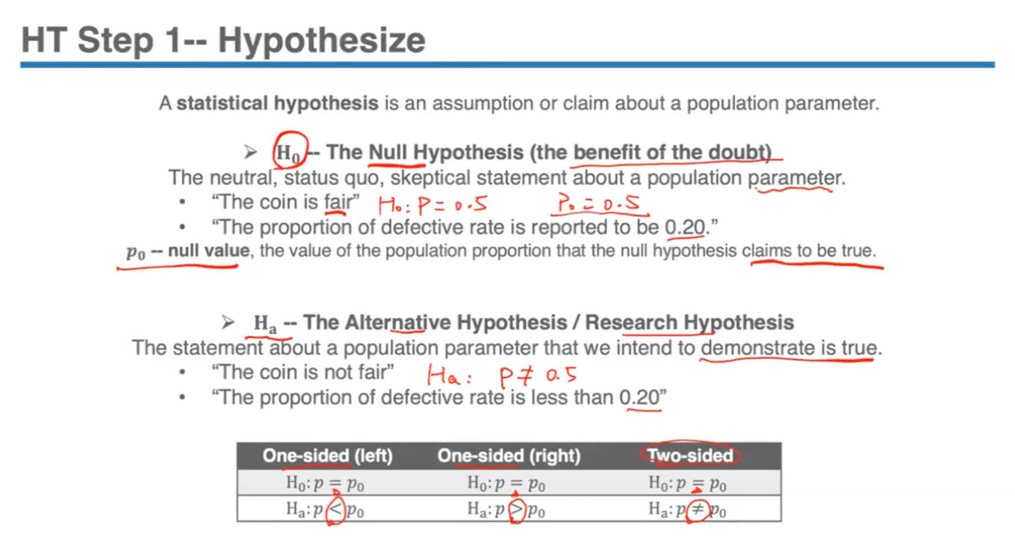

- The proportion that was reported originally or people used to normally believe is true is called a ‘Null Hypothesis’; this is like the innocent (until proven guilty) assumption in a criminal trial. It gets the benefit of the doubt since it is assumed to be true throughout the process until at the end, the evidence is beyond reasonable doubt.

- The ‘Alternative Hypothesis’ is analogous to the rejection of innocent in favour of a guilty verdict in a criminal trial. Also called the ‘Research Hypothesis’ because this is usually what the researchers want to use evidence to show.

- The Null Hypothesis usually suggests that nothing special is going on, there is no change from the status quo, no difference from the traditional state of affairs, no effect, no relationship.

This value that we claim the parameter to have and assume to be true is called the ‘null value’.

In contrast the Alternative Hypothesis disagrees with the Null Hypothesis since it states that something is going on, there is a difference in status quo and a relationship does exist. This usually represents what we want to check or suspect is really going on.

- Should note that the values in both hypotheses are statements about the population parameters, never about the sample statistic (not p-hat or x-bar values)

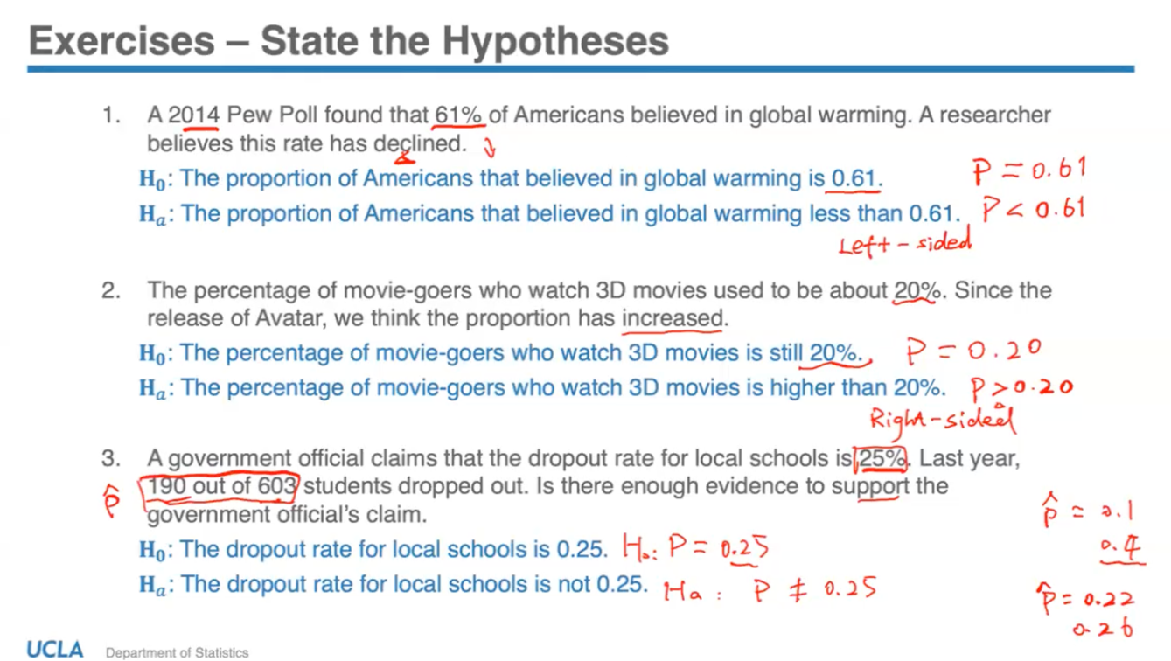

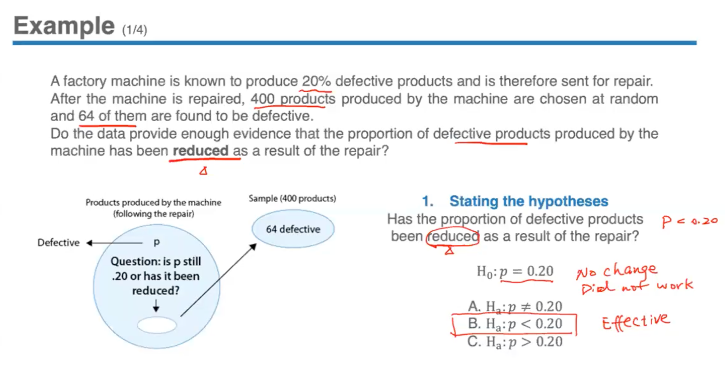

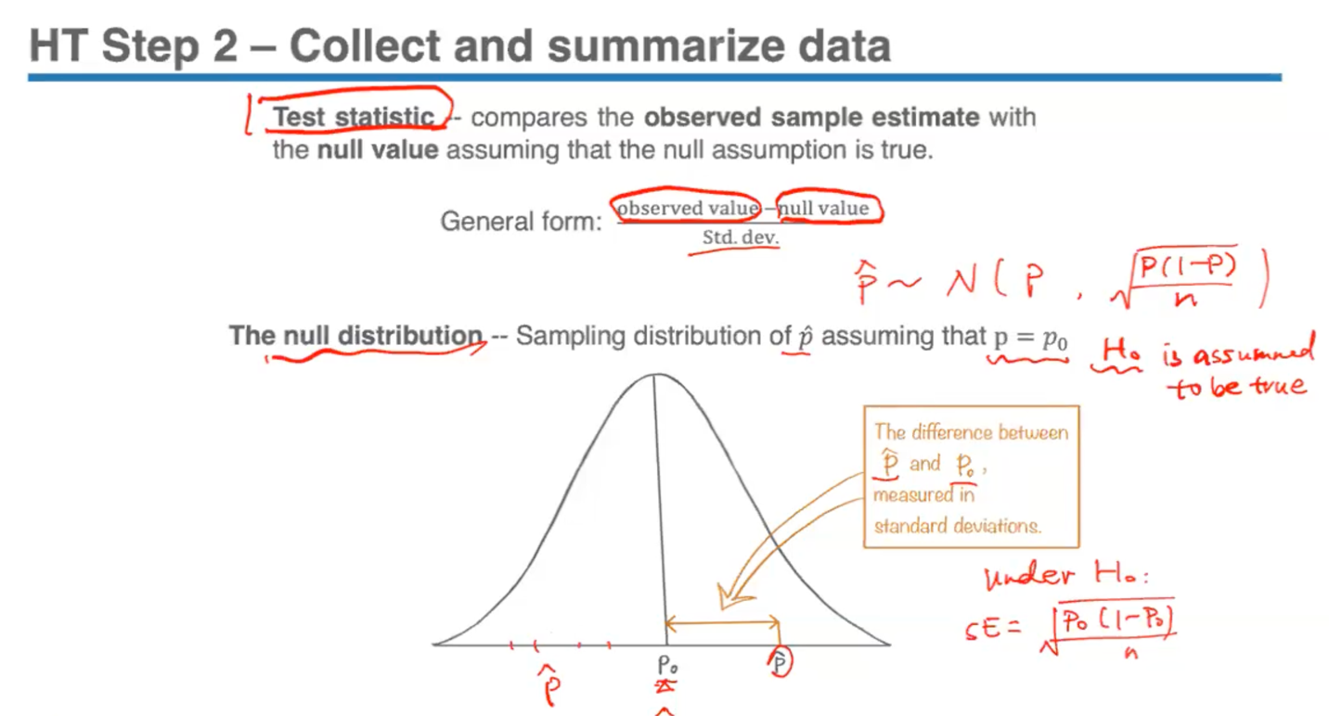

- We look at the sample data to draw a conclusion about the entire population – whether or not there is enough evidence to reject the null hypothesis.

- Want a statistic to capture the essence of the test- measures the difference between the observed and the hypothesized value while taking into consideration the variation (sd). Thus this is a measure of evidence against the null hypothesis.

- Assume that p = p0 under the null hypothesis and p0 is the true value until in the end we use evidence to reject it. Then the standard error can also be calculated using the p0 value. This is called the null distribution, assumed to be true under the null hypothesis.

- This statistic is actually a Z-score under the null distribution, and the test statistic follows the standard normal distribution. If the test statistic is = 0, it means what we observed is = what we expect in the null hypothesis. The larger, or further the statistic is from p0, the more evidence we have in the data against the null hypothesis.

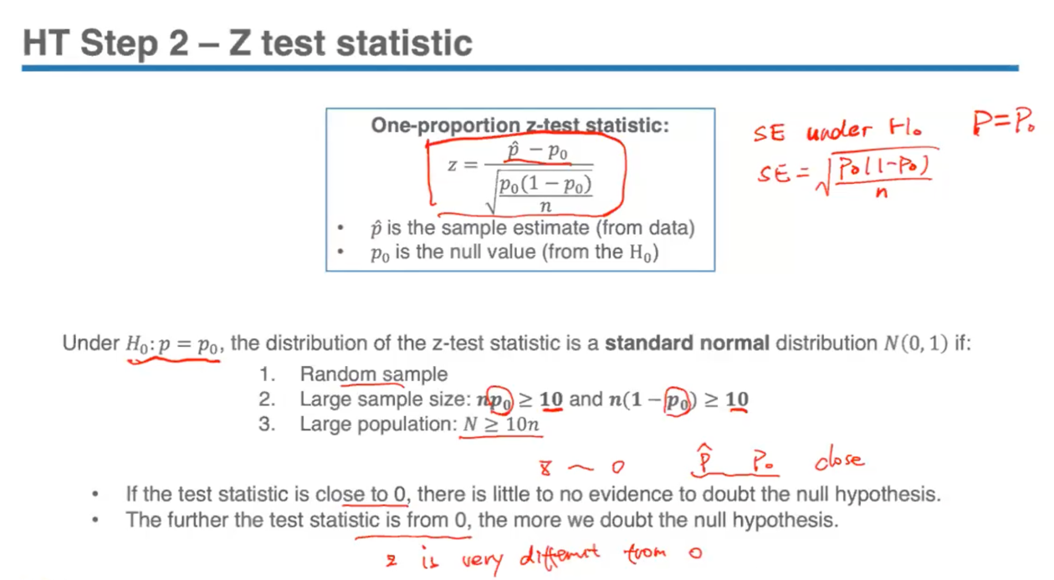

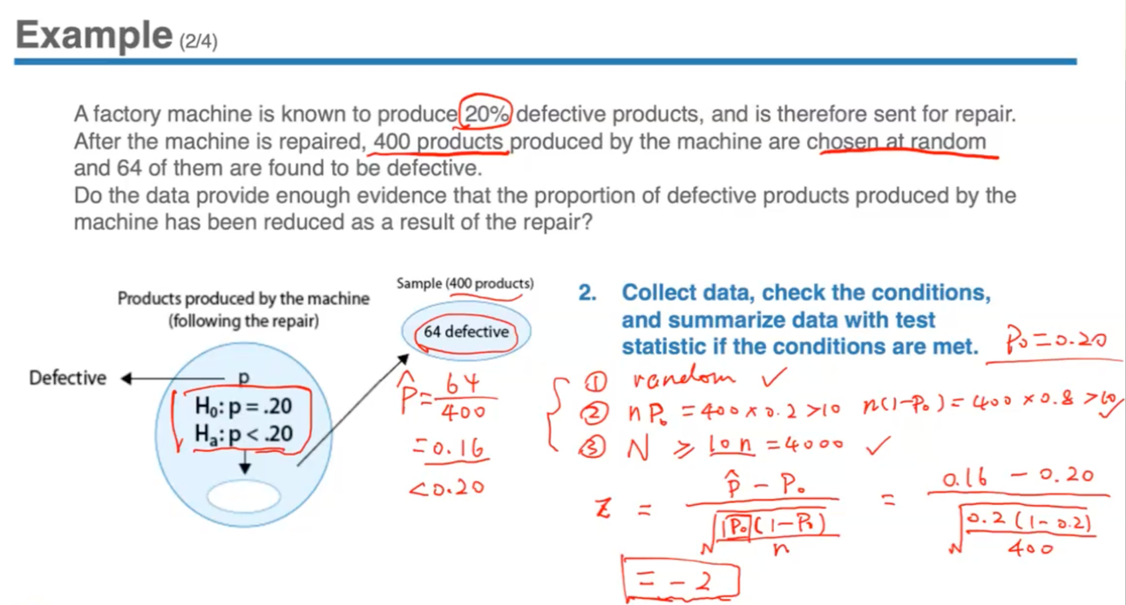

- Reveals that the Z-test statistic = -2. That is saying, the value we observed under the null distribution is 2 sds below the null value p0. So assuming this is true, the sample proportion is 2 sds below 20%.

- So basically, get the data, look at the discrepancy between what the data asks to be and what H0 claims to be.

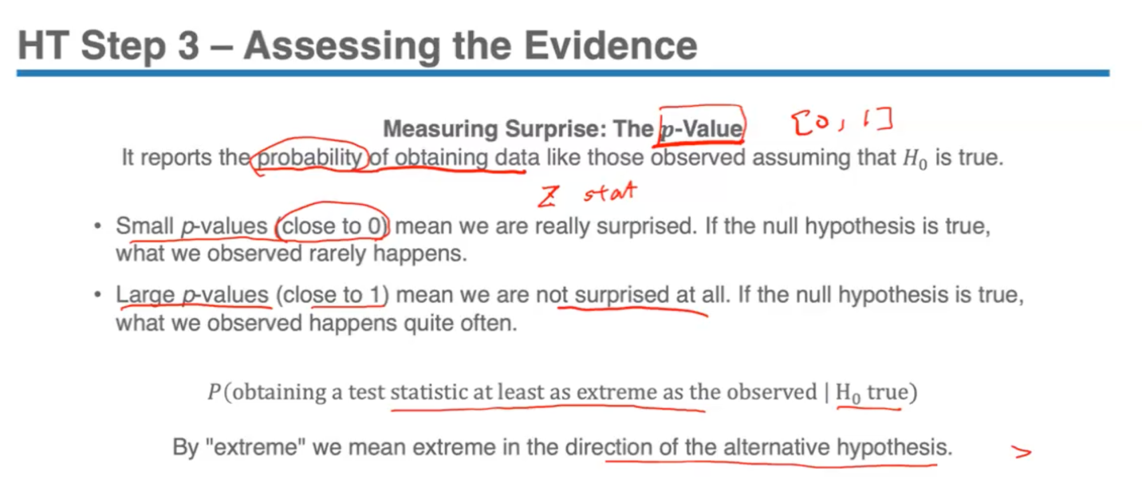

- Null hypothesis tells us what to expect when looking at the data. If we look at something unexpected and we are surprised to see such a sample statistic, then we have reason to doubt the null hypothesis. And if we’re really surprised, we should just reject the null hypothesis altogether. To formalize this decision-making, we calculate a probability of surprise – a crucial value called p-value of the test (is related to how the sample proportion deviates from the null value, the distance).

- The further the sample statistic deviates from the null value, the larger the test statistic is, but then the more surprised we are. Small p-values close to 0 means that we’re really surprised to see this statistic, and the more evidence we have against the null claim. Then, if the null hypothesis is true, what we observed rarely happens. It is the opposite as in Z-statistic we see, the larger the absolute value is the more surprised, and the larger the absolute Z-statistic is, the smaller is the p-value. Opposite for large p-values.

- Z-statistic can be negative, positive, 0 or 1, but p-value is always a number between 0 and 1 because it’s a probability.

- P-value can be thought of as conditional probability – given that H0 is true, what is the probability of obtaining such a Z-statistic that is even more extreme (in the direction of the alternative hypothesis)

*4th December, Monday*

**Lecture 10.1**

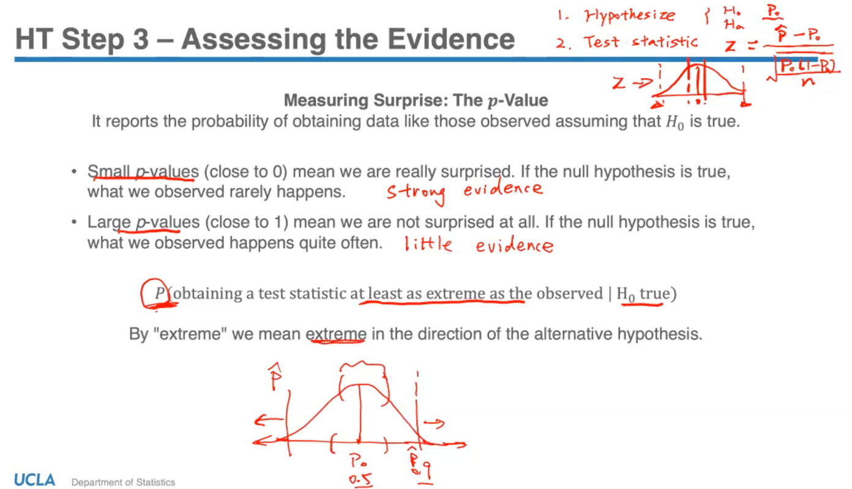

- P-value calculation depends on the type of alternative hypothesis. Since the distribution of test statistic follows a standard normal distribution and is denoted by Z, therefore the p-value calculation is simply standard normal calculations for the 3 types of Ha.

- Because in 2 tailed probability we have to sum up both sides, in general it will be harder to reject a 2-sided test vs rejecting a 1-sided test.

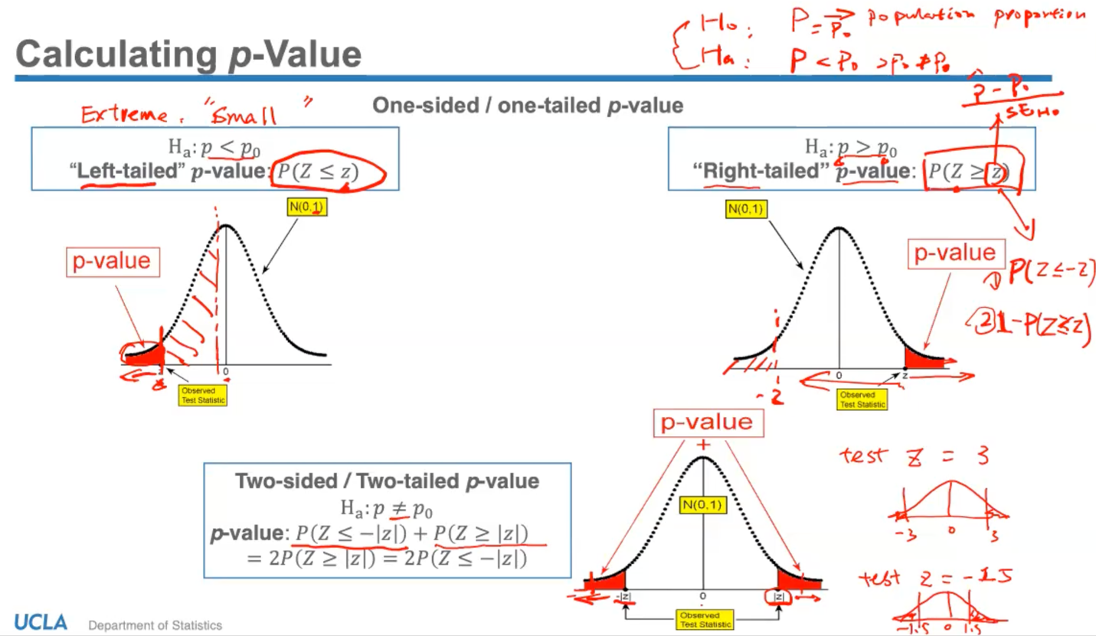

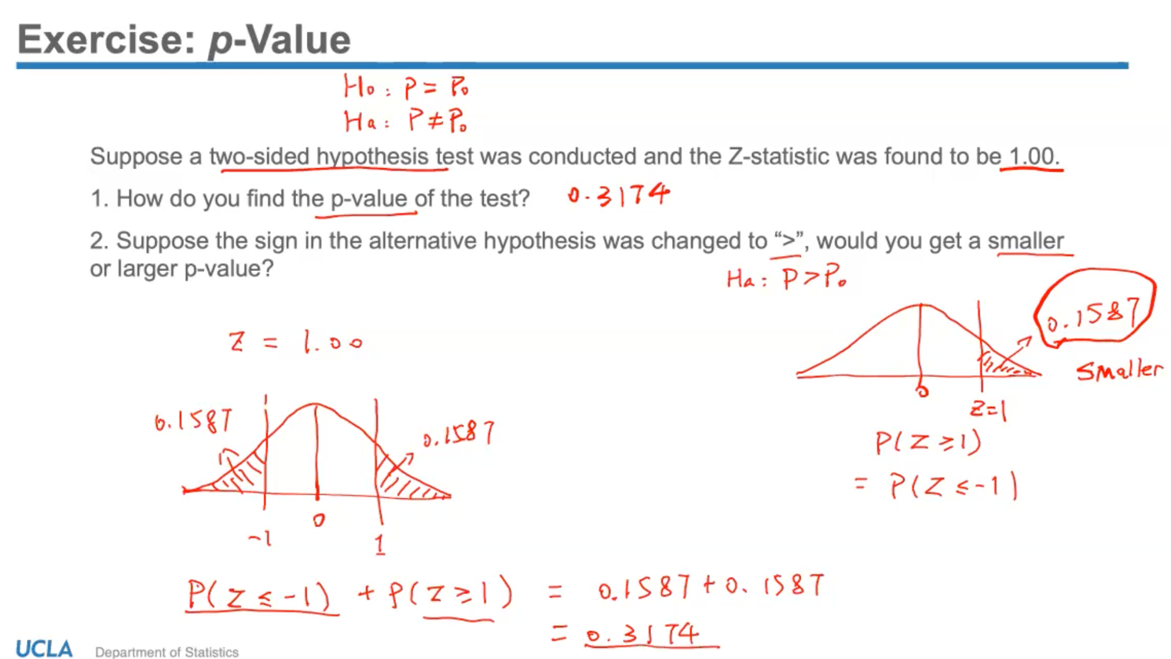

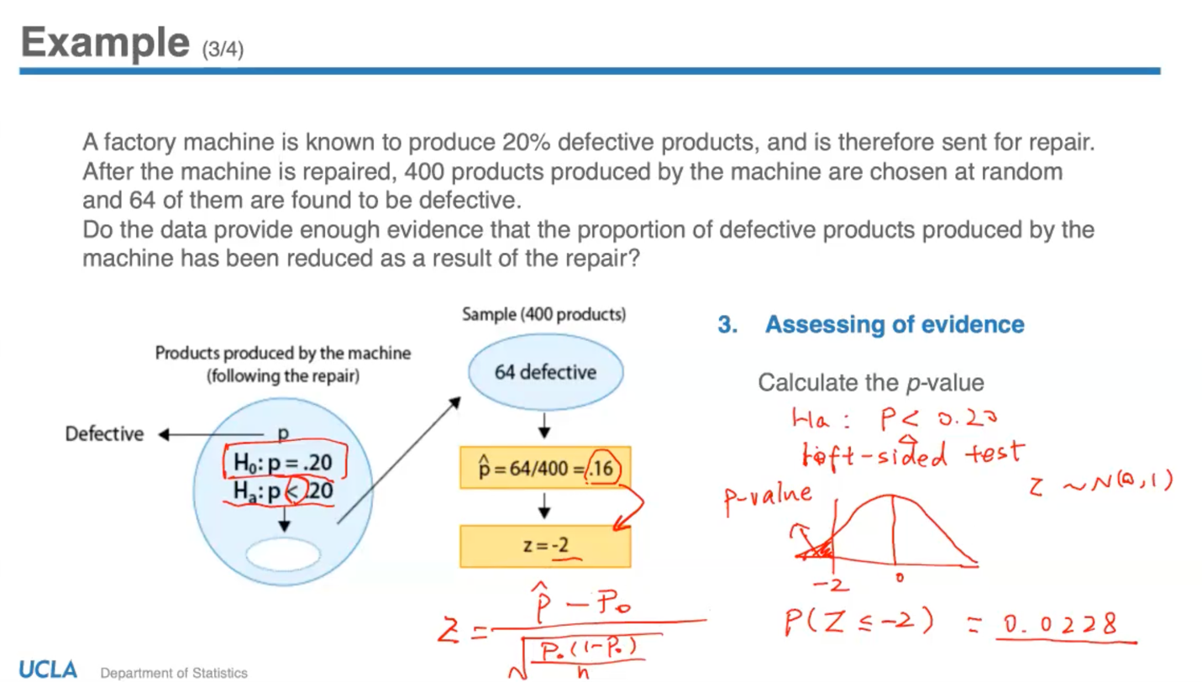

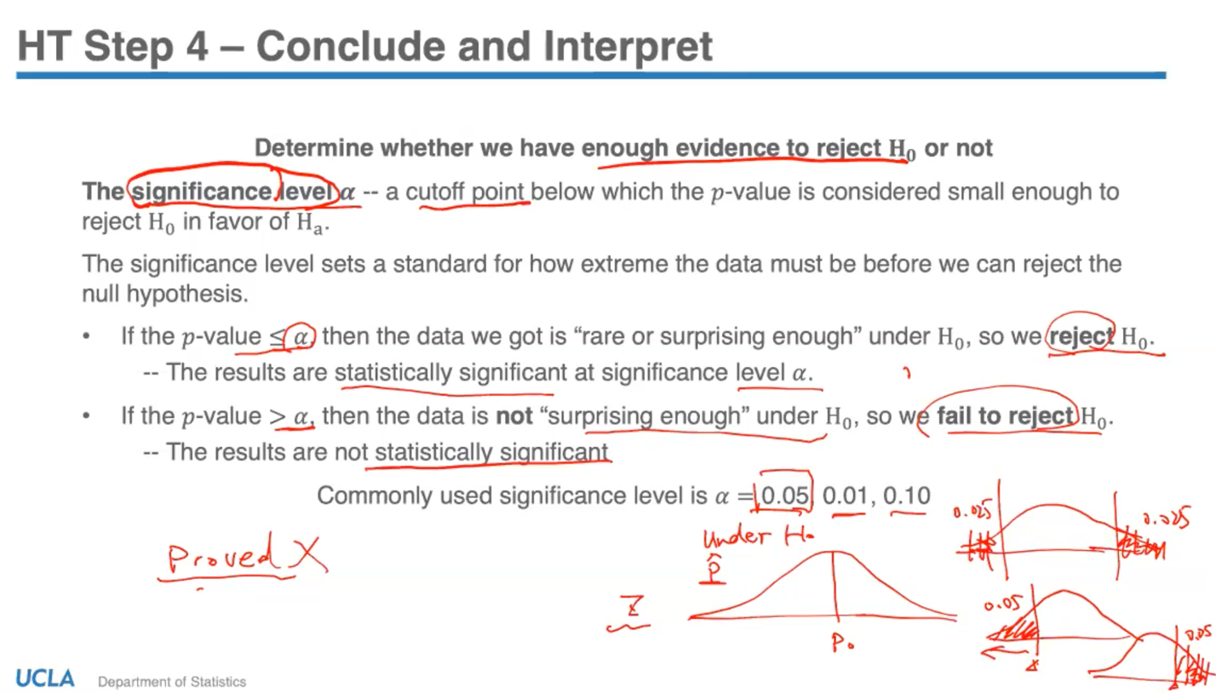

- Based on the null hypothesis, a sample statistic will deviate from the null value if it is more than 2 standard errors. Then that means only 5% of the time, we will observe such a statistic. Thus, when our sample statistic is more than 2 standard errors from the null value, then the p value will be less than 0.05. Usually, a commonly used border line/ level is 0.05. That means in a 2-sided test, we consider those values that occur less than 5 times to be very extreme.

- Usually in a study, we set a significance level (cut-off/;threshold for p-value) right before we assess the evidence.

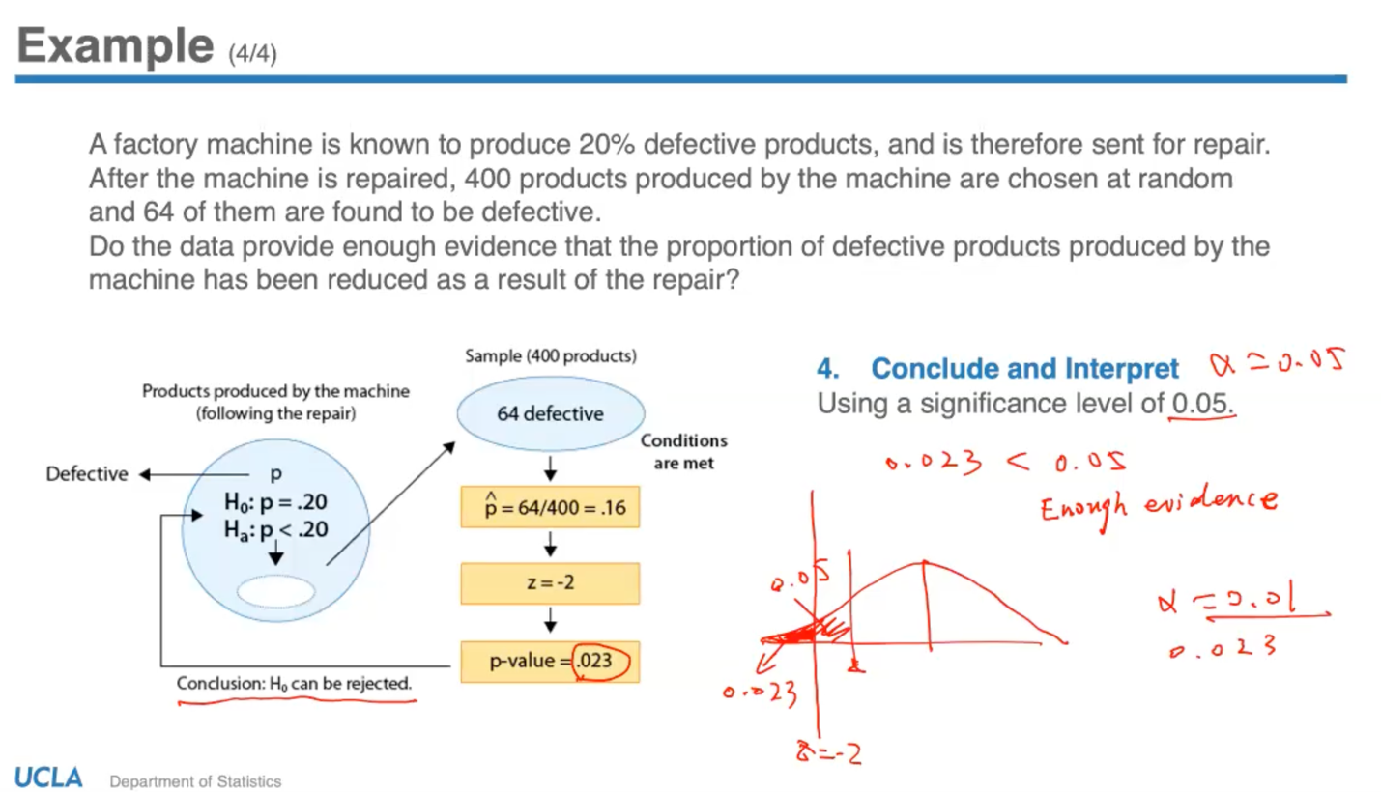

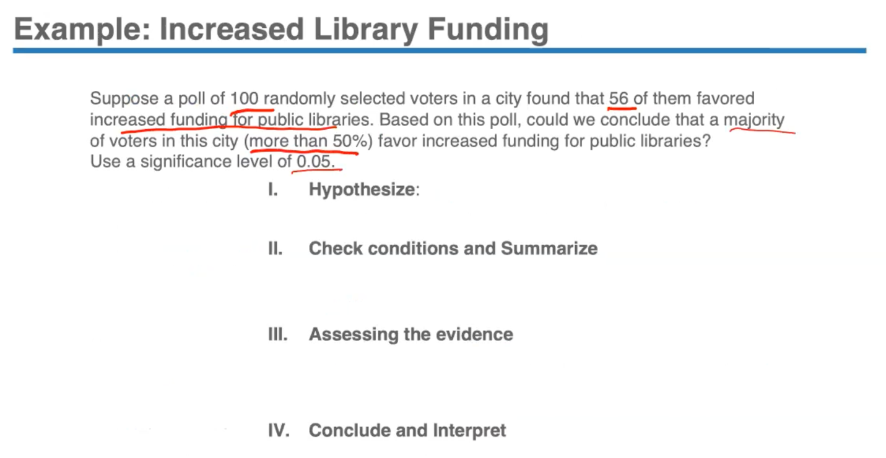

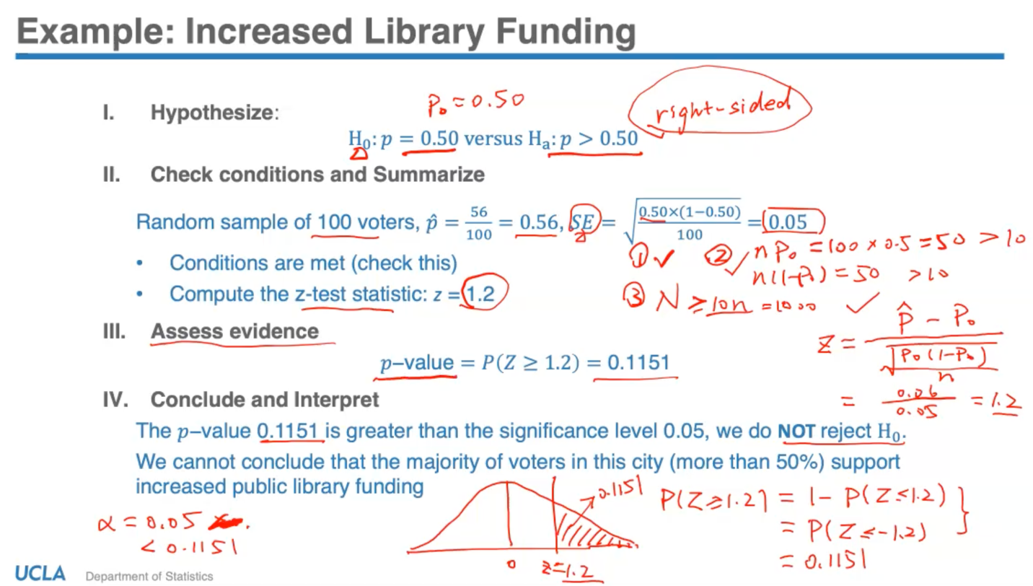

Thus, 4 steps are:

1. State the hypothesis – check if its 2-sided or 1-sided, right or left sided

2. Check the CLT conditions and summarize with the test statistic (calculate with formula)

3. Assess the evidence with the p-value

4. Conclude and interpret based on significance level set

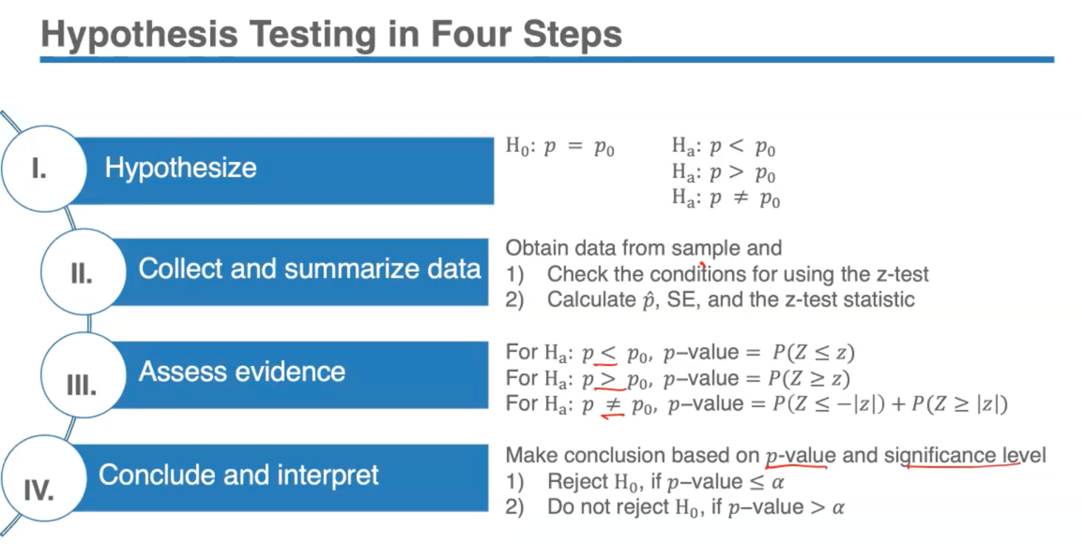

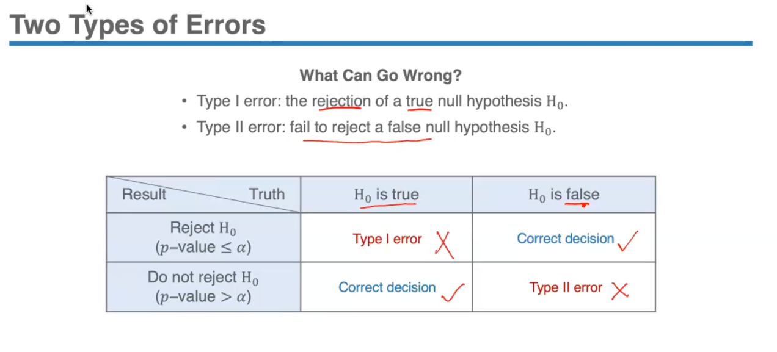

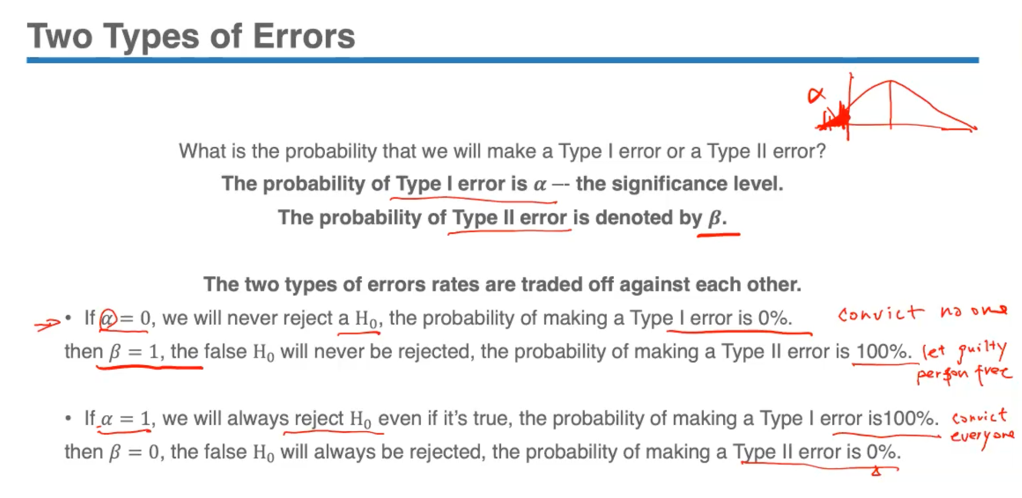

- Only way to keep both error probabilities (minimize alpha, beta) low is to increase sample size.

